RESETTLEMENT ACTION PLAN (RAP)
GATENGA SETTLEMENT

Prepared by JV ACE & CAVICON CONSULTANTS LTD

July 2022

LIST OF ACRONYMS
BNR National Bank of Rwanda
CAPI Computer Assisted Personal Interviewing
COK City of Kigali
CUC Community Upgrading Committees
DCF Discounted Cash Flow
DDC District Development Committee
DLOs District Land Offices
EICV Enquête Intégrale sur les Conditions de Vie des Ménages (Integrated Household Living Conditions Survey)
ESF Environment and Social Framework
ESMP Environmental and Social impact assessment
ESS Environment and Social Standard
GRC Grievance Redress Committee
GRM Grievance Redress Mechanism
GVB Gender Based Violence
IRPV Institute of Real Property Valuers
JADF Joint Action Development Forum
KUUT Kigali Urban Upgrading Team
LODA Local Administrative Entities Development Agency
M&E Monitoring and Evaluation
MINALOC Ministry of Local Government
MINECOFIN Ministry of Finance and Economic Planning
MINICOM Ministry of Trade and Industry
MININFRA Ministry of Infrastructure
MINIRENA Ministry of Natural Resources
MoE the Ministry of Environment
NGO Non-Governmental Organizations
NLC National Land Commission
NLUDMP National Land Use Development Master Plan
NST National Strategy for Transformation
OMU Open Market Value
PAH Project Affected Household
PAH(s) Project Affected Household(s)
PAP Project Affected Person
PAP(s) Project Affected Person(s)
PCDP Public Consultation and Disclosure Procedures
PMU Project Management Unit
PPP Public Private Partnership
PSF Private Sector Federation
RALGA Rwanda Association of Local Government Authorities
RAP Resettlement Action Plan
RDB Rwanda Development Board
REMA Rwanda Environment Management Authority
RGB Rwanda Governance Board
RHA Rwanda Housing Authority
RLMUA Rwanda Land Management and Use Authority
RoW Right of Way
RRA Rwanda Revenue Authority
RTDA Rwanda Transport and Development Agency
RUDP Urban Development Project
RUDP Rwanda Urban Development Project
RWF Rwandan Francs
TOR Terms of Reference
WASAC Water and Sanitation Corporation
WB World Bank

KEY DEFINITIONS
CONCEPT | DEFINITION
A Project | A project to improve Gatenga settlement
Affected Persons/People – (also Project Affected People or PAPs) | In general context, any person affected by Project-related activities which cause changes in use, or access to land, water, natural resources, or in some circumstances, can lead to loss of income and/or changes in livelihood.  However, in this report, PAP is used to refer to the owner of the property to be affected. Others are called “project affected Individuals”
Affected Household | All members of a household, residing under one roof and operating as a single economic unit that are adversely affected by the Project or any of its components. The household can include a single nuclear family or an extended family group.
Assets | An asset could be land, structures, trees, crops, businesses and any combination of these assets.
Census | This is a socio-economic survey within the defined project boundaries. A census provides complete count of the population affected by the project activity and includes demographic and socioeconomic information. A census identifies and determines the number of Project Affected Persons (PAPs) and the nature and levels of the project impact on PAPs.
Compensation | A payment in kind, cash or other assets given in exchange for the taking of land, or loss of other types of assets (including fixed assets) or loss of livelihood resulting from project activities.
Cut-off date | Refers to the date of completion of the census and assets inventory of persons affected by the project and signing of the Valuation forms upon disclosure. Persons occupying the area after the “cut-off” date are not eligible for compensation. Similarly, fixed assets such as built structures and perennial crops established after the date of completion of the assets inventory will not be compensated.
Host Community: | Community residing in or near the area to which affected people are to be relocated.
Involuntary Resettlement | Involuntary resettlement refers both to physical displacement (relocation or loss of shelter) and to economic displacement (loss of assets or access to assets that leads to loss of income sources or means of livelihood) as a result of project-related land acquisition or restriction of access to natural resources. Resettlement is considered involuntary when affected individuals or communities do not have the option to refuse land acquisition that may result into displacement. This occurs in cases of: (i) lawful expropriation or restrictions on land use based on eminent domain; and (ii) negotiated settlements in which the buyer can resort to expropriation or impose legal restrictions on land use if negotiations fail.
Economic displacement | Loss of income or means of livelihood resulting from land acquisition or obstructed access to resources (land, water, etc.), caused by the construction or operation of a project or its associated Facilities/components. Not all economically displaced people need to relocate due to the Project.
Entitlement | Range of measures (including compensation, income restoration, transfer assistance, income substitution, and relocation) aimed at compensating affected people and restoring their economic and social conditions.
Expropriation (in the public interest ) | An act based on power of Government, public institutions and local administrative entities with legal personality to remove a person from his/her property in the public interest after fair compensation.
Land | Refers to agricultural and/or non-agricultural land, which may be temporary or permanently required for the Project.
Land Acquisition | The process whereby for public purpose a government agency acquires all or part of the land owned by a person/business, in return for compensation.
Livelihood Restoration | Compensatory measures provided under the Resettlement or Livelihood Restoration Policy Framework and which include measures to restore affected people’s livelihood to at least the “prior to the project” level or improve it.
Physical displacement | Loss of shelter/residential structure and assets resulting from land acquisition triggered by a project that requires the affected person(s) to move to another location.
Project-Affected Household PAH) | A PAH is a household that includes one or several Project-Affected Persons as defined below. A PAH will usually include a head of household, his / her spouse and their children, but may also include other dependents living in the same dwelling or set of dwellings, like close relatives (e.g., parents, grandchildren).
Project Affected Persons (PAPs) | Affected persons are defined as those who stand to lose, as a consequence of the project, all or part of their physical and non-physical assets, including homes, productive land, commercial properties, income earning opportunities, etc.
Rehabilitation/ restoration | Re-establishing incomes, livelihoods, living, and social systems.
Relocation | This is rebuilding housing, assets including production land and public infrastructure in another location.
Resettlement | The entire process of relocation and rehabilitation caused by project related activities
Resettlement Action Plan (RAP) | Is a detailed plan of future resettlement activities to be prepared when the projects and sub-projects’ boundaries have been identified and finalized?
Resettlement Assistance | The measures to ensure that project affected persons who need to be physically relocated are provided with assistance such as moving allowances, residential housing or rentals whichever is feasible and as required, to mitigate resettlement impacts. The document in which a project sponsor or other responsible entity specifies the procedures that it will follow and the actions that it will take to mitigate adverse effects, compensate losses and provide developments to persons and communities affected by an investment/ development project.
Replacement value | The value of assets which is sufficient to replace lost assets and cover all relevant transaction costs (professional/notary fees, registration fees, etc.). In applying this method of valuation, depreciation of structures and assets are not taken into account.
Replacement value | In regards to land and structures, "replacement value" is defined as follows: For agricultural land, it is the pre-project or pre-displacement, whichever is higher, market value of land of equal productive potential or use located in the vicinity of the affected land, plus the cost of preparing the land to levels similar to those of the affected land, plus the cost of any registration and transfer taxes.
Replacement value | For land in urban areas, it is the pre-displacement market value of land of equal size and use, with similar or improved public infrastructure facilities and services and located in the vicinity of the affected land, plus the cost of any registration and transfer taxes. For houses and other structures, the market cost of the materials to build a replacement structure with an area and quality similar to or better than those of the affected structure, or to repair a partially affected structure, plus the cost of transporting building materials to the construction site, plus the cost of any labour and contractors' fees, plus the cost of any registration and transfer taxes.
Stakeholders | Any individuals, groups, organizations and institutions interested in and potentially affected by a project or having the ability to influence the project.
Vulnerable Groups | People who may by virtue of gender, ethnicity, age, physical or mental disability, economic disadvantage or social status get more adversely affected by resettlement than others; and who may have limited ability to claim or take advantage of resettlement assistance and related development benefits.

Table of Contents
LIST OF ACRONYMS ii
KEY DEFINITIONS iv
Table of Contents vii
List of Figures xiii
List of tables xv
EXECUTIVE SUMMARY xvi
Chapter 1 INTRODUCTION 1
1.1 Introduction 1
1.2 Format of the RAP report 1
1.3 Background 2
1.4 Objectives of RUDP II 3
Component 1: Support to the City of Kigali 3
Component 2: Support to Secondary Cities 3
Component 3: Institutional and Capacity Development and Project Management 3
Component 4: Contingency Emergency Response Component 3
1.5 Description of Gatenga Settlement 4
1.5.1 Location of the settlement 4
1.6 The Objectives of the RAP 9
1.7 Guiding Principles for the RAP 10
1.8 Scope of the RAP 10
1.8.1 Road and related infrastructures 10
1.8.2 Gatenga Settlement Community Facilities 11
1.9 RAP Approach and Methodology 12
1.9.1 Review and analysis of the secondary data 12
1.9.2 Reconnaissance and Designing a Comprehensive Plan 12
1.9.3 Stakeholder engagement 13
1.9.4 Cadastral Survey and Valuation Survey 13
1.9.5 Socioeconomic Survey Methodology 15
Chapter 2 LEGAL AND POLICY FRAMEWORK 18
2.1 Introduction 18
2.1.1 Key Rwandan Legislation 18
2.2 The Rwandan Constitution 19
2.3 Rwanda 7 Years Government Programme: National Strategy for Transformation (NST 1), 2017 – 2024 19
2.4 Vision 2050 19
2.5 National urbanization policy, 2015 20
2.6 National Housing Policy, 2015 20
2.7 Condominium law, 2010 20
2.8 National informal settlement upgrading strategies and guidelines, 2015 20
2.9 National land use guidelines, 2017 20
2.10 Urban planning codes, 2015 20
2.11 Kigali City Master Plan 2020 21
2.12 Expropriation law, 2015 21
2.13 National Land Policy, 2019 21
2.13.1 Categorization of Land 21
2.13.2 The National Land Commission 25
2.14 Ministerial Order No. 001/2006 of 2006 stipulating the Structure of Lands 25
2.14.1 Confirmation of land ownership 27
2.14.2 Surveys and Valuation of compensation 27
2.14.3 Public Consultations about Land Acquisition and Expropriation 28
2.14.4 Process of Land Acquisition, Expropriation and Compensation Process 28
2.14.5 Claims and Grievances 30
2.15 The World Bank’s Environment and Social Framework (ESF) 31
2.16 Gaps between Local Laws Covering Eminent Domain and Resettlement and the Bank’s ESF and The Mechanisms to Bridge Such Gaps 38
2.17 Institutional Framework 44
2.18 Organisation structure for the RAP implementation 49
Chapter 3 CONSULTATIONS AND PARTICIPATION 50
3.1 Introduction 50
3.2 Objectives of Stakeholder Engagement 50
3.3 Stakeholder Identification, Mapping and Analysis 50
3.4 Formation of the Community Upgrading Committees 51
3.5 The community Participation process 52
3.6 Stakeholder views 58
Chapter 4 SOCIOECONOMIC BASELINE CONDITIONS 64
4.1 Introduction 64
4.2 House hold characteristics 64
4.2.1 Gender of the head of household 64
4.2.2 Age of household head 64
4.2.3 Marital Status 65
4.2.4 Education of the head of household 65
4.2.5 Professional activity 65
4.2.6 Number of people in your household 66
4.2.7 Gender of the household members 66
4.2.8 Age group of household members 67
4.2.9 Education of household members 67
4.2.10 Access to schools 67
4.2.11 Literacy of the household head 69
4.2.12 Occupation of household members 69
4.3 Household economy 69
4.3.1 Category of PAPs 69
4.3.2 Most important income source 70
4.3.3 Income of another household member 70
4.3.4 Well-being indicators 71
4.3.5 Household source of social assistance during difficult times 71
4.3.6 Average income from different Sources of livelihoods in the 12 last months 71
4.3.7 Average monthly household expenditure on basic necessities 72
4.4 Health status of the household 72
4.4.1 Health Conditions 72
4.4.2 Health seeking behavior 72
4.5 Property ownership Status 73
4.5.1 Land ownership status 73
4.5.2 Impacts on the houses and land 73
4.5.3 Possible area for relocation 74
4.6 Housing Conditions 74
4.6.1 Ownership of the house 74
4.6.2 Type of dwelling 74
4.7 Services 75
4.7.1 Access to Water 75
4.7.2 Sanitation 75
4.8 Communication 75
4.9 Social Capital 76
4.9.1 Source of social assistance 76
4.9.2 Community based Activities 76
4.10 Compensation formation 77
4.10.1 Preferred compensation 77
4.10.2 Reasons for Preferred compensation option 77
4.11 HIV/AIDS 78
4.11.1 Methods of contracting HIV/AIDS 78
4.11.2 Method of avoiding HIV/AIDS 78
4.11.3 Major source of information about HIV/AIDS 79
4.12 Gender Based Violence (GVB) 79
4.12.1 Forms of GBV experienced in the last 12 months 79
4.12.2 female household member experiencing abuses in the last 12 months 79
4.13 Vulnerability of the Family Heads 80
4.13.1 Chronic Diseases Suffered by Household Heads 80
4.13.2 Disability of the other Household members 80
4.14 Births and Deaths 81
4.15 Orphanage hood 81
4.15.1 Deceased Property Owners 81
4.15.2 Orphans belonging or adopted in a household 81
Chapter 5 PROJECT DISPLACEMENT IMPACTS 82
5.1 Introduction 82
5.2 Determination of acquiring project land 82
5.2.1 Criteria of land acquisition 82
5.2.2 Typical sections of the road infrastructure 82
5.2.3 Demarcations for community facilities 83
5.3 Minimization of the impacts 83
5.3.1 Options for acquiring effect area 83
5.3.2 Other considerations 83
5.4 Nature of impacts 84
5.4.1 Physically affected PAPs 84
5.4.2 Economically affected PAPs 84
5.4.3 Institutions 84
5.5 Summary of the impacts 84
5.6 Arrangement of the PAPs list 85
Chapter 6 COMPENSATION STRATEGY, ELIGIBILITY AND ENTITLEMENTS 87
6.1 Introduction 87
6.2 Key Principles for Compensation and Eligibility 87
6.3 Lessons Learnt from Previous Resettlement and Compensation Activities 87
6.4 Eligibility 88
6.5 The Census 88
6.6 The Cut-Off Date 89
Chapter 7 PROPERTY VALUATION PROCESS 90
7.1 Introduction 90
7.2 Census and asset inventory survey and valuation 90
7.3 Land Survey 90
7.4 Valuation Survey Procedure 90
7.4.1 Valuation Data Collection 90
7.4.2 Valuation Analysis, Computation and Report Preparation 91
7.4.3 Approval of Valuation Report 91
7.4.4 Disclosure of Compensation Packages to the PAPs, Signing or Fingerprinting approved fair compensation report by the PAPs 92
7.4.5 Contesting the assessed value of land and property incorporated thereon and Analysis of counter-assessment report 92
7.5 Required Documents from PAP 93
Chapter 8 LIVELIHOOD RESTORATION 94
8.1 Introduction 94
8.2 Compensation related Actions 94
8.3 Financial literacy 94
8.3.1 Likely topics and benefits 94
8.4 Employment 95
Chapter 9 VULNERABLE GROUPS 96
9.1 Introduction 96
9.2 Types of vulnerabilities 96
9.2.1 Chronic disease suffered by household heads 96
9.2.2 Disability by Household members 96
9.2.3 Owner(s) of property deceased 96
9.3 Identification of Vulnerable People 97
9.4 Assistance to Vulnerable People 97
Chapter 10 GRIEVANCE REDRESS MECHANISM (GRM) 98
10.1 Introduction 98
10.2 General Practice 98
10.3 Possible sources of grievances 100
10.3.1 Grievance Channel for Gender Based Violence (GVB) 100
10.4 Principles of the GRM 101
10.5 Procedure for the GRM 101
10.6 The Grievance Redress Committee (GRC) (Internal First Tier) 101
10.7 Grievance Redress Committee (External Second Tier) 102
Chapter 11 IMPLEMENTATION OF ACTIVITIES AND RESPONSIBILITIES 104
11.1 Introduction 104
11.2 Implementation activities 104
11.3 Resettlement Capacity at CoK 104
11.3.1 Current staffing capacity 104
11.3.2 Proposed Resettlement implementation team 104
11.4 Resettlement Implementation Plan 104
11.4.1 RAP Activity timelines 105
11.4.2 RAP Implementation Schedule 106
11.5 RAP Implementation Completion Report 108
Chapter 12 MONITORING AND EVALUATION 109
12.1 Overview 109
12.1.1 Input Monitoring 109
12.1.2 Outputs Monitoring 109
12.1.3 Outcome Evaluation 109
12.1.4 Input and Output Monitoring 110
12.2 KPIs for Land Acquisition and Resettlement Process 110
12.3 KPIs for monitoring Output of Grievance and Compensation Process 110
12.4 Compliance Monitoring and Completion Audit 111
12.4.1 Compliance Monitoring 111
12.4.2 Monitoring & Evaluation 111
12.4.3 Completion Audit 112
Chapter 13 BUDGET 113
REFERENCES 114
APPENDICES 116
Appendix 1: Pictures of Stakeholder Engagements 116
Appendix 2: Research Tools 119
Appendix 2a: Data Inventory Form 119
Appendix 2b Property Valuation Form 124
Appendix 2c: Questionnaire for Socio-economic survey 132
Appendix 3: Valuation Report 155
Appendix 4: List of Affected PAPs 161
Appendix 5: RAP Terms of References 168
Appendix 6: Minutes of Stakeholders engagements 175
Appendix 7: Minutes of Property Valuation Kickoff Meeting 182
Appendix 8: List of RAP Team Members 186
Appendix 9: Template for Grievance Redress Mechanism Form 187
Appendix 10: Summary of Investment (Prioritisation) 190

List of Figures
Figure ‎1-1: Map Showing the Administrative cells and Sectors in the Study Area 5
Figure ‎1-2: Top Pictorial view of some of Gatenga Settlement 6
Figure ‎1-3: Clear Map of Proposed Investments 7
Figure ‎1-4: Gatenga Settlement Proposed Infrastructure on setilite image 8
Figure ‎1-5: During Community engagement with CUC and Local leaders of Gatenga settlement 13
Figure ‎1-6: Infrastructure Buffer Considered in the Valuation Works Murambi & Ihuriro Villages 14
Figure ‎1-7: Infrastructure Buffer Considered in the Valuation Works Murambi & Ihuriro Villages (Satellite) 15
Figure ‎1-8: The Sampled PAPs for the S.E Survey 16
Figure ‎2-1: RAP Organisation Structire 49
Figure ‎3-1: Community Senstization process 52
Figure ‎3-2: Attendance Sheet from the stakeholder meetings 1 55
Figure ‎3-3: Attendance Sheet from the stakeholder meetings 2 55
Figure ‎3-4: Gatenga CUC members’ attendance taken 56
Figure ‎3-5: Karambo Cell elected CUCs attendance 56
Figure ‎3-6: Nyanza Cell elected CUCs attendance 57
Figure ‎3-7: Gatenga Cell elected CUCs attendance 57
Figure ‎3-8: Stakeholder Engagement with Gatenga CUC members 58
Figure ‎4-1: Households’ Head Gender 64
Figure ‎4-2: Households' Head Age 65
Figure ‎4-3: marital Status Demographic 65
Figure ‎4-4: Households' Head Level of Education 65
Figure ‎4-5: PAPs Professional Activity. 65
Figure ‎4-6: Number of People per Household 66
Figure ‎4-7: Household Member Age groups 67
Figure ‎4-8: Education of the household members. 67
Figure ‎4-9: Children in Schools 68
Figure ‎4-10: Type of School attended 68
Figure ‎4-11: The vicinity of the school 68
Figure ‎4-12: Literacy Levels of the Household Heads 69
Figure ‎4-13: Occupation of household members 69
Figure ‎4-14: Economic Category of the PAPs 70
Figure ‎4-15: Most important Source of Income 70
Figure ‎4-16: Type of other household members 70
Figure ‎4-17: What Children had for Breakfast 71
Figure ‎4-18: Household source of social assistance during difficult times 71
Figure ‎4-19: Average Income 71
Figure ‎4-20: Average annual household expenditure 72
Figure ‎4-21: Illnesses for children below 5 years in the two weeks preceding the interview 72
Figure ‎4-22: Where consultation is first sought 73
Figure ‎4-23: Land Ownership 73
Figure ‎4-24: Impact on property ( L; on house and R: on land) 73
Figure ‎4-25: Possible relocation sites Preference. 74
Figure ‎4-26: Ownership of house 74
Figure ‎4-27: type of dwelling 75
Figure ‎4-28: Access to water 75
Figure ‎4-29: Type of Toilet Facility 75
Figure ‎4-30: Communication 76
Figure ‎4-31: Source of social assistance 76
Figure ‎4-32: Community Organization 76
Figure ‎4-33: Reason for compensation option (L- Cash R: In-Kind) 77
Figure ‎4-34: Methods of contracting HIV/AIDS 78
Figure ‎4-35: Methods of avoiding HIV/AIDS 78
Figure ‎4-36: Major source of information about HIV/AIDS 79
Figure ‎4-37: Forms of GBV experienced in the last 12 months 79
Figure ‎4-38: Chronic Disease Suffered by Household Heads 80
Figure ‎4-39: Disability by household head and for the other members 80
Figure ‎4-40: Births and Deaths recorded 81
Figure ‎4-41: Diseased Property owner 81
Figure ‎4-42: Existence of orphans in homes 81
Figure ‎5-1: Typical 10 RoW Road section 82
Figure ‎5-2: Typical 7.5m RoW Road section 82
Figure ‎10-1: Grievance Redress Mechanism (GRM) 103
Figure ‎11-1: RAP Implementation schedule 107
Figure ‎11-2: RAP Implementation Organisation Structure 108
Figure ‎0-1: some of the sensitization meeting with CUC members in Gatenga 118
Figure ‎0-2: Community members engaged in project activities for pay 118

List of tables
Table ‎1-1: Selected Unplanned Settlements 3
Table ‎1-2: Administrative entities of the study area 4
Table ‎1-3: Proposed roads for development 10
Table ‎1-4: Summary of Gatenga Community Facilities 11
Table ‎2-1: The ESS5 Requirements 32
Table ‎2-2: Comparative Analysis and Bridging Strategy between World Bank ESS5 and Rwanda Legislations. 38
Table ‎2-3: Institution and their Mandates 44
Table ‎3-1 Stakeholder Analysis 50
Table ‎3-3: Gatenga Settlement CUCs 51
Table ‎3-4: Sensitization activities 53
Table ‎3-5: Stakeholder engagement responses 58
Table ‎4-1: Preferred compensation options 77
Table ‎5-1: Status of land for Facilities 83
Table ‎5-2: Summary of impacts 84
Table ‎5-3: PAPs grouped into Streets 85
Table ‎6-1: Eligibility and entitlement matrix 88
Table ‎9-1: Estimates of vulnerable Household heads 97
Table ‎10-1: Proposed Composition of GRC and their roles 99
Table ‎11-1: Impending Activities and responsibilities 104
Table ‎11-2: RAP Activities and timelines 105
Table ‎12-1: KPIs for land acquisition and resettlement process 110
Table ‎12-2: KPIs for monitoring output 110
Table ‎13-1: Estimated Land Acquisition and Resettlement Budget 113
Table ‎0-1: List of Affected PAPs for Road and related Infrastructures per street 162
Table ‎0-2: Summary of Investment (Prioritisation) 191

EXECUTIVE SUMMARY
Introduction
The Government of Rwanda and the World Bank signed a financing agreement for the Second Rwanda Urban Development Project (Credit Number 6789- RW & Grant Number D737-RW) which became effective on February 10, 2021, with the main objective to improve access to basic services, enhance resilience and strengthen urban management in the City of Kigali and the six secondary cities where the City of Kigali will implement the component 1a of the project which include Flood risk management.
The Urban Development Project (RUDP II) aims at supporting critical investments to cope with increased urbanization pressures, deficient infrastructure and services in selected unplanned settlements (4) and improving resilience to cope with climate change impacts in the City. Gatenga settlement is part of the four settlements to be upgraded. A consultant was hired by the City of Kigali to carry out the detailed design studies of the proposed infrastructures include among others: road improvements, sewage and drainage systems and street lighting. Part of the assignment was to develop a Resettlement Action Plan (RAP) to provide a strategy for compensation and resettlement of people affected by the proposed infrastructure intended to improve Gatenga settlement. The goal of this RAP is to minimize the negative economic and social impacts due to involuntary resettlement and/or relocation arising from the proposed project.
Objectives of the RAP
The aim of the RAP as is to identify and assess the human impact of the planned infrastructure projects under RUDP II interventions in the City of Kigali 4 unplanned settlement sites. An Action Plan to be prepared and implemented in coordination with the civil works in line with World Bank Environmental and Social Framework (ESF) requirements, the RPF and Government of Rwanda policies and laws.
The main objectives of this RAP are:
- To clearly define steps and actions to be taken by the CoK in response to adverse impacts of the proposed project activities on (i) loss of property for project affected persons (land, assets, etc), (ii) public infrastructures, and (iii) social and economic livelihood of the project affected people.
- To design appropriate strategies for restoration and improvement of the income and livelihood of the Project Affected People, special support measures for vulnerable groups,
- To determine task assignments, resource allocation (budgeting) and implementation schedules for measures against adverse impacts of the project; and
- To prepare documented mechanisms for monitoring and evaluation of progress and performance in implementation of Resettlement Action Plan.

RAP Preparation
In developing this RAP, a number of principles have been followed. These principles are based on the objectives of the ESS5 of the World Bank’s Environment and Social Framework (ESF as well as the existing policies and legislation of the Government of Rwanda. The principles stress full and fair compensation. In addition, involuntary resettlement should be conceived as an opportunity for improving the livelihoods of the affected, full consultations with affected people and recognition of all PAPs who have formal legal rights to land or other affected assets and those who do not have formal legal rights to land.
The information that has been used in the development of this Resettlement Action Plan is based on both primary and secondary data. The secondary data was collected from official records available at National and sector levels. The primary data was generated through field interviews with the community in the project area. The RAP is based on national legislation related to land use, planning, and tenure and the international policies of the World Bank. The main institutions that will be involved in the City of Kigali, as well as monitoring and approval of issues related to Resettlement and Compensation are provided in the report.

Basic Data on the RAP
Description | Impacts in quantity
District | Kicukiro
Province | City of Kigali
Planned activity | Provision of basic Infrastructure and Community Facilities
Surface Area of permanent land taken for the roads and community facilities | 53,035 sqm i.e., 5.3Ha
Number of Project Affected Properties (to be paid by Plot Identification) | 225
Property Owners | 206
Number of Affected Households (PAHs) | 204
Males involved Property ownership (those who appear on Land titles) | 176
Females involved in Property ownership (those who appear on Land titles) | 61
Total Number of Affected Persons/Individuals (PAPs) | 842
Number of Physically-Displaced Households (Property owners Occupied) | 138
Number of Economically Displaced Institutions (Industry, cooperative, companies, churches, Government Land) | 2
Total number of identified Vulnerable people | 39
Number of Economically Displaced (Households) and with land, fences and crops | 47
Number of Affected Residences for rent and other economic activities | 8
Number of water taps affected | None
Cut-off date | Reference will be made to the Expropriation Law N° 32/2015 OF 11/06/2015 9 (Article 36 stipulating time frame for payment of fair compensation)
Estimated budget for the RAP Implementation (Frw) | 4,302,182,744

The implementation of this project involved 2 prioritisation processes, the first one concentrating on utilisation of the investment cost and the second looking to limit the expropriation cost.
At the design stage, the initial expropriation cost was USD 15,058,467 with 858 affected properties. The first prioritisation was done and had an expropriation cost of USD 11,435,597 with 633 affected Properties, the second/ final prioritisation which has been considered has an expropriation cost of USD 4,302,183 for 225 projects affected properties belonging to 842 PAPs and 2 institutions. The details are summarised including description of the infrastructures to be done and their respective RAP costs in the table below.

Gatenga Settlement Infrastructure and Community Facilities Budget Breakdown
ITEM | DESCRIPTION | Quantity and Unit | Design AMOUNT (USD) | Quantity and Unit | First Prioritization AMOUNT (USD) | Quantity and Unit | Final Prioritization AMOUNT (USD)
1 | Roads network | 23,074 | 10,555,826 | 17,457 | 8,069,814 | 11,855 | 4,948,040
2 | Street Lighting |  | 3,221,058 |  | 2,505,689 |  | 1,792,268
3 | Storm water Management |  | 595,990 |  | 595,990 |  | 595,990
4 | Water Supply Network |  | 3,087,249 |  | 300,000 |  | 300,000
 | Wastewater mgt. |  | 20,615,209 |  | 0 |  | 0
5 | Footpaths (2m wide) 3.8 km with street lighting | 3.8 km | 1,093,822 | 3.8 km | 1,093,822 | Footpaths (2m wide) 3.8 km with street lighting plus 64 km (4m wide) | 2,981,831
6 | Community Facilitates
6a | Gashyekero Selling Point (Market) |  | 76,725 |  | 76,725 |  | 76,725
6b | Groupe Scolaire Murambi facilities |  | 163,600 |  | 163,600 |  | 163,600
6c | Murambi Roadside Parking |  | 52,636 |  | 52,636 |  | 52,636
7 | Environmental Aspects |  | 791,038 |  | 89,774 |  | 220,017
Total |  |  | 40,253,152 |  | 12,948,050 |  | 11,131,107
8 | RAP | 858 Project Affected Properties | 15,058,467 | 633 project Affected Properties | 11,435,597 | 225 Project Affected Properties for 204 PAHs | 4,302,183

The socioeconomic assessment was conducted using a household questionnaire administered to a selected sample of affected households. Overall results indicated that most of the PAPs could sustain themselves once they are adequately compensated. The socioeconomic study identified some vulnerable people, this will continue throughout implementation and assistance given appropriately. The socioeconomic study was done, and the majority of household heads were males (77%). Majority of the PAPs are between 36-65 years (83%); a youthful population that needs to be resettled properly. There were 6% with elderly; these may need special assistance from CoK.
Data shows and according to the consultations held with the affected PAHs, 100% of the affected PAHs opted for compensation in monetary terms. This is because they can afford resettling elsewhere (71.4%), can use part of compensated money for other activities (19.5%); can buy a cheaper house elsewhere (6.5%) and 2.6% said they had other houses elsewhere.

The following categories of people have been identified in the project area and are eligible for compensation.
- People owning land only
- People owning land and property
- People owning land, building and crops
- People owning crops only and crops will be compensated for regardless of the years.
- People owning land and with titles, but not yet transferred.
- The people, who are economically displaced, include the roadside traders, hawkers and vendors.

Awareness on financial literacy is proposed after disclosure of compensation packages and before payment. It will be done as part of livelihood restoration through meetings to enable the proper utilization of compensation money so that PAPs can restore their livelihoods. In addition, during construction, project affected people will be given the first priority for employment.
A grievance Management System has been proposed and put in place, to include the Community Upgrading Committees (CUCs) including a PAPs representative and a woman representative who will participate during the RAP implementation. They will receive different trainings on their roles and grievance handling. The RAP proposes a Monitoring and Evaluation plan during implementation to be put in place.
Looking at the nature of their concerns that have been covered in this report, the consultant further proposes more sensitisation and awareness of the RAP implementation among communities where the project will be implemented.

INTRODUCTION

Introduction
The Urban Development Project (RUDP II) aims at supporting critical investments to cope with increased urbanization pressures, deficient infrastructure and services in selected unplanned settlements (4) and improving resilience to cope with climate change impacts in the City. Gatenga settlement is part of the four settlements to be upgraded. A consultant was hired by the City of Kigali to carry out the detailed design studies of the proposed infrastructures include among others: road improvements, sewage and drainage systems and street lighting. Part of the assignment was to develop a Resettlement Action Plan (RAP) to provide a strategy for compensation and resettlement of people affected by the proposed infrastructure intended to improve Gatenga settlement. The goal of this RAP is to minimize the negative economic and social impacts due to involuntary resettlement and/or relocation arising from the proposed project.
This chapter describes the background on which the framing of the project was based on. It covers the objectives in terms of component which the study was to achieve as well as the targets expected at the end of the project. It concludes with the methodology used by the RAP team to ensure that the objectives are fully achieved.

Format of the RAP report
The RAP report has been prepared taking into consideration the national legal requirements and the World Bank ESS 5 requirements. The Resettlement Action Plan (RAP) has following sections:
- Non-Technical Executive Summary concisely summarizes the contents of the main RAP report.
- Chapter 1 as the introduction of the project, the objectives, scope and the background of the RAP as well as the methodologies employed in producing it...
- Chapter 2 discusses the legal and the policy frameworks both for Rwanda and the World Bank and identifies the gaps and the measures therein. It extensively discusses the resettlement laws and the guidelines to in place for fair resettlement of the affected persons.
- Chapter3 Details the process of consultations, sensitisation and the participation of the communities. It discusses the stakeholders contacted and their views to ensure that the RAP Process is carried out with their full knowledge and appreciation
- Chapter 4 includes the carrying out of the social-economic baseline study of the potential PAPs of the project. It looks into the demographic characteristics of the households and provides guidance for the implementation phase.
- Chapter 5 details the impacts of the project as a result of displacement. It indicates the persons, structures and institutions which will be affected which grossly include Households, physically and economically displaced groups.
- Chapter 6 indicates the key principle to be followed during the compensation for resettlement which include eligibility and the cut-off dates
- Chapter 7 discusses hoe the valuation process took place using the available Laws and prevailing guidelines and proposes approaches to be used during the implementation process.
- Chapter 8 discusses about livelihood restoration of the displaced PAPs. Chapter 9 talks about the vulnerabilities groups which were identify and the proposal to deal with them in form of assistance for proper resettlement.
- Chapter 10 discusses the management and settlement of grievances which are likely to arise as a result of the project implementation and provides and Grievance redress mechanising to be followed to ensure harmony
- Chapter 11: proposes the implementation of RAP by the various stakeholders and assigns responsibilities I also proposes a schematic implementation schedule so that the implementation of the entire project is not delayed.
- Chapter 12: proposes means of RAP implementation monitoring procedures and tools by providing the KPIs and compliance requirements which the monitor will be referring to.
- Chapter 13 discusses the budget of the RAP implementation which will include resources for the various activities and the logistical needs for the implementers

Background
Developing countries are experiencing rapid urbanization with various challenges attached to it. The rate of urbanization in Rwanda has been increasing at a high tempo and the country envisages accommodating 35% of her population in cities by the year 2020.
While the first Economic Development and Poverty Reduction Strategy (EDPRS 1) set the urban planning foundation and the desired achievement to have 10,000 ha of developed plots throughout the national territory, the NST1 (2017-2024) set focus on promoting urbanization with socially inclusive, environmentally sustainable and economically viable green integrated cities.
The Government of Rwanda has embarked on the proactive management and promotion of urbanization and prioritizes the development of secondary cities, to link rapid urban growth to economic development. The secondary cities will be economic hubs with sustainable urban living rendering off farm opportunities and stimulating their attractiveness in vicinities where people can live and work for regional balance.
The Government of Rwanda is already benefitting from an initial Urban Development Project (RUDP I), which focused on Infrastructure upgrading of roads, streetlights, storm water drains and footpaths improvement) and has applied to the World Bank for assistance in financing another (RUDP II) over a five -year period. The Project aims at supporting critical investments to cope with increased urbanization pressures, deficient infrastructure and services in selected unplanned settlements (4) and improving resilience to cope with climate change impacts in the City.

Objectives of RUDP II
To improve access to basic services, strengthen urban management and enhance resilience in the City of Kigali and the six secondary cities of Rwanda

Component 1: Support to the City of Kigali
- Subcomponent 1a: Integrated urban planning for resilient, inclusive infrastructure delivery
- Subcomponent 1b: Sustainable Wetland Management

Component 2: Support to Secondary Cities
- Subcomponent 2a: Infrastructure and service delivery in Secondary Cities
- Subcomponent 2b: Institutional and Capacity Development of Secondary Cities

Component 3: Institutional and Capacity Development and Project Management
- Subcomponent 3a: Institutional Capacity Development at National Level
- Subcomponent 3b: Project Management

Component 4: Contingency Emergency Response Component

The four priority settlements identified (Table 1 below), such that basic infrastructure and services are improved to better support the residents living conditions and that they are better able to cope with major flood events in the future. The planning and design of the public spaces and infrastructure must prioritise in-situ upgrading, minimising relocations, and broadly applying principles of universal access and “green” design, utilising nature-based solutions wherever possible. The interventions will lead to displacement of people, thus the RAP.
Table ‎1-1: Selected Unplanned Settlements
 | Settlement | Sector | District | Area (ha) | No. of HH | Population | Comment
1 | Mpazi | Gitega/ Kimisagara/ Rwezamenyo I | Nyarugenge | 137 | 8,237 | 34,817 | FS done
2 | Gatenga | Gatenga | Kicukiro | 171 | 2,564 | 10,192 | FS done
3 | Nyagatovu | Kimironko | Gasabo | 40 | 665 | 2,103 | FS done
4 | Nyabisindu | Remera | Gasabo | 36.5 | 515.8 | 1,812 | FS done
 | TOTALS |  |  | 384.5 | 11,981 | 48,924 | Density 127p/ha

This particular RAP is for Gatenga settlement. A consultant was hired by the City of Kigali to carry out the detailed design studies the proposed infrastructures include among others: road improvement, sewerage, lighting and drainage.

Most of these services will be accommodated in a road reserve. The infrastructures will be of various widths as per the technical designs. This will involve widening the existing roads as well as creating new ones. To date, this development is impacting 225 properties (from 858 counted at the design stage), and therefore requires the development of a Resettlement Action Plan (RAP), which gives a strategy of how the affected people on these properties will be resettled in a way which does not make their lives worse, but if anything, better off.

Description of Gatenga Settlement

Location of the settlement
Gatenga settlement falls within City of Kigali, Kicukiro District, in Gatenga sector. It covers a total area of approximately 170.9 Ha. The following table shows the cells and villages of Gatenga settlement.
Table ‎1-2: Administrative entities of the study area
CELL | VILLAGE | AREA (Ha)
Karambo | Gwiza | 16.0
Karambo | Kamabuye | 19.3
Karambo | Rugwiro | 5.8
Karambo | Ruhuka | 20.4
Gatenga | Gakoki | 17.7
Nyanza | Murambi | 39.8
Nyanza | Juru | 51.9
 | Total | 170.9

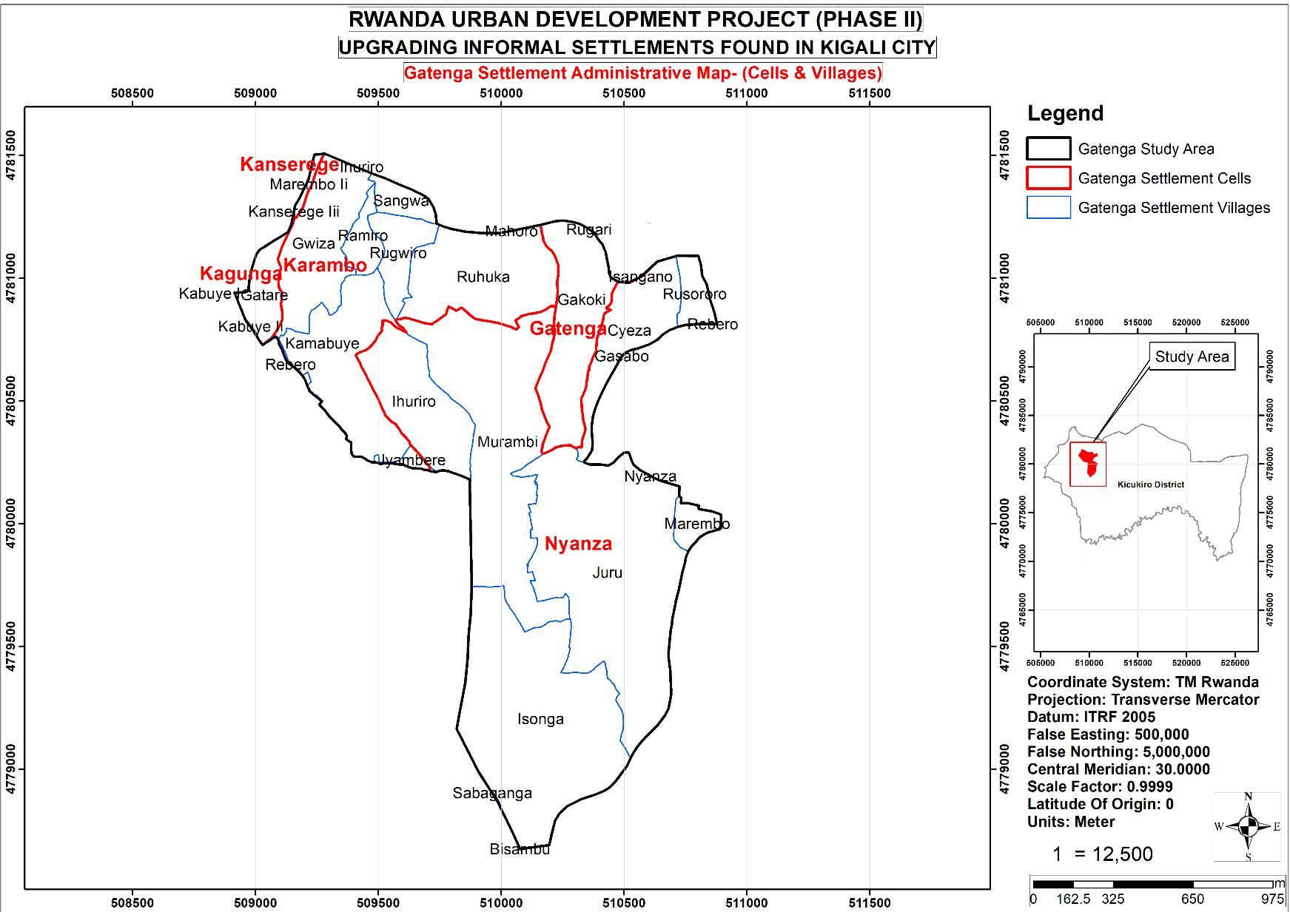
Figure ‎1-1: Map Showing the Administrative cells and Sectors in the Study Area

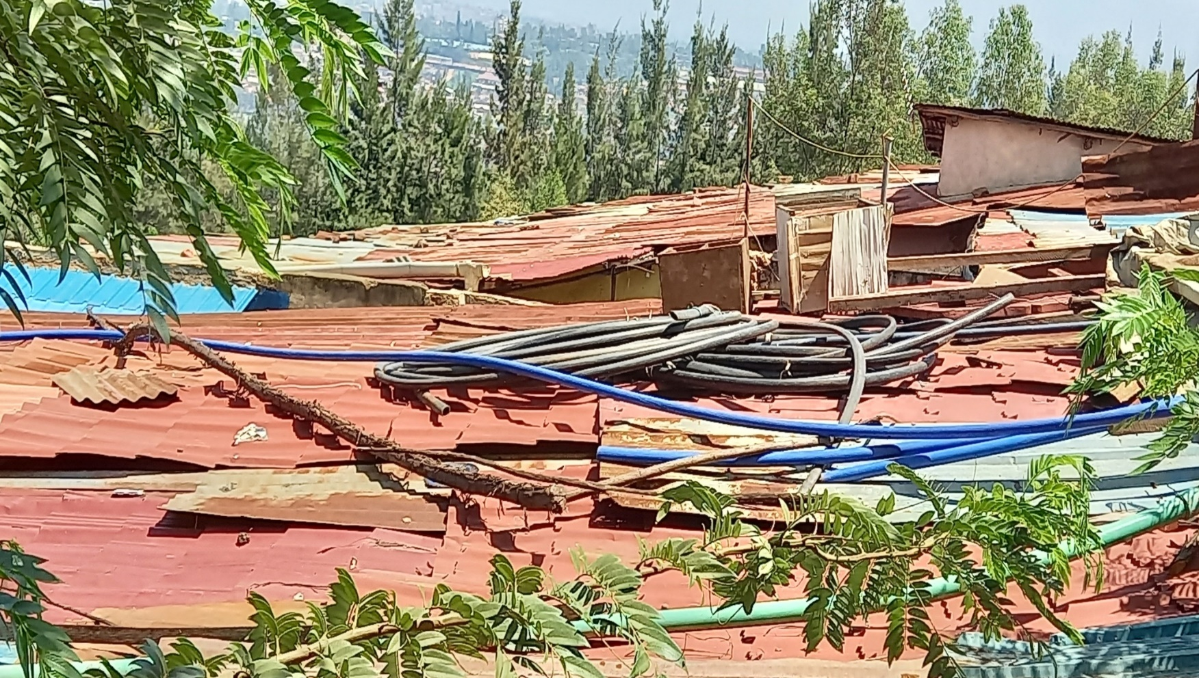
Figure ‎1-2: Top Pictorial view of some of Gatenga Settlement

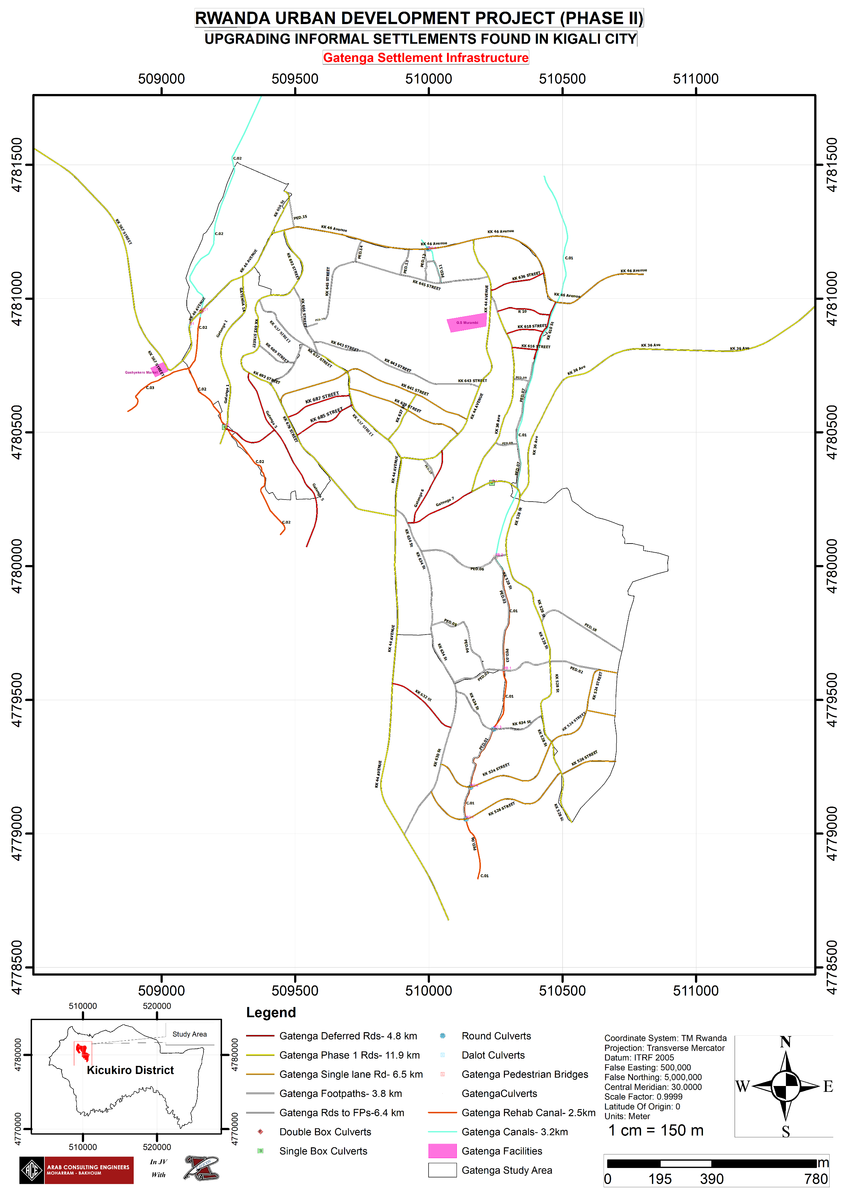
Figure ‎1-3: Clear Map of Proposed Investments
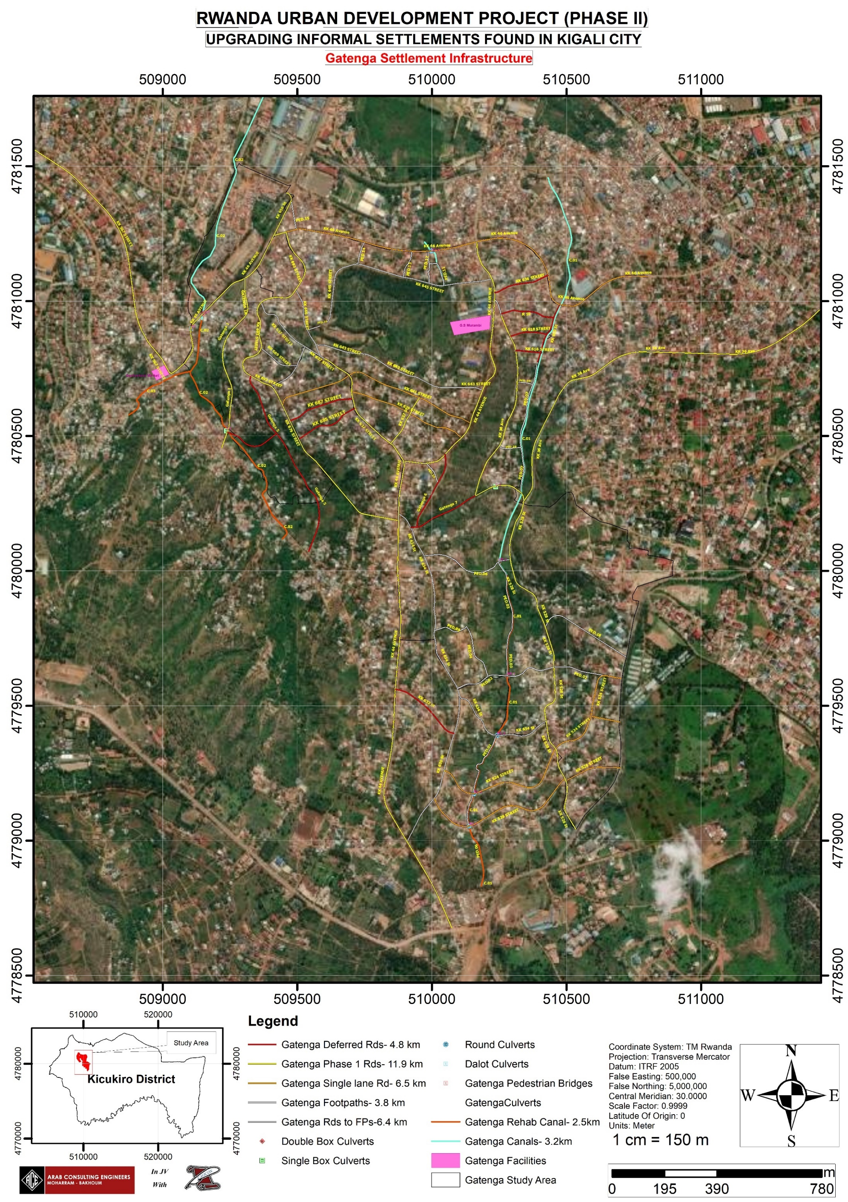
Figure ‎1-4: Gatenga Settlement Proposed Infrastructure on satellite image

The Objectives of the RAP
The aim of the RAP as per TOR is to identify and assess the human impact of the planned infrastructure projects under RUDP II interventions in the City of Kigali 4 unplanned settlement sites. Then after, prepare an Action Plan to be implemented in coordination with the civil works in line with World Bank Environmental and Social Framework (ESF), the RPF and Government of Rwanda policies and laws.
- Define entitlement matrix for eligibility for compensation based on the RPF entitlement matrix provided.
- The Resettlement Action Plan will identify the project affected persons (PAPs), determine the extent of displacement impact associated with construction of the roads, drainages, footpath, public spaces, mini-market solid waste collection point and any other intervention under the project, conduct a valuation of their assets to be expropriated. In addition, carry out their socio-economic baseline surveys and engage them in participatory discussions regarding the plan and formulating a plan of action to adequately compensate people for their losses.
- To identify the project affected persons (PAPs) and type of assets they own
- To present a social-economic basis of project affected persons (PAPs) for which identification of entitlements and livelihood restoration strategies for minimizing the impacts on the PAPs so as to improve their livelihoods and standards of living or at least to restore them in a pre – displacement levels
- To carry out consultations with relevant stakeholders including potentially affected persons to obtain their views and suggestions regarding the social impacts of the project and agree on the measures to cover the losses.
- To set the parameters and establish entitlements for project affected people, describe the institutional framework, mechanism for consultation and grievance resolution, the time schedule and the budget and propose a monitoring and reporting system.
- Carry out the valuation of affected properties by the project interventions in consultation with the local leaders as per the law Governing Expropriation in Rwanda, the World ESS 5 and inform the respective owners the process of valuation and their reserved rights during the valuation process.
- Identify gaps between World Bank guidelines/policies/laws and the laws of the Government of Rwanda on matters addressing issues of involuntary displacement and suggest how the gaps have been addressed to meet international best practices guided by the RPF for this project.
- To ensure participation of vulnerable groups including, female household heads, the elderly, persons with disability, the poor, as well as youth in RAP arrangements for their views and ideas for the project implementation.
These objectives have been achieved as shown in the following pages.

Guiding Principles for the RAP
In developing this RAP, a number of principles have been followed. These principles are based on the objectives of the ESS5 of the World Bank’s Environment and Social Framework (ESF). The objectives are outlined below:
- To avoid involuntary resettlement or, where unavoidable, minimize involuntary resettlement by exploring project design alternatives.
- To avoid forced eviction.
- To mitigate unavoidable adverse social and economic impacts from land acquisition or restrictions on land use by: (i) providing timely compensation for loss of assets at replacement cost and (ii) assisting displaced persons in their efforts to improve, or at least restore, their livelihoods and living standards, in real terms, to pre-displacement levels or to levels prevailing prior to the beginning of project implementation, whichever is higher.
- To improve living conditions of poor or vulnerable persons who are physically displaced, through provision of adequate housing, access to services and facilities, and security of tenure.
- To ensure that resettlement activities are planned and implemented with appropriate disclosure of information, meaningful consultation, and the informed participation of those affected.

Scope of the RAP
The RAP covers Gatenga settlement and is limited the infrastructures and community fact tiles as provided by the technical detailed design report.

Road and related infrastructures
The infrastructure to be done include widening of access roads within which services like water pipes, sewerage pipe, drainage and lighting will be installed. The roads to be implemented are shown in the table below colour coded to show the phases in which they are to be implemented, with pink showing the roads that were deferred, orange showing the roads that were converted to one-way roads to minimise expropriation costs with RoW 5.5m, green showing the roads that were designed as footpaths, and white showing the roads to be implemented in the first phase.

Table ‎1-3: Proposed roads for development
Gatenga Settlement Streets (Prioritized)
No. | Name | Length (m) | Class | Condition | RoW (m)
1 | KK 44 Ave | 2822.4 | Collector | Unpaved | 10
2 | KK 526 St | 840.2 | Access | Unpaved | 5.5
3 | KK 524 St | 844.1 | Access | Unpaved | 5
4 | KK 634 St |  | Access | Unpaved
5 | KK 528 St | 1775.0 | Access | Unpaved | 7.5
6 | KK 632 St
7 | KK 630 St |  | Access | Unpaved
8 | KK 36 Ave | 2460.3 | Access | Unpaved | 5
9 | KK 46 Ave | 2309.0 | Access | Unpaved | 5
10 | KK 616 St
11 | KK 618 St
12 | KK 610 St
13 | KK 636 St |  | Access | Unpaved
14 | KK 645 St | 803.8 | Access | Unpaved | 7.5
15 | KK 637 St |  | Access | Unpaved
16 | KK 639 St
17 | KK 641 St
18 | KK 643 St |  | Access | Unpaved
19 | KK 685 St
20 | KK 687 St
21 | KK 679 St |  | Access | Unpaved
22 | KK 666 St
23 | KK 689 St
24 | KK 693 St |  | Access | Unpaved
25 | KK 656 St |  | Access | Unpaved
26 | KK 567 St |  | Collector | Unpaved
27 | Gatenga 1 |  | Access | New
28 | Gatenga 3
29 | Gatenga 5
30 | Gatenga 6
31 | Gatenga 7
Total |  | 11,854.8

Gatenga Settlement Community Facilities
Due to the need to improve the livelihood of the dwellers of these two communities, a number of community facilities were proposed for development as indicated in the summary below. Detailed information is found in the technical design report.
Table ‎1-4: Summary of Gatenga Community Facilities
Gatenga Settlement Community Facilities
 | Activity | Scope of work
1 | Gashyekero Selling Point (Market) | The roadside market is to be improved
2 | Groupe Scolaire Murambi facilities | Provision of a football, basketball and volleyball pitches and the construction of a rainwater tank shall be done
3 | Murambi Market Roadside Parking | Construction of a roadside parking for the Murambi metalwork market

RAP Approach and Methodology
The approach and methodology of the RAP was in line with the requirements of The World Bank ESS 5 and to fulfil the Government of Rwanda expropriation requirements.
- Review and analysis of the secondary data collected,
- Stakeholder consultations, analysis and engagement,
- Identification of the Project Affected Persons (PAPs),
- Carry out an asset inventory to identify the nature, extent and value of losses,
- Carry out a socio-economic survey,
- Propose fair and equitable compensation measures and, if necessary, additional conditions for improving the quality of life of the PAPs,
- Compilation of the report.

Review and analysis of the secondary data
The RAP development started with the review and analysis of the secondary data contained in feasibility studies and other official documents. This also included relevant laws and international standards related to land expropriation. The review of secondary data helped to further refine the methodology for the whole RAP and the process of resettlement. The data formed part of the RAP report. The following are the documents reviewed.
- The Gatenga feasibility study
- The Gatenga Resettlement Action Plan 2017.
- The Rwandan Constitution (ratified in 2003); laws and policies related to land acquisition.
- The World Bank’s Environment and Social Framework.

Reconnaissance and Designing a Comprehensive Plan
Following the kick off meeting, which took place on 16th October 2020 the consultant set out for a reconnaissance field visit to the project area, from 19th October to 3rd November 2020. The main objective of the reconnaissance was to have an interface with the key stakeholders at the project site and gain an overall impression of the project area. Different stakeholders were engaged at National, District and Community levels.
The team visited all the four settlements to understand the general environmental and socio-economic conditions on which the methodology of the different studies would be based. In addition, communities were mobilized for the formation of the Community Upgrading committees. Subsequently, the committees were formed and inducted into their activities.
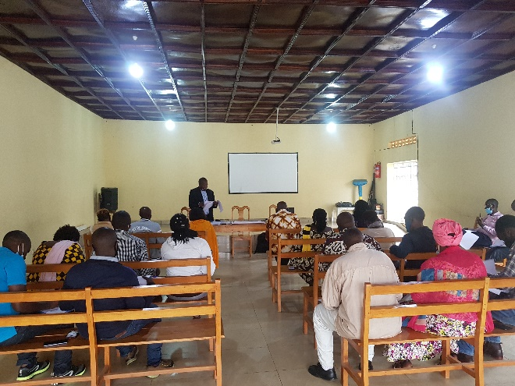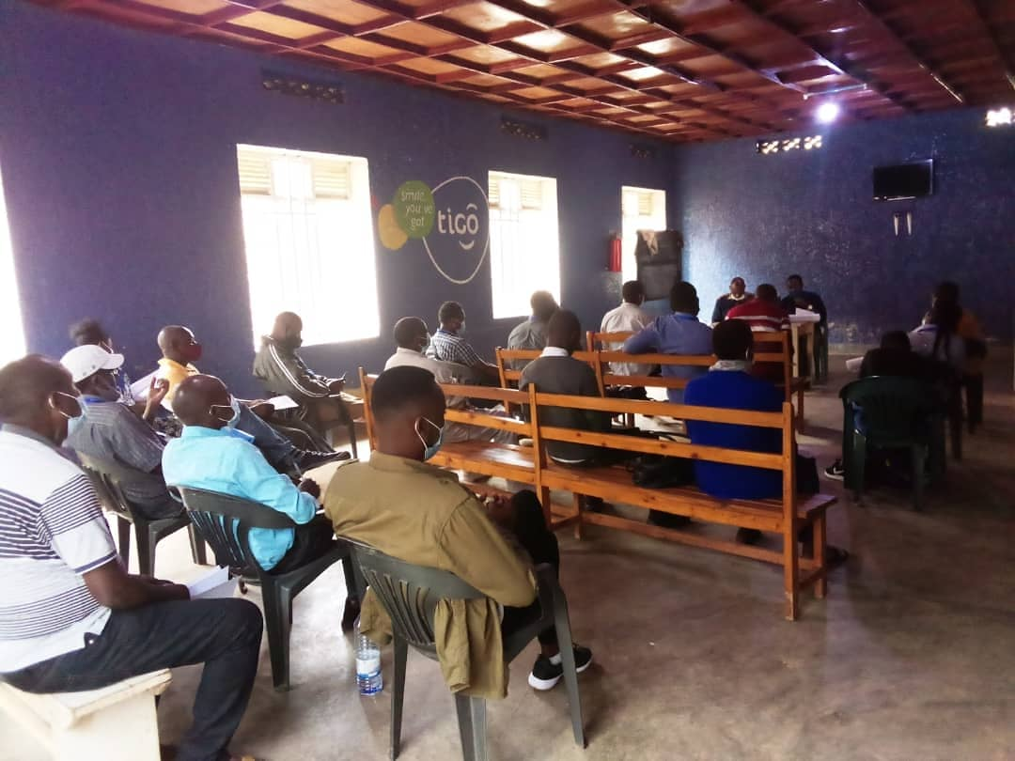
Figure ‎1-5: During Community engagement with CUC and Local leaders of Gatenga settlement

Stakeholder engagement
Stakeholder engagement involved meeting with different stakeholders, either in group or individually. The purpose was to disclose information about the project and also get their views for better planning. The stakeholders’ views are presented in chapter three.

Cadastral Survey and Valuation Survey
This involved, surveying the land parcels as per the road designs to identify the extent of the project. This resulted in a list of people to be affected by the project. It paved way for the Census, valuation and socioeconomic survey.
The maps below show a sample of the survey carried out to determine the parcels to consider in the valuation exercise for the Murambi & Ihuriro Villages.
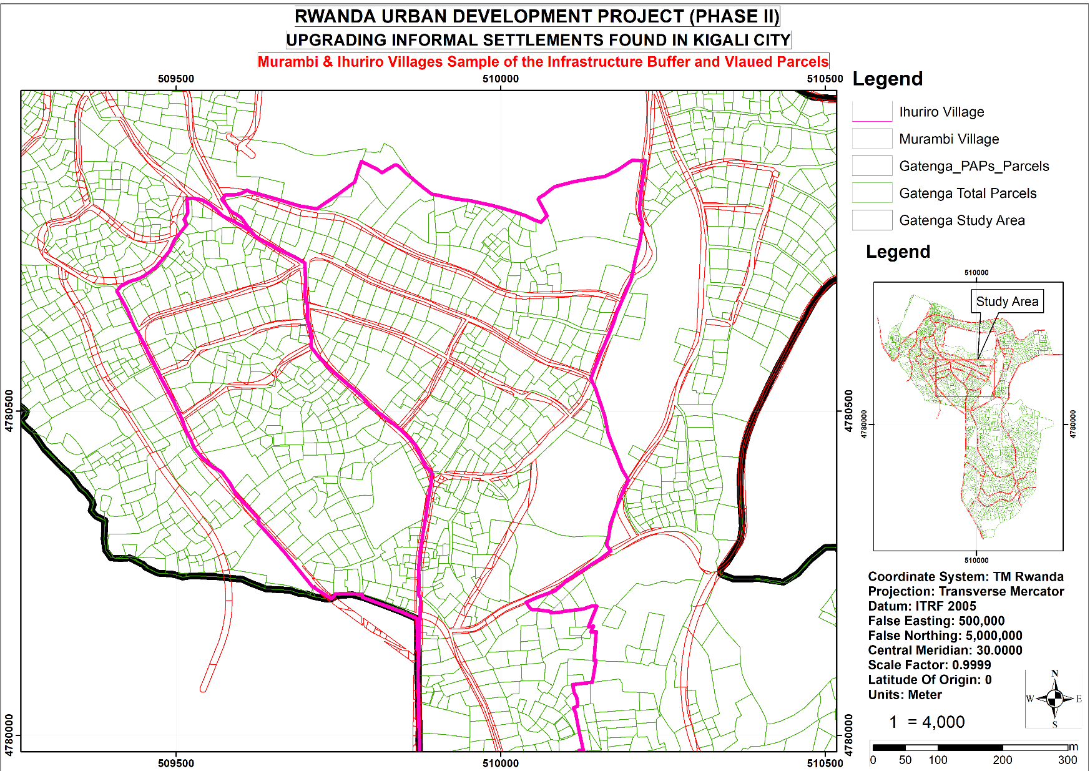
Figure ‎1-6: Infrastructure Buffer Considered in the Valuation Works Murambi & Ihuriro Villages

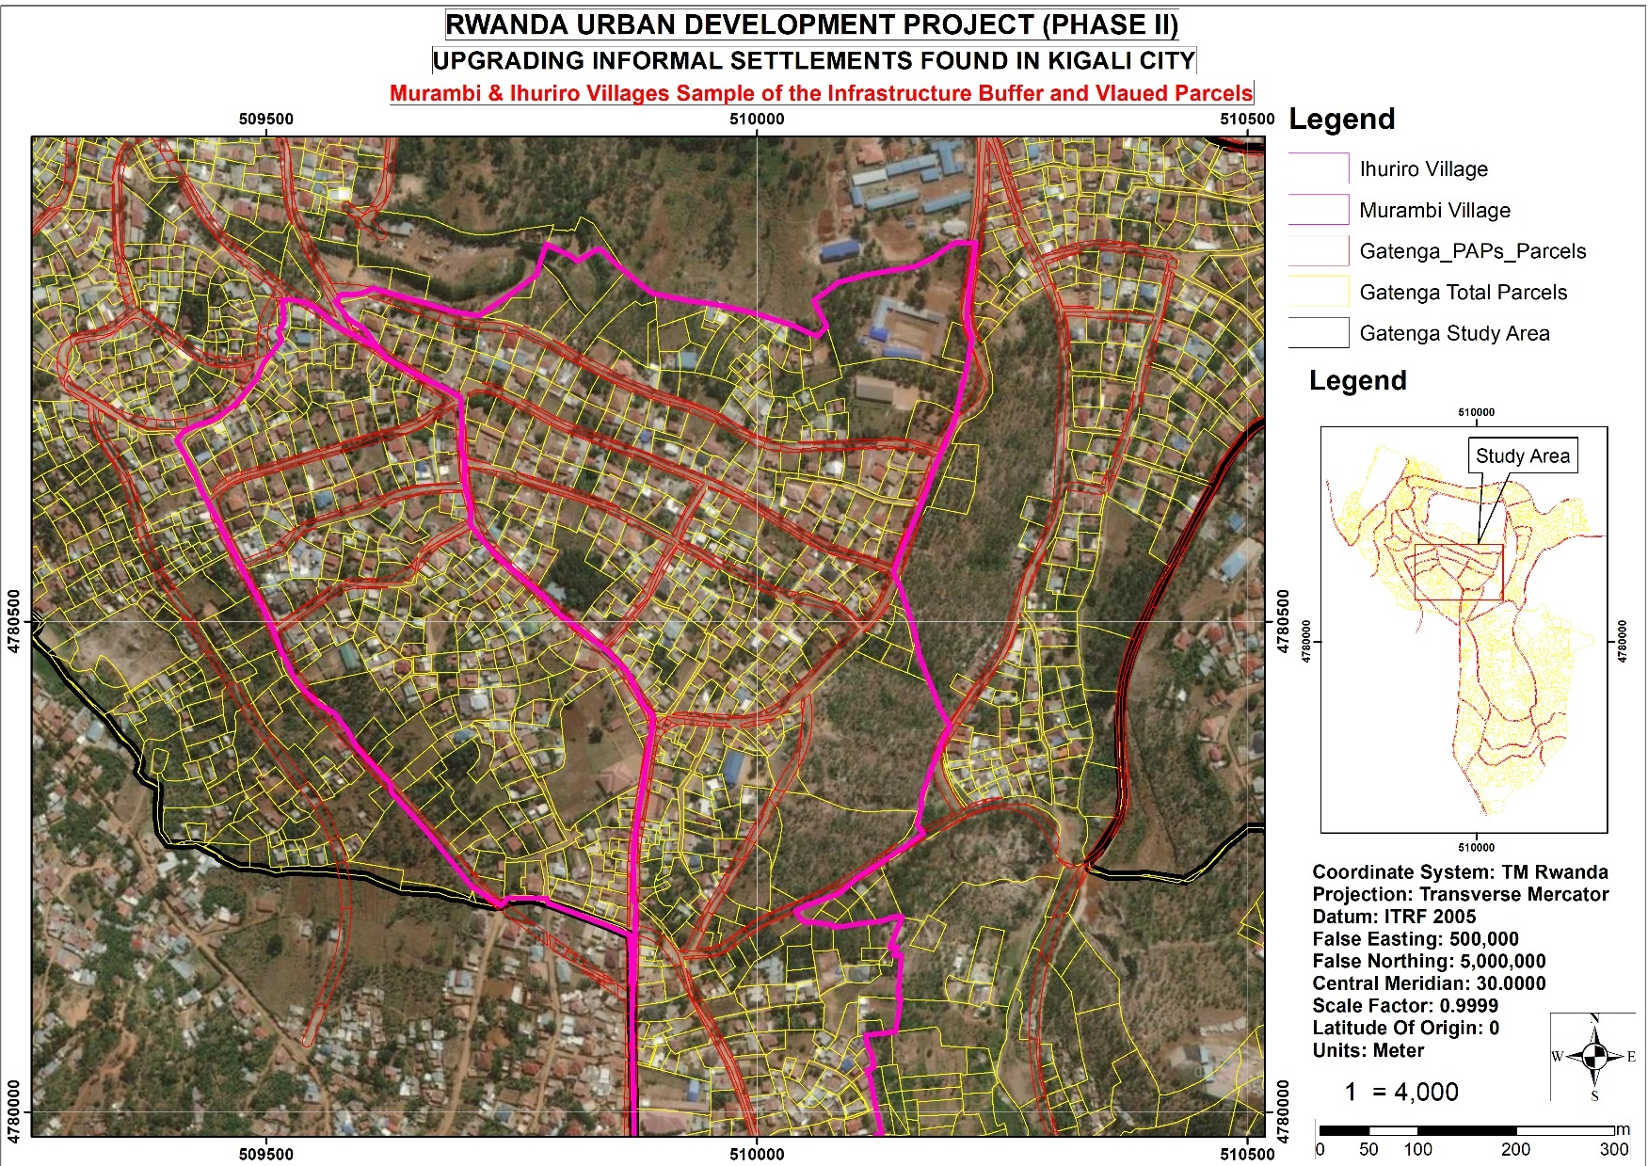
Figure ‎1-7: Infrastructure Buffer Considered in the Valuation Works Murambi & Ihuriro Villages (Satellite)

Socioeconomic Survey Methodology

Sampling of the PAPs
Because of the big number of PAPs and the time constraints, a decision was made to sample at least 10% of the PAPs. To determine the final sample from a list generated by the surveyors which was already random, we counted from one, and including every tenth parcel. The final sample size for Gatenga was 151 selected from 858 potential PAPs established after the initial design. In case it was not possible to get the selected parcel; a replacement was allowed with support from the supervisor.
Reliability of findings
In carrying out the socio-economic survey, conducting a reliability test ensured the capacity of the socioeconomic survey questionnaire to produce consistent results, if administered in different circumstances. First, the data collection team was to ensure common understanding of concepts. The tool was pre-tested before the full-scale study to ensure validity of responses. When the survey questionnaire was again administered on the final sampled households, it obtained the similar and consistent results.
Validity
The data was collected using tablets, which ensure internal validity and reliability of responses. They are self-correcting in case there is an error. The socioeconomic study is intended to understand the conditions of PAPs to enable proper planning and therefore no hard statistics are employed because we are not testing theories or hypotheses. At least 10% of the total population is commonly used to give a good representation. Otherwise, if resources allowed, a full census is recommended.

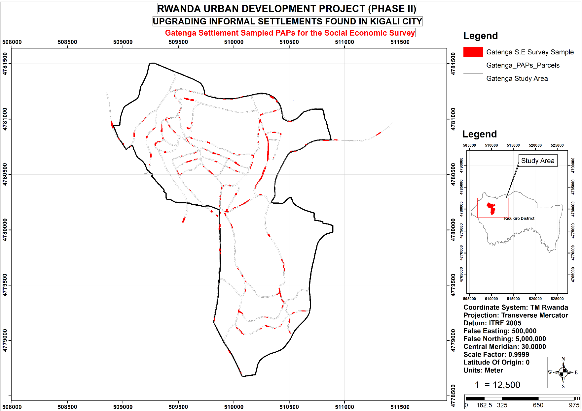
Figure ‎1-8: The Sampled PAPs for the S.E Survey

Training of enumerators
Recruitment of enumerators was based on their experience in conducting quantitative and qualitative surveys and having a strong experience in collecting digitalized data using a tablet. The field enumerators and supervisors were trained to be acquainted with the electronic questionnaire programmed into android tablets. The training was done in one day. The pre-test was carried out for one day to allow enumerators and supervisors to be familiar with the questionnaire.
To equip data collectors with practical skills and familiarize them with the questionnaire, the trainer used “the fill-in questionnaire” technique where one data collector conducted the interview while the other acted as the respondent (mock interview).

Field Data collection
The Computer Assisted Personal Interviewing (CAPI) technique was used to collect data. This system has proved to be more reliable and efficient than the usual Paper and Pencil (PAP) techniques. It also allows for better real-time monitoring of the data collection exercise. The approved questionnaire was uploaded into the tablets using Open Data Kit software (ODK). The latter helps to collect field data on a tablets device and upload it to a server from where they are extracted for analysis. In addition, the GPS incorporated in ODK helps to regularly monitor geographical location and progress of the interviews.
Interviews were conducted in a safe and confidential place. The supervisor was responsible for deploying enumerators in the respective villages, validating the collected data before sending them to the server as well as conducting interviews him/herself. Data collection was conducted by 4 enumerators and 2 supervisors in twenty (20) working days. At the end of each day, all collected data was sent to the server. The data manager provided regular progress updates to the survey team during data collection.

Data quality assurance and Data analysis
A data-collection tool was programmed using a digital data collection platform (KOBOCOLLECT) and uploaded onto android devices (tablets) and the data was directly recorded from the interview onto the devices and then sent to the server at the end of the day.
The data cleaning process started immediately after the first day of surveying. This allowed the enumerators to be able to return to any respondent or data collection sites, in case an issue arises. Speed and efficiency using digital data collection reduced both data collection time and the time required for cleaning data collection errors. The dashboard was generated to get a current summary of collected data where outliers were automatically highlighted. Online Google Map was used to detect whether the enumerator was truly collecting data in the place where he/she was supposed to be.
As data was collected through tablets, there was no need for data entry. Data analysis including descriptive analysis and interactive editing were done using STATA 16Data visualization in form of tables and pie-charts was constructed in Ms Excel.

LEGAL AND POLICY FRAMEWORK

Introduction
This chapter analyses the relevant Rwandan laws and policies, which are relevant to the development of this RAP, the chapter also covers the Environment and Social Framework (ESF) of the World Bank that are applicable to the project implementation.

Key Rwandan Legislation
The following laws reflect national legislation related to land use, planning, management and tenure, the Land Law, Presidential and Ministerial orders and decrees related to land and land expropriation and land valuation. The key regulations on Land Acquisition and Resettlement in Rwanda include the following:
- The Rwandan Constitution (ratified in 2003 as amended in 2015);
- Rwanda 7 Years Government Programme: National Strategy for Transformation (NST 1), 2017 – 2024.
- Vision 2050
- National urbanization policy, 2015
- National Housing Policy, 2015
- Condominium law, 2010
- National informal settlement upgrading strategies and guidelines, 2015
- National land use guidelines, 2017
- Urban planning codes, 2015
- Kigali City Master Plan 2013
- Expropriation law, 2015
- National Land Policy, 2019
- Organic Land Law No. 43/2013 of 16/06/2013 governing the main land legislation in Rwanda as mentioned in the Official Gazette, Special Edition from 16/06/2013, which determines the procedure for use and management of land in Rwanda;
- Property Valuation Law No. 17/2010 which defines Property Valuation in Rwanda;
- Presidential Order No. 54/01 of 12/10/2006 stipulating the structure and the responsibilities of Land Commissions
- Ministerial Order No. 001/2006 of 26/09/2006 stipulating the structure of Land Registers and the responsibilities of the District Land Bureau, and
- Ministerial Order Determining Dispute Resolution process related to Land Issues, and
- Organic Law N° 32/2015 of 11/06/2015 relating to expropriation in the public interest (also known as the “old” law No 18/2007 of 19/4/2007 on Expropriation)
- The guidelines on unit prices of 2018 provided by IRPV
- The World Bank Environment and Social Framework.

The Rwandan Constitution
The Constitution of Rwanda, Article 11 stipulates that; all Rwandans are born and remain free and equal in rights and duties. Discrimination of whatever kind based on, inter alia, ethnic origin, tribe, clan, colour, sex, region, social origin, religion or faith, opinion, economic status, culture, language, social status, physical or mental disability or any other form of discrimination is prohibited and punishable by law. Therefore, no one has been discriminated in the development of this RAP.
Rwandan Constitution recognises that every person has a right to private property whether personal or owned in association with others (Article 29). It also states that private property ownership, whether individually or collectively owned, cannot be violated. The right to property may not be interfered with except in public interest, in circumstances and procedures determined by law and subject to fair and prior compensation. Eligibility for compensation is enshrined under the Rwandan constitution and the Expropriation Law (Organic Law No 18/2007 of 19/4/2007).
Therefore, following the constitution of Rwanda; as long as the PAPs can provide proof of ownership they will be compensated.
Further still, Article 22 states that: “everyone has the right to live in a clean and healthy environment”. Therefore, displacing people to create a better environment is justified because of this greater good.

Rwanda 7 Years Government Programme: National Strategy for Transformation (NST 1), 2017 – 2024
The NST 1 had the following relevant objectives relevant to this project;
- Accelerate Sustainable Urbanization from 18.4% (2016/17) to 35% by 2024
- Create 1,500,000 (over 214,000 annually) decent and productive jobs for economic development
- Establish Rwanda as a Globally Competitive Knowledge-based Economy
- Promote industrialization and attain a structural shift in the export base to High-value goods and services with the aim of growing exports by 17% annually.
- Sustainable Management of Natural Resources and Environment to Transition Rwanda towards a green economy

Vision 2050
The Vision 2050 sets a new pathway that will lead the country to the living standards of upper middle income by 2035 and high-income countries by 2050. The Vision 2050 has overarching objectives of promoting Economic Growth and Prosperity and High Quality of Life for Rwandans and is anchored around five pillars. Under Pillar No.4; Urbanization and agglomeration the aim among others is to promote universal access to services and amenities. The upgrading of the settlement falls directly under this vision.

National urbanization policy, 2015
The policy recommends that in order to have healthy environment in urban area; prevention and upgrading informal settlement shall be ensured and monitored.

National Housing Policy, 2015
The policy provides a framework which enables the private sector to satisfy the current and growing demand for housing in terms of quantities and access costs offered to clients. The final plan for the settlement is to upgrade the houses in the settlement. This will give guidance.

Condominium law, 2010
Condominium: a type of joint ownership of real estate in which portions of the property are commonly owned and other portions are individually owned” (Art.2). It supports the efforts of individuals to collectively buy/build and own units within a single building. This can boost housing supply. The upgrading of the settlement is going to be blocks of houses put together into a storied building and houses will be owned jointly. This gives guidance.

National informal settlement upgrading strategies and guidelines, 2015
This document takes up the principles and recommendations from the National Housing Policy and the Urban Planning Code and expands those by providing further administrative and technical detail needed to implement the policy recommendations and implementation laws to the Law Governing Urban Planning and Building in Rwanda. This project is about upgrading of an informal settlement. Therefore, these guidelines are very relevant.

National land use guidelines, 2017
This document recommends ensuring optimal and efficient use of infrastructure, services, facilities and land. This is very relevant in this area where land is very scarce.

Urban planning codes, 2015
This document recommends that urban neighbourhoods should be upgraded to ensure an agreed standard of service provision for their residents, if the neighbourhood is on suitable land which is not health hazardous and:
- not prone to flooding,
- not on weak soil,
- not on sloped terrain steeper than 20 %.

This further justifies the whole project.

Kigali City Master Plan 2020
This document forms a broad roadmap for spatial development of the city and features individual physical plans for each District. It contains detailed land use and zoning plans that will guide the city's anticipated urban design.

Expropriation law, 2015
Activities of public interests include those undertaken to implement land use and development master plans” (Art.5).

National Land Policy, 2019
This Policy was enacted to fill the gaps which had been realised while enforcing the of 2004 and it is aligned with the National Strategy for Transformation (NST1) that will serve as the implementation plan and strategy up to and the first four years (2021-2024) of the Vision 2050.
Its main objective is to put into place and to implement an efficient system of land administration and land management that secures land ownership, promotes investment in land for socio-economic development and poverty reduction. The policy specifies land tenure systems, guiding principles of land management, land registry system, and land transactions.
According to the National Land Policy, all Rwandese enjoy the same rights of access to land, implying no discrimination against women or any other groups. All land should be registered for security and transparency reasons.
The National Land Policy specifies that marshlands are a special category of public land and should not be cultivated except after environmental impact assessment has been commented on and approved by Ministry of environment and adequate planning permission has been obtained.
Land Tenure, the use and Management of Land in Rwanda Law No. 43/2013 of 16/06/2013 as mentioned in the Official Gazette, Special Edition from 16/06/2013.

Categorization of Land
The Law recognises three broad categories of land, namely: the private land of individuals (including both natural and legal persons), land vested in the State and land vested in the Local Government Authorities (Districts, Towns and Municipalities). Land in the latter two categories is further divided, in the conventional manner under Civil Law, into land in the public domain and land in the private domain respectively. In addition, specific provision is made with respect to lands to be allocated to the landless. The provisions of the Law with respect to these categories of land can be summarised as follows:
- Private land
Private land consists of land acquired under customary or written law, by purchase, gift, exchange or partition (Art.11). This includes land to be held under rightful (or emphyteutic) leases (Art.5), which create property rights analogous to full ownership during the term of the lease, and by virtue of absolute title (Art.6).
With respect to land acquired under customary law, the Law provides (Art.5) for title to be conferred on individuals who are recognised as the customary landowners (Art 7) in the form of a rightful lease for a renewable term of 3 to 99 years, as specified by the Presidential Order (Art.24). What this means is that anybody who has a claim of right to land nationalised in 1976, either under customary law or by virtue of official authorisation, or who has purchased such land, may apply for documentary title to that land. The Law does not specify what evidence will be required to support such a claim of right. The procedures whereby such leases will be obtained from the State or Local Government Authority in which the land is vested are specified by Ministerial Order (Art.25 & 27).
Registration of title to land is compulsory (Art.30). While rights based on land are freely transmissible upon death and transferrable by sale or gift, and land may be leased, rented out, encumbered or mortgaged in accordance with the Civil Code (Art. 33 & 34), no transfer, mortgage, rightful lease, rental agreement, or servitude is binding on third parties unless recorded on the register (Art.38). In cases of joint ownership, the prior consent of specified family members is required for the lawful transfer or mortgage of land, long term rental agreements and creation of servitudes (Art.35, 36, 37 & 38).
These arrangements effectively mean that the existing forms of private land tenure – both under the Civil Code and customary law are being replaced with new forms of tenure that will give all existing landowners a new set of rights and obligations embodied in a registered title. This will include rights to use the land, to exclude others, within set limits, and to dispose of it. However, to ensure compliance with government policy on land use, the right to develop land would be regulated by the Law.
- State Land
Under the Law, the State land is divided into land in the public domain (land reserved for organs of the State or for environmental protection. It also includes land and buildings dedicated to public use, service and administration, state roads and road reserves, national lands reserved for environmental conservation (including national forests, national parks, reserved swamps, public gardens and tourist sites); the foreshore of lakes and rivers) and land in the private domain.
All land that does not belong to private individuals or local authorities (District, Sector, Municipality and Kigali City) and is not comprised in the public domain is classified as State land in the private domain. It also includes any vacant land (defined as land, which is without an owner and land confiscated under Article 75 of the Law). Furthermore, it includes land expropriated for public purposes or purchased by or donated to the State; land occupied by State forests; swamps and wetlands suitable for agricultural use; and land previously part of the public domain that has been reclassified in accordance with law (Art.14).
Under the Civil Law the basic distinction between these two types of State land is that land in the public domain does not have commercial properties and cannot be inadvertently alienated by prescription, whilst land in the private domain, although it belongs to the State, is analogous to private property and often is occupied by squatters.
- District, Sector, Town & Municipal Land
As is the case with State lands, lands vested in the District, Town, Sectors and Municipal authorities may be categorised as land in the public domain and land in the private domain respectively. Land transferred to the local authorities by the State may be allocated to the public or private domain.
The local authorities may also acquire land by purchase or donation from private persons and corporations for incorporation into either its public or private domain (Art.16). In relation to the individual land, the law gives a landowner full rights to exploit his or her land in accordance with the existing laws and regulations. The law also provides for expropriation, which stipulates that land expropriation can be undertaken only if it is in public interest.
The law also states that wetlands and marshlands belong to the state and usufruct rights (takeover of land of such was unofficially been used over a long period of time) cannot be enforced on such land, regardless of how many years a person has have tended to such land.
In regard to gender, Article 4 stipulates that any discrimination either based on sex or origin in matters relating to land ownership or possession of rights over the land, is prohibited. The wife and the husband have equal rights over the land.
Following the Land policy, the RAP has respected the rights of the people; both men and women have been consulted and where the title bears the name of husband and wife the project will pay both man and women. They have been advised to open joint accounts.

2.12.2 Models of land acquisition and land ownership
In Rwanda, there are mainly two models of land acquisition, (i) acquisition according to customary law, and (ii) acquisition according to the rules of the written law.
- Through the customary law
Through land occupation or the “rule of axe”
According to customary law, land ownership is held by whoever occupies the land first. However, in modern times, this model has become nearly obsolete since all vacant land belongs to the State.

- Through inheritance
Customarily, land rights are passed on from father to son through inheritance, and recently daughters are increasingly inheriting land, too. With regards to inheritance rights of widows, the custom gives them the right to use the land that belonged to their deceased husbands.
- Method of acquisition through written law includes:
- Tenancy contracts for plots with structures for a 3-year period in urban areas.
- Long lease contracts for agricultural land for a period of 15 years or more in rural areas.
- Land purchase/sale contracts and title deeds transfers for land in urban areas. Land acquisition or expropriation process, which is typically used by government institutions in public interests. All these methods have been considered by the valuation team and PAPs will be compensated accordingly. Those without certificates, through consultation led by the RAP team, it has been agreed that certificates of recognition will be issued by the respective local authorities from the village level, cell and sector level.
- Property Valuation - Law No. 17/2010 on the Property Valuation process in Rwanda.
- Articles 27, 29, 30 and 31 of the law deals with valuation methods. These articles stipulate that the property value should be close or equal to the market value. The valuation could also compare land values country wide. Where sufficient comparable values are not available to determine the value of improved land, the replacement cost approach shall be used. The law also allows the use of international methods not covered in the law after approval from the Institute of Real Property Valuers (IRPV) council.
- This law should be read together with the law on expropriation, as it defines the process of property valuation. Valuation of real property can only be done by a person certified as a Valuer under this law (Article 26). A Valuer may use one or more valuation methods to determine the value of real property.
- The Valuer shall select the best valuation method to determine the fair market value of the real property (Article 27). The methods used shall be clearly explained in the valuation report. If given an approval by the Regulatory Council for the Real Property Valuation Profession in Rwanda (established under this law,) a Valuer may also use any other relevant worldwide methods not provided in this Law in order to determine valuation values.
- There has been establishment of an IRPV of Rwanda which is an autonomous body. In order to be recognized as a real property Valuer in Rwanda, a person must be a member of the Institute. The above-mentioned Regulatory Council for the Real Property Valuation Profession in Rwanda is established as a regulatory agency.
- The IRPV proposes regulations, guidelines and standards for valuation while the function of approval lies with the Council. A register list of qualified Valuers is maintained by the Council. The Chairperson of the Council approves valuation. A person dissatisfied with a real property valuation shall refer the matter to the Council for determination. The Council shall select alternative certified Valuers who can decide to use other valuation methods. If the dispute remains unsettled, it will be submitted to a court of law for adjudication.

The National Land Commission
Presidential Order No. 54/01 of 12/10/2006 stipulating the structure and responsibilities of Land Commissions. The National Land Commission was established by the Presidential decree No. 54/01 of 12/10/2006 determining the structure, the Responsibilities, the functioning and the composition of land commissions. The National Land Commission has competence all over the country, and is composed of seven (7) members, whose responsibilities include land administration and land use management.
Whereas, the main responsibilities of the National Land Commission are monitoring the implementation of land administration and land use management procedures and guidelines, one of its specific roles is to monitor and approve expropriation of land required for public interest purposes. There are also land Commissions and land Committees at Kigali City, District, Sector and Cell levels. The National Land Commission will also play a key role in grievance resolution.

Ministerial Order No. 001/2006 of 2006 stipulating the Structure of Lands
This law determines the structure of Land Registers, the responsibilities and the functioning of the District Land Bureau in each district (Article 1).
Article 3 of this Order defines how the Cadastral register, short term lease and long-term lease contract should be prepared and maintained. Chapter 2 (Article 3-4) highlights the structures of land registers while responsibilities are stipulated in Chapter 3 (Article 5-7). According to this order, the overall responsibility for implementing the land policy lies with the Land Bureau (Article 5-7).
All types of land tenure must be in compliance with the designated land use and environmental protection measures as outlined in the Land Use Master Plan. Expropriation Process, Organic Law No 32/2015 of 11/06/2015 (“the “old” law No 18/2007 of 19/4/2007) relating to expropriation in the public interest, Official Gazette Special Edition 2015. This Expropriation Law is the main tool that provides for the State’s right to expropriate private property in the public interest. The 2015 changes in the Expropriation Law now define the permissible acts of public interest, giving rise to the State’s right of expropriation for:
- Roads and railway lines;
- Water canals and reservoirs;
- Water sewage and treatment plants;
- Water dams;
- Rainwater canals built alongside the roads;
- Waste treatment sites;
- Electric lines;
- Gas, oil, pipelines and tanks;
- Communication lines;
- Airports and airfields;
- Motor car parks, train station and ports;
- Biodiversity, cultural and historical reserved areas;
- Acts meant for security and national sovereignty;
- Hospitals, health centres, dispensaries and other public health related buildings;
- Government administrative buildings and their parastatals, international organisations and embassies;
- Public entertainment playgrounds and buildings;
- Markets;
- Cemeteries;
- Genocide memorial sites;
- Activities to implement master plans of the organisation and management of cities and the national land in general;
- Valuable minerals and other natural resources in the public domain.

Basic infrastructure and any other activities aimed at public interest, which are not indicated on lists that are approved by an Order of the Minister in charge of expropriation, at his or her own initiative or upon request by other concerned persons.
In addition to acts of public interest, the Expropriation Law also determines the specific procedures for expropriation, including the processes of property valuation and paying of compensation, and identifies the organs competent to approve and carry out expropriation.
The law furthermore indicates the rights of expropriated persons and expropriating entities. Other minor legal instruments have also been adopted, such as Ministerial Orders relating to reference land prices 5, and 7 which also influence the expropriation process.
Any individual who is expropriated under the law is entitled to receive “just compensation” for the property lost. The amount of compensation should be established based on “market prices” of the property. Funding for the compensation and for other related costs must be available before taking any steps in the expropriation process and every project must provide in its budget funds to ensure fair compensation of property, including a full inventory of assets of each person to be expropriated.
This project falls under those that the Government has a right to expropriate. The process has followed the recommended procedures of valuation and compensation. This has been possible with the involvement of the relevant stakeholders, and their involvement will continue throughout implementation.

Confirmation of land ownership
According to Article 18 of the law, the person who owns land intended for public interest shall provide evidence to confirm that (s)he possesses rights on that land through a certificate of acknowledgement of the members of his or her family.
Among the evidence to confirm ownership of the land, there shall be included: written evidence indicating that (s) he purchased the land, or received it. It shall indicate whether the land was received as a donation or as a legacy or a successor; a document or a statement of local administrative entities indicating rights of the expropriated person on the land;
A document or testimony of the neighbours confirming the ownership of the land or a Court certificate shall be provided. The person, who occupied the expropriated land parcel after the publication of the Expropriation Decision, is not entitled to any compensation.
For those without confirmation of ownership; it is recommended that they are assisted to get certificate of recognition.

Surveys and Valuation of compensation
Article 17 stipulates that a person to be expropriated should be informed about the beginning of the land surveys and asset inventory. Land survey and inventory should be carried out in presence of the affected party or his/her representatives, as well the representatives of the local administrative bodies.
The owner of the land is not allowed to carry out any development activities after the land survey and the inventory of the properties. In case he or she decides to go forward with any development activities, they are not to be compensated. The person, who moves into the area after the publication of taking land for public interest, shall not be entitled to any compensation.
According to Article 21 of the Expropriation Law, the properties to be valued for just compensation include land and other assets on the land including different crops, forests, any buildings or any other activity that was carried out to improve the land’s productivity (irrigation systems, etc.). The value of land and other assets that belong to the persons, whose assets are being expropriated, shall be calculated considering their size, nature and location and based on the prevailing market prices.
Article 23 of the Law provides that if an agreement on compensation is reached between the person whose assets are being expropriated, and the project Initiator, the just compensation could be monetary or like for like (i.e., an alternative land plot or a similar structure/building). In order for the expropriation to be implemented, the just compensation shall be paid to the expropriated person before he or she relocates.
Article 24 stipulates that the just compensation approved by the Land Commission shall be paid within a period of one hundred and twenty (120) days from the day of the approval and publication of the land acquisition decision by the Land Commission. In case the compensation is paid later than the indicated period, the land acquisition and expropriation process shall be invalid except in case where an affected individual agrees to compensation and reaches an agreement with the project initiator.
After receiving just compensation, the affected person has ninety (90) days to vacate the area. While the affected person is still waiting for payment, he or she has a right to cultivate crops within a period not exceeding ninety days (90) and harvest these crops on his or her land. Forceful relocation is permitted only where a person receives an award and refuses to vacate the area. Such forceful removal shall be undertaken only by competent authorities.
Where the agreed compensation was not paid on time as provided by Article 24, the project initiator pays an additional 5% annually for the delays, which is added on top of the agreed compensation. The delays with compensation payment should not exceed two (2) years.
Article 25 states that the compensation amount should be deposited into a bank account of the expropriated person in a bank or any financial institution recognised by law.
The RAP team informed the PAPs and other stakeholders about the process of valuation and inventory taking. Compensation has been agreed on and they will be paid and relate within 120 days.

Public Consultations about Land Acquisition and Expropriation
The Expropriation Law also requires that local residents should be provided with information about the importance of the project and information on why land acquisition and expropriation are required. Article 12 of the Expropriation Law stipulates that the relevant Land Commission, after receiving the request for expropriation, should examine the basis of the proposed development.
If the development is approved, the relevant Land Commission should request in writing that the district authorities should organize a consultation meeting with local residents within the next thirty (30) days after receipt of the application for expropriation, and indicating the date, time and the venue where the public consultation meeting is to be held. The relevant Land Commission should confirm their decision within a period of fifteen (15) days after the consultation meeting with the population where views expressed by the local communities, are taken into account.
The project developer is obliged to inform project-affected people about their rights and entitlements at each stage of the land acquisition and expropriation process (Articles 17-20).
Meaningful sensitization has been done before the valuation process through the community meetings and to individual households during the valuation exercise. Sensitization will continue throughout the project implementation.

Process of Land Acquisition, Expropriation and Compensation Process
Organic law on expropriation (Organic Law No N° 32/2015 of 11/06/2015) stipulates that the land acquisition process starts with public announcements and consultations where the public is informed and consulted about the development. A project developer should discuss the suggested development with local communities and provide them with a copy of application for expropriation, so that this dialogue can establish and confirm the need for land acquisition.
A consultation meeting is held within 30 days after submission of the application for expropriation. Based on the results of consultations with local communities, the relevant Land Committee (Cell level and Sector Level) has 15 days to present their decision on the land acquisition required by the project.
The application for expropriation should contain relevant information about the project, including description, the justification that the project is aimed at the public interest, the Land Use Master Plan for the land area on which the project shall be implemented, documentation indicating that the project does not have negative impacts on environment (or that the impact is mitigated by the project) as well as proof confirming the availability of funds to fully cover compensation costs.
All these details and documentation will be prepared by the Project Developer after the ESIA has been commented on and approved by REMA, and after a detailed census and asset inventory survey is done during the RAP preparation. An estimate of the compensation cost was presented to the City of Kigali. The Land Use Master Plan will also be taken into consideration by the Project Developer in regards to the proposed activities.
The Land Commission decision is normally communicated publicly to the population by the relevant Land Commission. The decision is also advertised and communicated in posters in the local public offices as well as on radios and in State newspapers to inform all concerned parties. The disclosure and advertising of the Expropriation decision should be finished within the first 30 days after the decision has been made (article 13 of the Expropriation Law). The process subsequently proceeds with the census and asset inventory survey.
In parallel, Independent certified Valuators are asked to provide their valuation on each affected asset. Where a private property is affected resulting in a loss, an affected party receives “just compensation”, where the estimation or calculation of the amount of “just compensation” is left for independent valuators. The valuators may use one or more of the valuation methods to determine the value of the property in question.
The Valuator selects the best valuation method to determine the fair market value of the property in question. The valuation methods are clearly explained in the valuation report.
Upon approval by the Regulatory Council for Real Property Valuation Profession, a Valuator can choose to use alternative relevant valuation methods with justification.
The eligibility for compensation is enshrined under the Rwandan constitution (Article 29) and the Expropriation Law. Both laws provide that affected parties are entitled to compensation, regardless whether or not they have written customary or formal tenure rights. The person to be expropriated is defined under article 2 (7) of the Expropriation Law to mean “any person or legal entity who is to have his or her private property transferred due to a public interest cause”, in which case they are legally entitled to compensation.
After the survey process is completed and approved by Resettlement Committees involved, the involved authorities, the project developer and the affected parties sign a Contract stating the objective of land acquisition and expropriation, the value of compensation and the payment method and schedule. The Contract serves as evidence of full consent of all parties to the rights and obligations, as defined by the Expropriation Law and binds the parties to the agreement made and the Contractual provisions detailed. The contract binds the parties to this signed commitment and the contractual provisions become a legal agreement between the parties.
Through consultations between the affected parties and the project developer, an agreement is reached on the mode of payment. A mode of payment could either be monetary, alternative land or a structure equivalent to the one to be demolished, as long as any non-monetary option is close to, or equivalent to the compensation amount agreed in the Contract.
Prior to payment of compensation, the affected person provides evidence to confirm that (s) he has rights on the affected asset. This can be done through a number of means, including: a certificate of acknowledgement that this person can represent the entire family, as well as a written evidence indicating that (s) he either inherited the land, purchased it or received it as a donation; a document or a statement from the local administrative body indicating rights of the affected person on the land; a document or testimony of the neighbours confirming the ownership of the land; or a Court certificate.
Based on the confirmation of asset ownership, the project developer deposits the compensation amount to a bank account specified by the head of the household. Where household members share the rights on the affected asset, the compensation amount is deposited to a joint account where the compensation amount can be withdrawn by each household/family member based on a written permission from other household members who share the account.
Where the affected property is mortgaged to a Bank, the compensation amount is deposited to the account agreed with the Bank. After receiving compensation, the person(s) has/have between ninety days (90) to one hundred and twenty (120) days to relocate and leave the area. While a person is waiting for the compensation payment, he or she has a right to cultivate crops within a period not exceeding ninety days (90) and harvest such crops on his/her land but not construction. This law has been followed as sensitization has been done. This has led to just compensation after consultations with the relevant stakeholders. The 120 days will be respected.

Claims and Grievances
Ministerial Order 002/2008 Determining Dispute Resolution process related to Land Issues.
Expropriated persons have the right to appeal against the Land Acquisition and Expropriation decision taken by the relevant land commission to the immediate superior land commission within thirty (30) days after the decision is taken. If the appeal is not successful, the case may be referred to a competent court.
Annex 3 of the ministerial order defines the dispute resolutions procedures and some provisions related to the Cell level GRC”), which, if necessary, provide a formal judgment on a disputed matter. Articles 17, 20, 22, and 23 provide the process for resolving land related disputes. Article 17 also states that with the involvement of the GRC, the parties are bound by that agreement, and may not later attempt to raise the issue.
Article 20 describes how the GRC hears disputes, and that the hearing could be open to public, in which case it should be announced eight days in advance, among other requirements. Articles 22 and 23 describe the process of lodging and processing objections and corrections should take place during a 60-day period. The GRC typically consists of five members of the cell who were selected by the PAPs... This process is typically used to resolve land- or resettlement-related grievances.
A person dissatisfied with his/her property valuation has thirty (30) days after the project approval decision to refer the matter to the GRC for a review. The GRC usually selects other certified Valuators who should use alternative valuation methods. If the dispute remains unsettled, it will be referred further to a Court of law for adjudication.
All grievances related to the project developer failure to comply with the provisions of the Contract, be it the compensation value or payment timing or seizure of assets without compensation, are addressed to the Land Commission at the Cell or Sector level, depending on the project area.
Depending on the nature of the complaint, the complainant is provided with a legal expert in the matters of Land Law or any other lawyer specialising in the matter in question. If the complaint is related to the valuation of the affected asset, the complainant can ask for an alternative valuation. In the event that the Land Commission rejects the new valuation, the complainant can appeal to the higher Land Commission; within 15 working days, which must then deliver its verdict within 30 days.
If the complainant is still dissatisfied with the decision, their final resort shall be to file the case to the competent Court of Law. According to Article 26 of the Expropriation Law, filing a case in courts of law does not stop the expropriation process from being carried out in parallel to the expropriation process.

The World Bank’s Environment and Social Framework (ESF)
The World Bank Environment and Social Standard (WB-ESS5) on Land Acquisition, Restrictions on Land Use and Involuntary Resettlement is triggered in situations where project-related land acquisition and restrictions on land use are inevitable. ESS5 recognizes that project-related land acquisition and restrictions on land use can have adverse impacts on communities and persons.
Project-related land acquisition or restrictions on land use may cause physical displacement (relocation, loss of residential land or loss of shelter), economic displacement (loss of land, assets or access to assets, leading to loss of income sources or other means of livelihood), or both.
Experience and research indicate that physical and economic displacement, if unmitigated, may give rise to severe economic, social and environmental risks: production systems may be dismantled; people face impoverishment if their productive resources or other income sources are lost; people may be relocated to environments where their productive skills are less applicable and the competition for resources greater.
Furthermore, community institutions and social networks may be weakened; kin groups may be dispersed, and cultural identity, traditional authority, and the potential for mutual help may be diminished or lost. For these reasons, involuntary resettlement should be avoided. Where involuntary resettlement is unavoidable, it will be minimized and appropriate measures to mitigate adverse impacts on displaced persons (and on host communities receiving displaced persons) will be carefully planned and implemented.
This is the aim and objective of this RAP. The overall objectives of the ESS5 are as follows:
- To avoid involuntary resettlement or, when unavoidable, minimize involuntary resettlement by exploring project design alternatives. To avoid forced eviction.
- To mitigate unavoidable adverse social and economic impacts from land acquisition or restrictions on land use by:
- providing timely compensation for loss of assets at replacement cost and
- assisting displaced persons in their efforts to improve, or at least restore their livelihoods and living standards, in real terms, to pre-displacement levels or to levels prevailing prior to the beginning of project implementation, whichever is higher.
- To improve living conditions of poor or vulnerable persons who are physically displaced, through provision of adequate housing, access to services and facilities, and security of tenure.
- To conceive and execute resettlement activities as sustainable development programs, providing sufficient investment resources to enable displaced persons to benefit directly from the project, as the nature of the project may warrant.
- To ensure that resettlement activities are planned and implemented with appropriate disclosure of information, meaningful consultation, and the informed participation of those affected.
There are a number of requirements under the WB-ESS, specifically ESS5 and ESS10 for which this RAP should apply and comply with. The table below shows how the policies have been applied:
Application of the World Bank ESF
Table ‎2-1: The ESS5 Requirements
Requirements | Application
- Eligibility definition  According to the ESS5 definition and categorization of PAPs and eligibility criteria, three main groups of potentially displaced people are entitled to compensation or resettlement assistance for loss of land or other assets taken for project purposes in any of the following situations: Displaced persons may be classified as persons (i) who have formal legal rights to the land or assets they occupy or use;(ii)who do not have formal legal rights to land or assets, but have a claim to land that is recognized or recognizable under national law; or(iii) who have no recognizable legal right or claim to the land or assets they occupy or use under national law;14 or (c) Who have no recognizable legal right or claim to the land or assets they occupy or use. | The RAP adopts this definition, and all PAPs are eligible for compensation. In case of the settlement the people who may have limited rights are those who bought land and have not sub-divided it yet. Or those whose plots are too small to be sub-divided. All these will get compensation. The CoK will assist all parties to get the necessary documentation for compensation.  The RAP also recognises economically affected people; including the tenants, vendors and roadside side walkers. They will be assessed and possible assistance given to them to restore their livelihoods.  For those owning kiosks and other movable structures; they will be compensated for the cost of moving them to a different location.
- Project design  The Borrower will consider feasible alternative project designs to avoid or minimize land acquisition or restrictions on land use, especially where this would result in physical or economic displacement, while balancing environmental, social, and financial costs and benefits, and paying particular attention to gender impacts and impacts on the poor and vulnerable. | The widening of the roads has been limited to one side so that both sides are not affected, and mainly the upper side, where there is a cut slope.
- Compensation and benefits for affected persons  When land acquisition or restrictions on land use (whether permanent or temporary) cannot be avoided, the Borrower will offer affected persons compensation at replacement cost, and other assistance as may be necessary to help them improve or at least restore their standards of living or livelihoods… | The valuation has been done at market price, and an addition of 5% disturbance allowance is added to cater for any disturbances including transaction costs during replacement as per the Law on expropriation
- Disclosure of compensation standards and awards  Compensation standards for categories of land and fixed assets will be disclosed and applied consistently. In all cases, a clear basis for calculation of compensation will be documented, and compensation distributed in accordance with transparent procedures. | The project has worked with CUCs to sensitize PAPs on the project. They have been sensitized about their roles and expectations from the project.
- Compensation alternatives including in-kind resettlement options, where livelihoods of displaced persons are land-based, or where land is collectively owned, the Borrower will offer the displaced persons an option for replacement land in accordance with paragraph 35(a), unless it can be demonstrated to the Bank’s satisfaction that equivalent replacement land is unavailable. | For Gatenga settlement there is no land-based livelihoods. Most of the land has structures.
- Opportunities to derive appropriate development benefits from project  As the nature and objectives of the project may allow, the Borrower will also provide opportunities to displaced communities and persons to derive appropriate development benefits from the project. | The communities will benefit through the following ways:  - Employment opportunities during construction, operation and maintenance of the infrastructure.  - Improved facilities and access to services, sanitation, water, and lighting.  - Improved mobility  - Improved housing
- Compensation payments made before displacement and land takeover  The Borrower will take possession of acquired land and related assets only after compensation in accordance with the ESS5 has been made available and, where applicable, displaced people have been resettled and moving allowances have been provided to the displaced persons in addition to compensation. | No construction will take place before PAPs have received their compensation and relocated. In Rwanda people are given 3 months’ notice after disclosure.
- Community engagement  The Borrower will engage with affected communities, including host communities, through the process of stakeholder engagement described in ESS 10. Decision-making processes related to resettlement and livelihood restoration will include options and alternatives from which affected persons may choose. Disclosure of relevant information and meaningful participation of affected communities and persons will take place during the consideration of alternative project designs referred to in paragraph 11, and thereafter throughout the planning, implementation, monitoring, and evaluation of the compensation process, livelihood restoration activities, and relocation process. | The stakeholders have been engaged at national, district and local levels and these engagements will continue through implementation and monitoring.  The stakeholder views, concerns and recommendations have been documented, analysed and synthesized. Minutes of public consultations are appended.
- Consideration of women perspectives and interest  The consultation process should ensure that women’s perspectives are obtained and their interests factored into all aspects of resettlement planning and implementation. Addressing livelihood impacts may require intra-household analysis in cases where women’s and men’s livelihoods are affected differently. Women’s and men’s preferences in terms of compensation mechanisms, such as replacement land or alternative access to natural resources rather than in cash, should be explored. | Although Covid-19 restrictions have limited community engagements, the team has organized focus group discussions with women to seek their views.  In addition, the councillors and CUCs have good representation of men and women.  In Rwanda, where man and women have a marriage certificate, they have equal share of the compensation. For those without certificates, the local administration will assist them on a case-by-case basis.
- Grievance redress mechanism  The Borrower will ensure that a grievance mechanism for the project is in place, in accordance with ESS10 as early as possible in project development to address specific concerns about compensation, relocation or livelihood restoration measures raised by displaced persons (or others) in a timely fashion. Where possible, such grievance mechanisms will utilize existing formal or informal grievance mechanisms suitable for project purposes, supplemented as needed with project-specific arrangements designed to resolve disputes in an impartial manner. | A grievance management system has been proposed in this RAP. To avoid congestion and overlapping roles, on the already existing Community Upgrading Committees, we propose to add 2 PAPs, a male and female. CoK will build the capacity of GMCs through training them in grievance management and resolution in order to enable perform their functions effectively. The 2PAPs will be added during the RAP implementation.
- Planning and implementation  Where land acquisition or restrictions on land use are unavoidable, the Borrower will, as part of the environmental and social assessment, conduct a census to identify the persons who will be affected by the project, to establish an inventory of land and assets to be affected, to determine who will be eligible for compensation and assistance, and to discourage ineligible persons, such as opportunistic settlers, from claiming benefits.  The social assessment will also address the claims of communities or groups who, for valid reasons, may not be present in the project area during the time of the census, such as seasonal resource users. | A census has been conducted to determine those who are eligible; they include people with land only, both land and structures, structures only.  For the economically affected people who include the tenants, vendors and roadside side walkers. Focus group discussions have been held and their views on possible assistance has been recorded and used to make proposals for livelihood restoration.
- Establish and declare “cut of date”  In conjunction with the census, the Borrower will establish a cut-off date for eligibility. Information regarding the cut-off date will be well documented and will be disseminated throughout the project area at regular intervals in written and (as appropriate) none-written forms and in relevant local languages. This will include posted warnings that persons settling in the project area after the cut-off date may be subject to removal. | A cut-off date in Rwanda is determined when they are ready to pay and it is the day compensation packages are signed by the district authorities. This is when the four months grace period takes effect.
- Additional or enhancement measures for livelihood restoration and assistance  To address the issues identified in the environmental and social assessment, the Borrower will prepare a plan proportionate to the risks and impacts associated with the project:  For projects causing physical displacement, the plan will set out the additional measures relevant to relocation of affected persons; (c) For projects involving economic displacement with significant impacts on livelihoods or income generation, the plan will set out the additional measures relating to livelihood improvement or restoration…. | The PAPs are given an additional 5% of the compensation money to cater for any disturbance.
- Physical displacement  In the case of physical displacement, the Borrower will develop a plan that covers, at a minimum, the applicable requirements of this ESS regardless of the number of people affected. The plan will be designed to mitigate the negative impacts of displacement and, as warranted, to identify development opportunities.  It will include a resettlement budget and implementation schedule, and establish the entitlements of all categories of affected persons (including host communities). Particular attention will be paid to gender aspects and the needs of the poor and the vulnerable. The Borrower will document all transactions to acquire land rights, provision of compensation and other assistance associated with relocation activities. | The PAPs will be engaged further on their choices during disclosure, before final payment is done. This will be done after ascertaining the actual number of PAPs.  The PAPs will be given choices between cash and in-kind compensation. Those who opt for in-kind compensation will be accommodated in government houses being constructed in Gatenga settlement.  In addition, there a number of approved settlements in Kigali; the PAPs will be encouraged to buy houses in this settlement using their compensation money.
- Choice of resettlement options for physically displaced  If people living in the project area are required to move to another location, the Borrower will:(a) offer displaced persons choices among feasible resettlement options, including adequate replacement housing or cash compensation; and (b) provide relocation assistance suited to the needs of each group of displaced persons. | The PAPs will be presented with options of either cash or in-kind compensation during disclosure
- Living standards and choices for resettlement sites  New resettlement sites will offer living conditions at least equivalent to those previously enjoyed, or consistent with prevailing minimum codes or standards, whichever set of standards is higher. If new resettlement sites are to be prepared, host communities will be consulted regarding planning options, and resettlement plans will ensure continued access, at least at existing levels or standards, for host communities to facilities and services. The displaced persons’ preferences with respect to relocating in pre-existing communities and groups will be respected wherever possible. Existing social and cultural institutions of the displaced persons and any host communities will be respected. | The CoK intends to provide better houses than the existing ones including improved services.
- Comparative advantage and security of tenure  In the case of physically displaced persons under paragraph 10 (a) or (b), the Borrower will offer the choice of replacement property of equal or higher value, with security of tenure, equivalent or better characteristics, and advantages of location, or cash compensation at replacement cost. Compensation in kind should be considered in lieu of cash. | The new houses in Gatenga settlement will be managed under the condominium law and there will be security of tenure.
- Choice of compensation in lieu of impacted structures
In the case of physically displaced persons under paragraph 10 (c), the Borrower will provide arrangements to allow them to obtain adequate housing with security of tenure. Where these displaced persons own structures, the Borrower will compensate them for the loss of assets other than land, such as dwellings and other improvements to the land, at replacement cost .22 Based on consultation with such displaced persons, the Borrower will provide relocation assistance in lieu of compensation for land sufficient for them to restore their standards of living at an adequate alternative site.
- Speculations management  The Borrower is not required to compensate or assist those who encroach on the project area after the cut-off date for eligibility, provided the cut-off date has been clearly established and made public. | This phenomenon does not exist in Rwanda and specifically in the project area.
Economic displacement  33. In the case of projects affecting livelihoods or income generation, the Borrower’s plan will include measures to allow affected persons to improve, or at least restore, their incomes or livelihoods. The plan will establish the entitlements of affected persons and/or communities, paying particular attention to gender aspects and the needs of vulnerable segments of communities, and will ensure that these are provided in a transparent, consistent, and equitable manner. | The PAPs owning businesses in the project area will be compensated at full replacement cost, and the tenants will be given 3 months’ rent-free period to allow them relocate to new areas.  For those who are economically displace, including the tenants, vendors and roadside side walkers. They will be accommodated in the markets, which are being proposed in the project areas.
36. Transitional support will be provided as necessary to all economically displaced persons, based on a reasonable estimate of the time required to restore their income-earning capacity, production levels, and standards of living. | All this is included in the 5% disturbance allowance for the property owners and the 3 months grace period for the tenants.

Gaps between Local Laws Covering Eminent Domain and Resettlement and the Bank’s ESF and The Mechanisms to Bridge Such Gaps

There are some differences between the World Bank Policy and the Rwandan Laws on Resettlement and Compensation. The following table shows the difference and how they will be harmonised.
Table ‎2-2: Comparative Analysis and Bridging Strategy between World Bank ESS5 and Rwanda Legislations.
Category of PAPs &other compensation aspects | Rwandan Law | Summarized World Bank ESS5 and ESS10 | How the Gap will be filled
Eligibility | According to the provisions of National Constitution and National Land Policy, all Rwandese citizens have equal rights of access to land, with no gender discrimination in regard to land ownership. | Eligibility criteria should recognize the rights of the affected people:  - Who have formal legal rights to the land or assets they occupy or use;  - Who do not have formal legal rights to land or assets, but have a claim to land that is recognized or recognizable under national law;  - Who have no recognizable legal right or claim to the land or assets they occupy or use; | The project recognizes all sitting land owners and users. All people will be adequately compensated whether they have a title or not.
Land Owners (loss of land) | Land ownership is proved through relevant documentation or cadastre data. The 2004 land reform ensured that all land should be (with time) registered in one national land management system (cadastre). | Project Affected People (PAPs) with title as well as PAPs who do not have a formal title but have customary and traditional land rights or who have a recognized claim to the land at time the census begins – are entitled to compensation for land that they lose (as well as other assistance)  Land-for-land exchange is the preferred option; compensation for affected assets is to be provided for full replacement cost based on market values. | All PAPs without land titles will be assisted by the District Authorities to obtain titles to facilitate payment.
Land Squatters (i.e., those who have no recognizable claim to the land that they are occupying) | Based on the National Legislation, only those who are  “landholders” with legal rights to the property, are entitled to compensation.  Land tenants, under Rwandese Law, are entitled to compensation based on the contracts that they have in regards to the land in question. | This category of people will need to be assisted with the resettlement process and livelihood restoration regardless of their land-less status (see above the definition of PAPs).  This category of people is also entitled to compensation for loss of crops/trees or developments on land. | There are no squatters in the settlement.
Owners of temporary structures (residential or otherwise) | According to Rwandan laws they do not differentiate between permanent or temporary. All structures are treated the same. They all get compensated based on market values. | Recommend in-kind compensation or cash compensation at full replacement cost including labour and transaction costs. | All structures affected will be compensated in-kind or cash, depending on the choice of the PAP.
Owners of Permanent buildings | Cash Compensation is based on market value. A Disruption allowance of 5% is applicable and rates are based on market value. | Entitled to in-kind compensation or cash compensation at full replacement cost including labour and relocation expenses, prior to displacement. | All structures affected will be compensated in-kind or cash, depending on the choice of the PAP.
Business Income | No compensation. 3 months’ notice to vacate premises | Establish access to similar opportunities.
Timing of compensation payments | The agreed compensation must be paid by a project developer within 120 days (or 4 months) after the publication of the Land  Acquisition and Expropriation decision by the Local Land Committee.  If the project developer does not fulfil this timing obligation, the process of land acquisition and expropriation is invalidated.  A PAP who received compensation, must vacate the area within the next 90 days. Failure to vacate the land within this period will trigger forceful evictions. | The promoter is required to have made the payment by cheque or deposited beforehand the agreed compensation (as per valuation undertaken) to an individual or joint account for the affected person’s access prior to accessing land. | Following ESS5 of the WB, no one will be evicted before payment. The national law will be followed, which allows 120 days.
Consultation and disclosure | The Expropriation Law provides for public consultation on, and disclosure of reasons for the project to be developed and the need for expropriation.  In addition to this, the Expropriation Law requires prior consultative meetings and examination of the project proposal involving expropriation, with a view to avoid eventual prejudice towards a person or entity subject to expropriation. A consultative meeting is held within 30 days after receipt of the application for expropriation.  Based on these consultations, the relevant Land Committee (the Cell level) takes a decision to approve the project within a period of 15 days. | Consult project-affected persons and host communities as appropriate. Provide them opportunities to participate in the planning, implementation, and monitoring of the resettlement program, especially in the process of developing and implementing the procedures for determining eligibility for compensation benefits (as documented in a project resettlement policy framework),and establishing appropriate and accessible grievance mechanisms. | Following the Rwandan legal and policy framework and the ESS10 objectives; the PAPs and other stakeholders have been meaningfully consulted. A comprehensive social economic survey to get the detailed information about them.
Relocation assistance and livelihood restoration | There is no provision for relocation assistance or post resettlement livelihood restoration in the Rwandan Legislation. | Where involuntary resettlement cannot be avoided, assist displaced persons in improving or at least restoring their livelihoods and standards of living in real terms relative to pre-displacement levels or to levels prevailing prior to the beginning of project implementation, whichever is higher. Provide assistance (such as moving allowances) during relocation. | For this project there is no relocation assistance, but a 5% disturbance allowance is given to the PAPs to cater for moving costs. All those affected by the project will be entitled to livelihood restoration.
Grievance mechanism and dispute resolution | The Expropriation Law Article 26 defines the complaints procedures for individuals dissatisfied with the estimates of their compensation values. The complainant has 30 days after the project approval decision to appeal against the compensation value estimates (Article 19). | The promoter should set up and maintain an independent and free grievance mechanism to address specific concerns about compensation and relocation from the affected people and host communities. The mechanism should be easily accessible, culturally appropriate, widely publicized, and integrated in the promoter’s project management system. It should enable the promoter to receive and resolve grievances related to compensation and relocation by Affected persons or members of host communities, and use the grievance log to monitor cases to improve the resettlement process. | A grievance management system is being proposed as recommended by the project. The committee members will be trained on their roles before RAP implementation so that they help in RAP implementation.
Cut-off date | A cut-off date in Rwanda is determined when they are ready to pay and it is the day compensation packages are signed by the district authorities. This is when the three months take effect. | Information regarding the cut-off date will be well documented and will be disseminated throughout the project area at regular intervals in written and (as appropriate) no written forms and in relevant local languages. This will include posted warnings that persons settling in the project area after the cut-off date may be subject to removal. | The cut off-date in Rwanda is determined after the district has signed the compensation forms. Once determined, the cut-off date will be well publicized.
Valuation | Rwandan law allows for valuation at market value and an addition of 5% Disruption allowance to cater for any additional expenses during resettlement. | When land acquisition or restrictions on land use (whether permanent or temporary) cannot be avoided, the Borrower will offer affected persons compensation at replacement cost, and other assistance as may be necessary to help them improve or at least restore their standards of living or livelihoods..  “Replacement cost” is defined as a method of valuation yielding compensation sufficient to replace assets, plus necessary transaction costs. This includes administrative charges, registration or title fees, reasonable moving expenses, and any similar costs imposed on affected persons. | The 5% additional value given to the property will caters for transaction costs in order to achieve replacement cost.
Time frame for RAP implementation and compensation, | In Rwanda after compensation a PAP is allows 120 days to organise moving. | The Borrower will take possession of acquired land and related assets only after compensation in accordance with this ESS has been made available and, where applicable, displaced people have been resettled and moving allowances have been provided to the displaced persons in addition to compensation. In addition, livelihood restoration and improvement programs will commence in a timely fashion in order to ensure that affected persons are sufficiently prepared to take advantage of alternative livelihood opportunities as the need to do so arises. | The project will follow this diligently as no property will be demolished before the 120 days elapse.
Treatment of vulnerable groups | There is no specific provision for the treatment of vulnerable groups. | It is often poor and vulnerable people who are required to move as a result of displacement for project purposes. In such circumstances, the calculation of replacement cost … establishes a minimum standard that should enable the purchase or construction of housing that meets acceptable minimum community standards of quality and safety, even though the house being replaced may have been substandard. | The vulnerable people will be identified and given special assistance as deemed necessary.
Disclosure of information. | Rwandan law allows for consultation and disclosure of information with people affected with by development project. | The Borrower will engage with affected communities, including host communities, through the process of stakeholder engagement described in ESS10. Decision-making processes related to resettlement and livelihood restoration will include options and alternatives from which affected persons may choose. Disclosure of relevant information and meaningful participation of affected communities and persons will take place during the consideration of alternative project designs … and thereafter throughout the planning, implementation, monitoring, and evaluation of the compensation process, livelihood restoration activities, and relocation process. | This will be upheld and different stakeholders have been consulted during RAP development. This will continue throughout the lifetime of the project.
As shown in above table, the WB’s ESF more favourable to Project Affected People than the provisions of the Rwandan Legislation, although some principles are very closely aligned. As much as possible a compromise will be found so that people are resettled properly.

Institutional Framework
The institutions, which are relevant to RAP development and implementation, are the key stakeholders and they include the following:
Table ‎2-3: Institution and their Mandates
Institution | Mandate | Responsibility in RAP development and implementation
The Ministry of Infrastructure (MININFRA) | Is responsible for developing policies in infrastructure sectors namely water and sanitation, roads, housing, transport, communication and energy. MININFRA is also responsible for budgeting oversight, monitoring the implementation of those policies. | The policies have guided RAP development. They will be instrumental in monitoring the project implementation process.
Rwanda Housing Authority (RHA) Law N°40/2010 of 25/11/2010 Official Gazette no 09 of 28/02/2011 | The key objectives among others are to:  - Advises the Government on the formulation of the policy on housing, urban development and construction;  - Advises the Minister in charge of urban housing and construction on the formulation of systems and procedures for the development of construction in Rwanda in accordance with the law; contribute to establish and promote grouped settlement. | RHA is important because the major objective of the infrastructure development is to pave way for improved housing construction.
The Rwanda Water Board and WASAC LTD | Is responsible for providing reliable, affordable water and sewerage services in the city of Kigali and the whole country. | They will be the main implementers of the water and sanitation component of the project and monitoring the activity during the RAP implementation.
The Ministry of Environment (MoE) | Is responsible for development of policies and norms for efficient use of land, water resources and environmental management. | Developing the policies and laws relating to expropriation in the public interest  Approving independent land valuers
Rwanda Environmental Management Authority (REMA) | In November 2003, the Government of Rwanda approved the law establishing the Rwanda Environment Management Authority (REMA) to manage the bio-physical environment. REMA is responsible for implementing environmental policies and strategies. | Will guide the implementation of the project in an environmentally safe way.
The Rwanda Management and Land Use Authority (RLMUA) | Rwanda Land Administration and Use Authority is a key Institution set up to implement the National Land Tenure Reform Program as provided for by the National Land Policy and the Organic Law determining the use and management of land in Rwanda. This program aimed at improving land tenure security by putting in place an efficient, transparent and equitable system of land administration. | RLMUA will be important in resolving a number of issues related to land.
Rwanda Transport Development Agency (RTDA) Law N°02/2010 OF 20/01/2010 | Implement Government policy on roads, railways, cable car and waterways transport infrastructures. RTDA manages all the National Roads with in the urban cities. RTDA is also the technical advisor to the district for planning and development of road networks. | RTDA will advise in the design and construction of the roads in the settlement.
The Rwanda Development Board (RDB) | This is a one stop institution bringing together several government bodies in Rwanda focused on promoting investment in Rwanda. The mission is to improve the well-being of all Rwandans by fast-tracking development and facilitating sustainable economic growth. | RDB will be responsible for following-up implementation of social and environmental mitigation measures.
The City of Kigali and Local administration | Have the role of coordination and monitoring of performance of  implementation of the respective subprojects, risk management, implementation of RAPs and EMPs, monitoring &evaluation and disclosure of information, developing and putting in place performance agreements, and developing and implementing the communication strategy for Urban Development project. | -The CoK will be responsible for management of the expenditure of the allocated funds for the investments and for resettlement.  -Identification of affected families and land -asset inventory for PAPs.  -Verification of PAHs  -Compensation agreements  -Payments  -Monitoring and Evaluation.  -Overall management of RAP and coordination of the Project Implementation
Ministry of Local Government (MINALOC) | The Ministry of Local Government plays a key role in the decision-making process, particularly through territorial management as the authority at decentralized level, in the districts, as well as urban areas. | The local authorities at decentralized levels are important in mobilizing people to participate in the project.
The Local Administrative Entities Development Agency (LODA) | It is crucial as a central agency located under MINALOC with staff located at the district level that acts as an interface for funding and program implementation with several of the central ministries to further the Vision 2020 and EDPRS goals.  As a national coordinating body, the LODA mobilizes central funds for infrastructure development, including construction of roads and increasing access to electricity, public works and community-based projects, and Vision 2020 programs like the Umurenge SACCO.  It also plays a crucial role in capacity building in Local Economic Development (LED) through the provision of necessary technical and training support to district administration staff and the financing of feasibility studies. | They will be key persons in monitoring of resettlement and livelihood restoration.
Rwanda Association of Local Government Authorities (RALGA) | This is a membership association of local governments in the country and serves as an advocacy and lobbying group, representing local government interests to the Central Government. Overall, it is responsible for the implementation of the decentralization process and for transparent and accountable local government.  The association has a special unit in charge of LED that supports the development of District LED strategies through community participation and capacity building of the District Government.  Each of the six secondary cities has a district RALGA that is also represented at the district JADF. | They are in the mobilization of people to participate in the project.
Joint Action Development Forum (JADF) | This is another key institution at the district-level that acts as a multi-stakeholder forum for discussion, planning, implementation and monitoring and evaluation of local development processes.  This district-level platform is set up under the Rwanda Governance Board (RDB) as part of the country’s decentralization policy to provide advisory functions cutting across all areas of district LED activities. The JADF is organized into sub-committees for specialized inputs in key areas.
The district administrations of Kicukiro | Responsible for the provision of access to basic services, including Roads, water, sanitation and solid waste management. Local governments have financial autonomy (fiscal decentralization); own the top centre infrastructure; are in charge of implementing urban projects; are encouraged to contract private operators for infrastructure O&M; prepare and implement consolidated district development plans. | They are important in the compensation of the PAPs; they approve compensation packages.
Civil society / NGOs | Contribute to the implementation of Urban projects; participate in the Sector-Wide Approach and in coordination mechanisms at the district and national level; plays a major role in solid waste management. | Support in mobilization, project implementation and monitoring.
Communities | They are the impacted communities, will be involved in implementation and maintaining of the service improvement. | They are the major beneficiaries and implementers of the proposed activities in the RAP.
Established/elected grievance committees | The committees address any grievances or complaints put forward by the people affected by the resettlement process | -They participate in the field verification visits to provide information on the ownership of the properties to be affected.  -They ensure that all complaints/grievances that were received in writing (or written when received verbally) are registered and addressed; and participate in solving grievances
Rwanda Private Sector Federation (PSF): | This is a professional organization representing the interests of the business community in Rwanda. It represents the interests of the private sector and promotes entrepreneurship through private sector capacity building.  The private sector is an important part in the urbanization and human settlement sector through import and sale of construction materials, and in the production of local buildings materials and is also involved in constructing and rehabilitating different categories of public and private buildings. | Participate in operation and maintenance of service improvements. They can be involved in construction of houses.

Organisation structure for the RAP implementation
The City of Kigali will be the RAP implementing institution in collaboration with different concerned institution/parts for its efficiency and effectiveness. The diagram below gives the summary of responsibility and roles that should be played by every institution/part during the implementation of RAP for Gatenga Settlement.
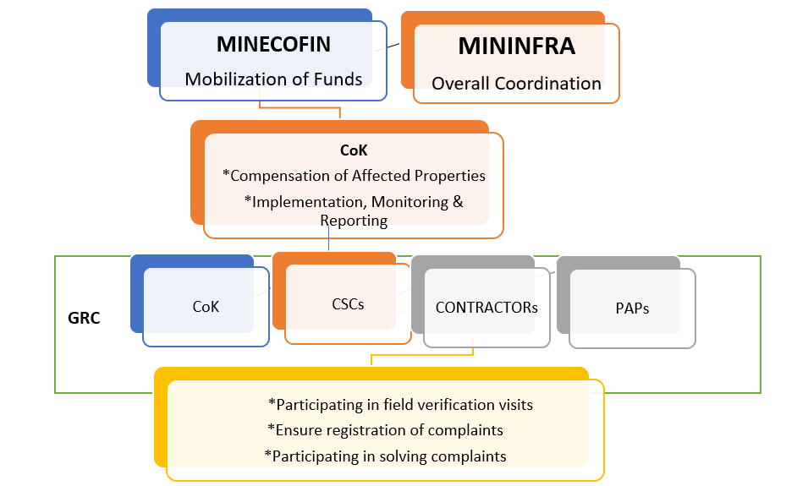
Figure ‎2-1: RAP Organisation Structure

CONSULTATIONS AND PARTICIPATION

Introduction
Stakeholder engagement and public participation in a project interactive process between the project (and or developer) and those potentially affected by or have an interest in the project. It aims at building and maintaining an open and constructive relationship with stakeholders and thereby facilitating project management of its activities and operations, including its environmental and social effects and risks.
Stakeholder engagement for this project took the form of formal meetings with small groups of people, focused group discussions and individual interviews. PAPs were provided with relevant and sufficient information on the project prior to its start-up. These stakeholders include the central and local authorities, as well as the community.

Objectives of Stakeholder Engagement
The objectives of the stakeholder engagement process were:
- To identify project stakeholders and build a constructive relationship with them, in particular project-affected parties.
- To disclose appropriate project information on environmental and social risks and impacts to stakeholders in a timely, understandable and appropriate manner and format.
- To assess stakeholders’ interests about and support for the project and to enable stakeholders’ views to be taken into account in project design, environmental and social performance.
- To promote effective and inclusive engagement with project-affected parties throughout the project life cycle on issues that could potentially affect them or the project activities.
- To provide stakeholders with accessible and inclusive means to raise issues and grievances, and to and appropriately manage such issues and grievances.

Stakeholder Identification, Mapping and Analysis
The stakeholder identification and categorization criteria applied, was in respect to location, potential impact, interest, power, mandate and influence. The main Ministries, Authorities, Institutions and Bodies that are involved in the project are presented in the following table 3.1.
Table ‎3-1 Stakeholder Analysis
Administrative level | Institution/designation | Interest/information requirement
National level | - The Ministry of Infrastructure (MININFRA)  - Rwanda Housing Authority (RHA) Law N°40/2010 of 25/11/2010 Official Gazette no 09 of 28/02/2011  - The Rwanda Water Board  - The Ministry of Environment (MoE)  - Rwanda Environmental Management Authority (REMA)  - The Rwanda Management and Land Use Authority (RLMUA)  - Rwanda Transport Development Agency (RTDA) Law N°02/2010 OF 20/01/2010  - The Rwanda Development Board (RDB)  - The City of Kigali and Local administration  - Ministry of Local Government (MINALOC) | Policy, guidance and control
National level | - The Local Administrative Entities Development Agency (LODA)  - Rwanda Association of Local Government Authorities (RALGA)  - Joint Action Development Forum (JADF) | - Policy, guidance, compensation
National level | - Rwanda Water Board  - Civil Society organisations | Advocacy
National level | - Rwanda Private Sector Federation (PSF):
District level | - The district administrations of Nyarugenge | Policy implementation, compensation, revenue collection, law and order
District level | - Affected people in the settlement | Disclosure of appropriate information, Compensation and resettlement.

Formation of the Community Upgrading Committees
The community meetings resulted into the formation of the Community Upgrading Committees. The meetings that resulted into the formation of CUCs were organised at cell level. Because of the restrictions of COVID-19, there were no general community meetings. Therefore, 3 representatives from each of the 7 villages gathered at each cell office to form a Council which then elected the committee (CUC). They followed guidelines provided by the client, who included electing five members: A Chairperson, a Vice Chairperson, two women representatives and an opinion leader.
The following are the committees as per cells in the settlement:
Table ‎3-3: Gatenga Settlement CUCs
Gatenga Settlement Community Upgrading Committees
Sector | Cell | CUC members | Role | Sex | Contact
Gatenga | Karambo | Rwiririza Denys | President | Male | 0788558683
Gatenga | Karambo | Uwanyirigira M Jeanne | Vice President | Female | 0788561103
Gatenga | Karambo | Niyonkuru Emmanuel | Executive Secretary | Male | 0788298903
Gatenga | Karambo | Bicamumpaka Jerome | Member | Male | 0788422720
Gatenga | Karambo | Nkunzwenimana Agathe | Member | Female | 0788868628
Gatenga | Gatenga | Karuranga Hyacinthe | President | Male | 0788403827
Gatenga | Gatenga | Kayitesi Betty | Vice President | Female | 0788635692
Gatenga | Gatenga | Ngiruwondanga Innocent | Executive Secretary | Male | 0788410282
Gatenga | Gatenga | Havugimana Felix | Member | Male | 0788851066
Gatenga | Gatenga | Businge Jolly | Member | Female | 0788802405
Gatenga | Nyanza | Gategaya Elias | President | Male | 0786678320
Gatenga | Nyanza | Munyandinda Evode | Vice President | Female | 0788445470
Gatenga | Nyanza | Ncongoza Emmanuel | Executive Secretary | Male | 0785698838
Gatenga | Nyanza | Nzamwita Eudosie | Member | Male | 0788818651
Gatenga | Nyanza | Umubyeyi Theodosie | Member | Female | 0788549645

Information flow within the community is indicated in the following structure

The community Participation process

Figure ‎3-1: Community Sensitization process

Community participatory planning involved the following sections:
The Consultants prepared a Meeting with the CUCs. Then CUCs met with the community leaders, “the council” to sensitize them on the Project Developments. They could also take with them Visual Aid Charts and pin them at the Village, Cell and Sector Offices, where the local leaders (Council) would relay this information to the communities to receive their feedback.
Due to COVID-19, meetings were held at their respective Cells (utugari) and Sector Offices;
This process was repeated after the final designs, during the Valuation process and also during the selection of the investments
There were also continuous updates through the CUCs and any preferable media led by the Client (CoK) were also made.

Table ‎3-4: Sensitization activities
Duration | Activity and Venue | Number of Participants | Actions
22nd October 2020 | Formation of CUCs from Members of the Council at each Cell level. All 3 cells in Gatenga settlement were involved in the selection process, from where 5 members were selected per cell to form a total of 15 CUCs in Gatenga settlement. Each cell had 9 representatives to choose from  50 villages and each village was presented by 3 people.  The meeting took place at Gatenga sector offices. | 24 | Introduction of the Project to the community and then selection of the CUC members
22nd October 2020 | Sensitization of the of the CUCs members of their roles in the project at Gatenga Sector offices. | 15 | One day seminar with Experts explaining the roles of the CUC members in the planning process, selection and decision making. Modules of the roles were developed and were given out to the CUCs
2nd-11th November 2020 | Meetings with CUCs to explain the preliminary developments and scope of the Project as per the feasibility studies at Gatenga Sector Offices | 15 | -confirmation of the investment selections  -suggestion of new ones from the Community  -visited sites with the CUCs to identify locations for the proposed investments
19th April 2021 | Meetings with CUC members for selection of the Final Investments after Draft detailed Design at Gatenga Sector offices | 15 | -The CUCs presented and gave feedback from community members.  -Shared the planning process with the guidance of the Consultants, Sector Authorities and the Client representatives  Presentations were made with the help of animated Visual Aid presentations  Selection of the Investment by the CUCs. Copies of maps were given to the CUCs to pin at cell offices and receive comments from the general community
22nd June 2021 | Meetings with CUC members For Sensitisation on the property Valuation Process, at Gatenga cell offices | 15 | The CUCs were informed of the process of the census of carrying out the census and valuation of the affected properties. They were requested to inform all the persons whose list had been given to be present at the specified days as the Valuers take inventory for their properties
22nd June 2021 | Continuous meetings with CUC as required depending on information needs and updates. | 15 | CUC continue to feedback to their leaders and villages.
22nd June 2021 | Update of the community on the final investments selected. | 15 | Feedback and validation of final plans.

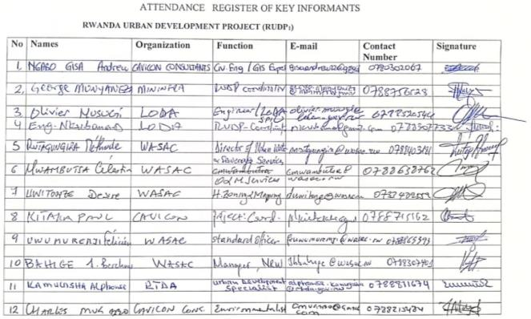
Figure ‎3-2: Attendance Sheet from the stakeholder meetings 1
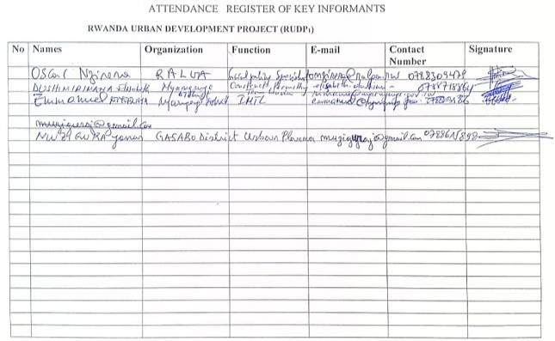
Figure ‎3-3: Attendance Sheet from the stakeholder meetings 2

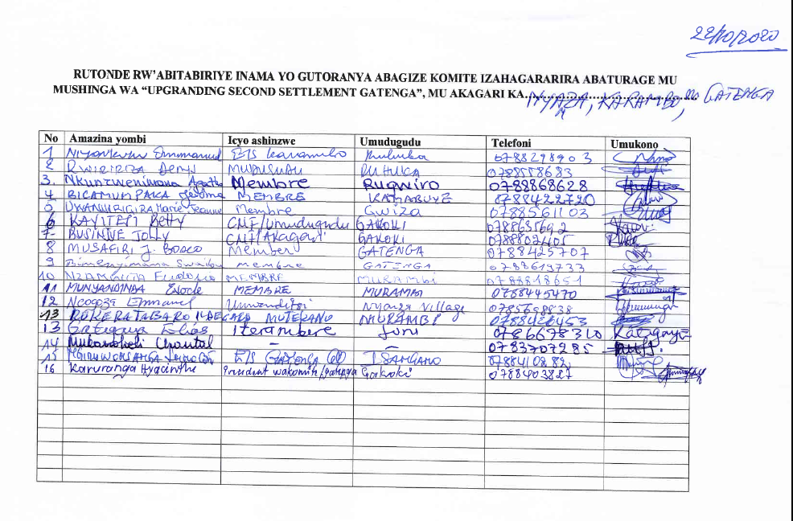
Figure ‎3-4: Gatenga CUC members’ attendance taken

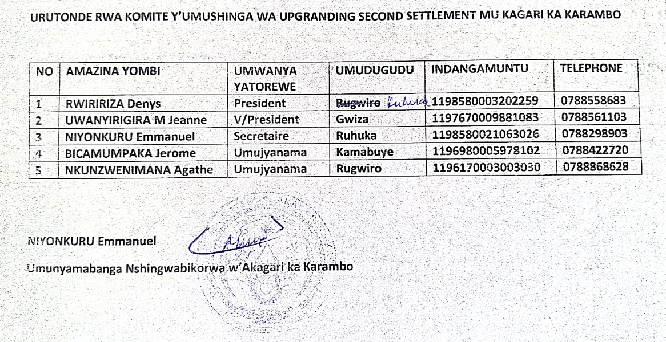
Figure ‎3-5: Karambo Cell elected CUCs attendance

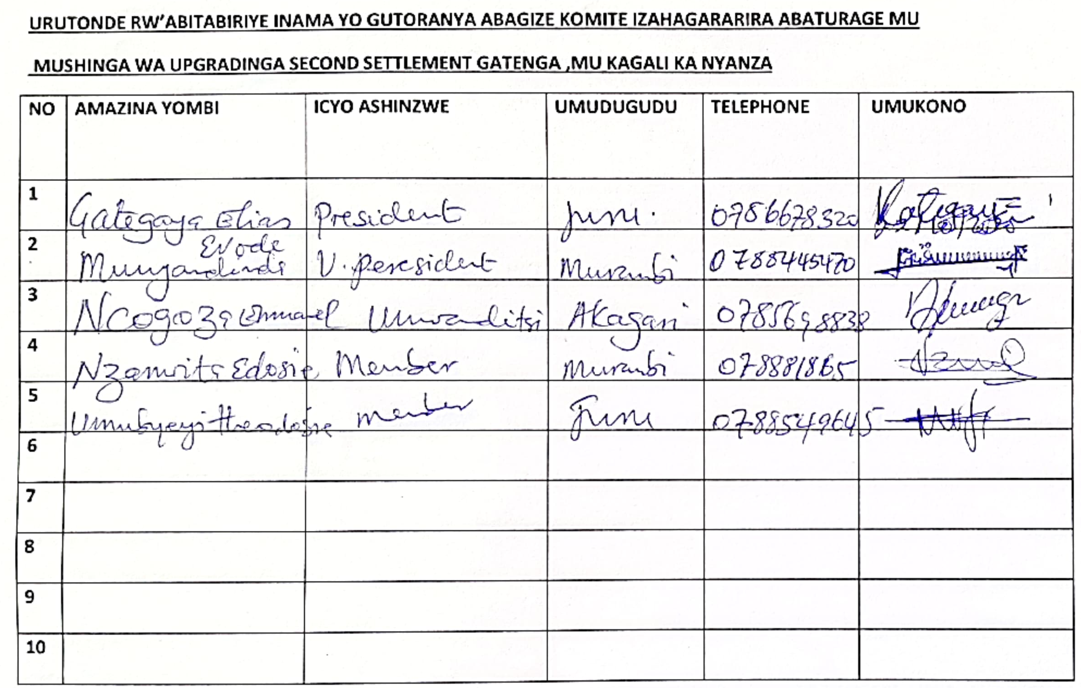
Figure ‎3-6: Nyanza Cell elected CUCs attendance

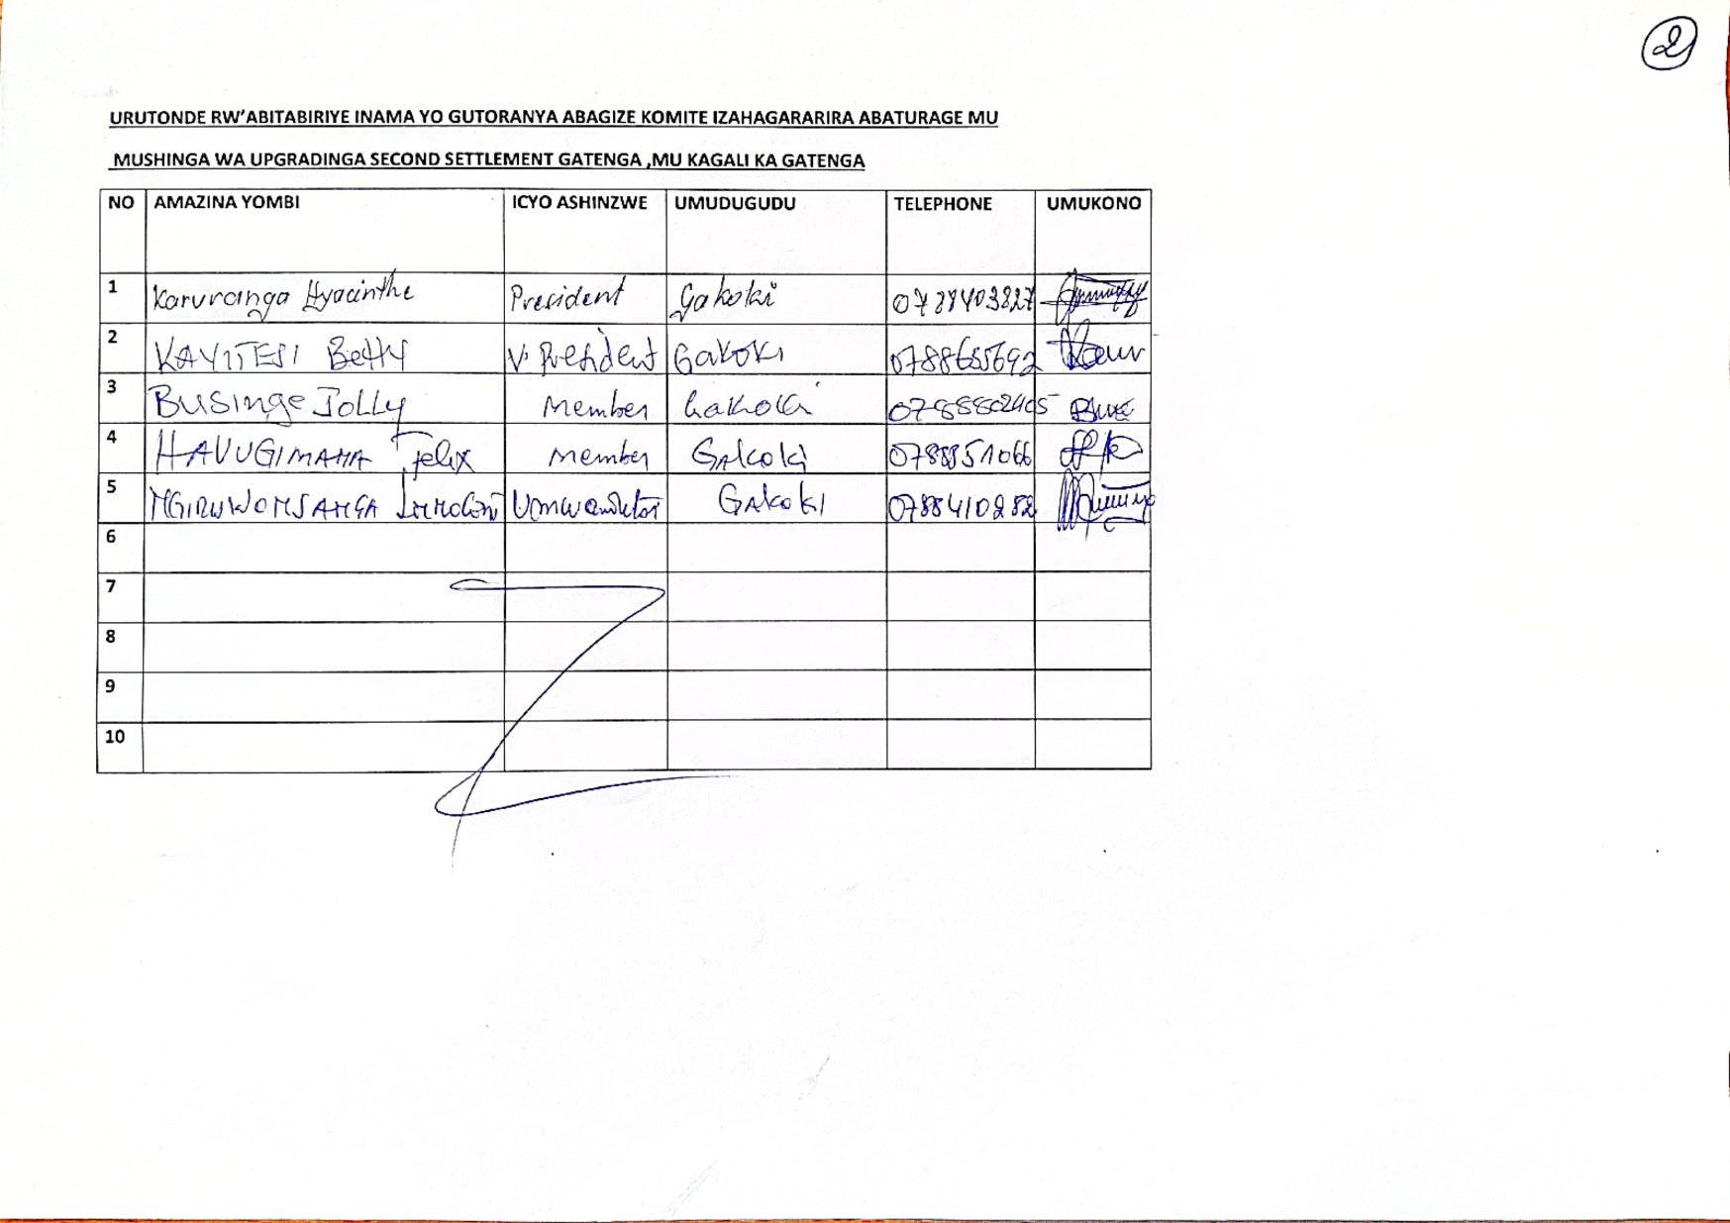
Figure ‎3-7: Gatenga Cell elected CUCs attendance
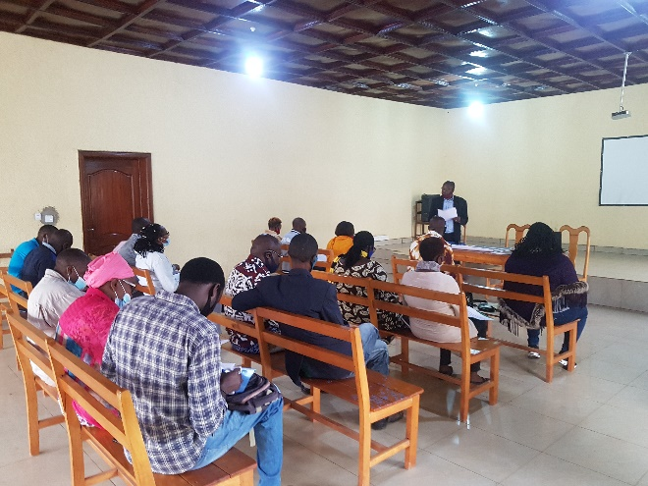
Figure ‎3-8: Stakeholder Engagement with Gatenga CUC members

Stakeholder views
The following are key observations from the different stakeholders so far engaged. The responses have been adopted in all the RAP reports since they provide various experiences for proper project implementation of the infrastructures in each settlement.
Table ‎3-5: Stakeholder engagement responses
Type of stakeholder | Comments/Views/questions
LODA | - The urgent need to limit expropriation as much as possible.  - Follow the World Bank guidelines as they were very key in the validation process.  - During the detailed study provide multiple scenarios, showing the most probable, most optimistic and the pessimistic choice.  - Keep all stakeholder involved in the planning, especially the key stakeholders involved in the project such as WASAC, RTDA, RHA, RWB, REMA and EUCL, since the approval of the detailed designs had to be properly validated and in conformity to all stakeholders.  - Considering narrower roads, as the cost of expropriation greatly reduced, and they helped with reducing the speed of motor vehicles.  - Considering cheaper construction technologies such as chip seal in the settlement access roads.  - Having drainage trenches with concrete slab covers doubling as pedestrian walkways.  - Limiting the margin of error in the topographic survey as much as possible.  - Consider current unit prices in the pricing as this had been a major issue in previous projects as well.
WASAC | - Rwanda has national standards that have to be followed before adhering to international standards.  - The present water network in the settlements needed to be considered in the design of the proposed network, to avoid cases where existing pipes that haven’t reached their design life are damaged or removed in the implementation of the project.  - The final detailed designs should have both designs for the water network and the sewer network, incorporating the 2 settlements of Mpazi and Gatenga in the planned centralized sewerage system.  - Provide proper demand projections considering the development that would arise with the new infrastructure.  - Work closely with the various stakeholders and accept their input rather than guiding them, during implementation, preparing the Bills of Quantities and other stages.  - Look properly into the cost recovery aspect on the project.  - Consider the formation of the stakeholder committee consisting of all the stakeholders to ensure that all the stakeholders were involved in the project and their input considered.
Rwanda Association of Local Government Authorities (RALGA). | - Limit expropriation as much as possible as it was costly and majority of evacuated people normally tend to lead to informal settlements elsewhere, rather build around the residents and make them realize how the infrastructure was meant to improve their livelihoods.  - Consider including People with Disabilities (PWDs) on the Community Upgrading Committees.  - The role of RALGA in the City of Kigali projects is in linking the local entities with central government in capacity building.  - Provided studies for review: study to access opportunities in land readjustment with RHA and MININFRA.  - The team at RALGA had also conducted a study to observe how expropriation would be minimized on Agatare (RUDP phase I), and they had the documentation on how the eviction was on-going.  - Look at the Resettlement Upgrading Model by the UN Habitat from Ms. Catherine Kalisa as some areas in the project scope had been considered in their habitat study.  - Propose means the residents would get to improve on their houses and surrounding following the master plan, after the implementation of the project.
Rwanda Transport Development Agency (RTDA) | - The Rwandan standards that had been drafted by RTDA have not been validated and the process stopped. It better to follow internationally approved standards.  - Limit expropriation; consider having narrower roads, probably making one-way traffic roads to limit the carriageway to the narrowest possible.  - Look at road drainage while minding the cost of expropriation during implementation.  - For road drainage consider more in-sloping and out-sloping crowns, rather than the common centerline crowns, as the centerline crown required 2 side ditches while the former required one.  - pay close attention to the surveys, such as;  - Traffic volume, traffic design speed and flow.  - Traffic counts, Intersection volume studies, Origin-Destination surveys planning for the unplanned traffic, and the vertical and horizontal alignments.  - Concerned about RUDP first phase works, where some roads in Agatare had very steep slopes that looked very dangerous in both the friction of the vehicles and sight-viewing distance.  - The cobblestone project had failed as a pavement material to limited resources, and encouraged chip seal as a pavement material for low traffic roads as the cost was cheaper per kilometer compared to the common asphalt concrete.  - Advice on the pavement layers; the common crushed stone base could be ignored basing on the traffic volumes and the wearing course applied directly over the well compacted murram fill provided it is strong enough with regards to its California Bearing Ratio.  - Design side ditches with concrete slab covers that act as walk path.  - Look at Base on the road to Byumba were proper drainage on the retaining wall was done, for occasions were the retaining walls fail.  - There are conflicting interests between the different stakeholders, such as WASAC water pipes and EUCL and REG fibre network, where they depend on the road network for their infrastructure. To this he suggested the team considers smaller carriageways and planning for the services of the other stakeholders in the roadway, this would involve planning for water pipes and fibre optic cables in the roadway.  - Ongoing road works damage underground water pipes hence leaving residents without water for some considerable time, stating how before any works are done, RTDA requests for the mapping showing the locations of pipes, however since most pipe locations are unknown, damaging the pipes becomes an unavoidable situation.  - Consult the WASC master plans during the design to avoid any conflicts that may arise during implementation.
MININFRA | - Ensure the residents take ownership of the project.  - Keep the residents as a priority during the project implementation ensuring all qualified residents in the settlements took priority in employment.  - Emphasized how in technical aspects the team should not be driven so much by the residents as on most occasions they have personal interests at heart even if the upgrading works must be comprehensive and based on the residents’ proposals.  - No benefits had been budgeted for the CUC members, but some logistics can be arranged for the committee members during meetings.  - Incorporate the new 2020 master plan in the new design.  - Pay attention to the designed road width, and limit expropriation as much as possible as the cost for expropriation fell to the Government (District), He proposed that the footpath would be limited to 1.5m -2.5m.  - Include the road KG 8 Av which is beyond the boundary of the project scope, as it wouldn’t be proper to construct settlement access roads when the main road is not worked on, and also because the said road would reduce the traffic on the main road of KG 11Av, he also argued that the traffic on KG 11 Av would increase once the Nyagatovu settlement roads had been constructed.  - The consultant needed to consider practicality as much as possible, reach on site and observe the works on ground, especially the ongoing SKAT works in Akabahizi.  - Shared the contact of the Urban Planner working with Rwanda Housing Authority (RHA) Urban Planning Consultant. The consultant team should schedule a meeting with her to share information and experiences on the matter of upgrading informal settlements.
RHA | - The consideration of maintaining people where they are living without removing them during the upgrading so as to avoid creating other slums which may result where they may relocate. This is evident in how people have shifted to neighbouring Districts and callused other informal settlements upon being expropriated from the city  - Taking care of the neighbourhood of the settlement being upgraded since in many incidents they share the challenges  - There is need for land readjustment as such there will be need to have temporary units in which to relocate people as the settlements are being upgraded  - The consideration of playgrounds (recreations grounds) for the children to grow well while managing to play, construction of small markets is to be considered within the upgrading of the settlements  - The issue of Bus stops and road side parking in general also needed to be put in consideration  - The issue of ensuring that the tenants still afford the accommodation within the same environment also has to be thought of.  - Information given the team indicated that there is a total of 10 housing settlements being developed concurrently: 4 by City of Kigali, 2 by RISD and 4 by RHA.
REMA | - The meeting with REMA centred round the liquid waste management disposal  - The proposals to have lagoons as a system of liquid waste treatment for the two settlements of Nyabisindu and Nyagatovu were not recommended due to the fact the proposed systems (lagoons) have shown poor performance and have resulted in more pollution and yet the proposed sites are used by locals to grow some crops (vegetables). It was recommended to consult the feasibility study on Kinyinya catchment that was conducted under LVEMP II. Meanwhile, a proposal to have a temporal waste water treatment plant was seen as the best option in the event that the settlements are no yet connected to the Centralized sewerage system.  - Another discussion was the storm water management. Discussion on how the storm water velocities and debris can be reduced prior to reaching the marshland so as to minimize flooding. Proposals for retention basins along the drainage channels to curb both can be a better option.  - Another discussion was that all the marshlands are undergoing rehabilitation as per the Rwanda Environment Development Programme (REDPII) as such all upgrading programmes need to be intergraded. This programme is including Gikondo and Nyabugogo wetlands  - Ensuring adequate buffer zones are respected during the upgrading processes.  - The team was requested to work in consultations with other projects which included Flood modelling team, Nature based solutions and the Environmental Management Unit of the City if Kigali  - Other documents for reference include The National Land use and Management Master Plan, Kigali Master Plan, Kigali Wetland Masterplan, there is also a strategic Assessment for the Environment which is undertaken. ESM framework is the one being used to date.  - There was also need to get in contact with the Pollution control unit as the team opts for the best alternative for liquid waste management.  - Finally, the REMA recommended that the detailed study for upgrading the informal settlements be developed using an integrated approach as much as possible in order to make use of previous studies and avoid duplication.
Kicukiro District | - The team introduced the status of the project to the district officials who are headed by the Director of Infrastructure  - The discussion centred around the need to see that PAPs are adequately compensated prior to relocation  - The district committed to offer the necessary assistance to remove the barriers to the implementation of the upgrading program.  - Contacts for the focal point persons of the districts in charge of land and infrastructure development were provided
Meeting with the Gatenga Settlement elected Community Upgrading Committee members, discussing their roles, responsibilities during the different stages of the project. | - The consultant team to consider the new master plan, as there was a worry of constantly adjusting the outcomes with each new construction phase.  - The committee was to calm the residents rather than cause the unnecessary fear and panic due to people worrying about loss of land and property.  - The committee members were to encourage the community members to desist from the habit of rushing to sell of their property and do unnecessary rehabilitation on their property targeting raising the value of their property during expropriation.  - The committee members to provide maps with the features as they would appear in the final design to avoid providing miscommunication when there are variations between the feasibility study findings and the detailed design findings.  - Inquired on whether there was any upkeep budgeted for them would be replied when they were called in the next meetings.

SOCIOECONOMIC BASELINE CONDITIONS

Introduction
This chapter presents the analysis and interpretation of the findings from the socioeconomic survey including: demographic characteristics, household economy, economic and health status and information and communication.

Household characteristics

Gender of the head of household
The findings show that the majority of household heads are males (77%). This is not surprising in an African setting, but 23% to be females is a cause for alarm and call for proper planning not to make these women more vulnerable.

Figure ‎4-1: Households’ Head Gender

Age of household head
Majority of the household heads are between 36-65 years (83%). This is an indication of a youthful population that needs to be resettled properly. The (5.8%) with elderly will get assistance from the young ones working. The following table shows the age groups. The following table shows the age groups.

Figure ‎4-2: Households' Head Age

Marital Status
Majority of the household heads (74%) are married, however, there is a considerable proportion (17%) who are widowers. Widowers are categorised as a vulnerable group, so it’s important that the project takes care not to make them more vulnerable, when they lose their places of abode and cannot replace them. There is therefore a strong recommendation for in-kind compensation for those who lose their houses.
Figure ‎4-3: marital Status Demographic

Education of the head of household
Data shows that (29.2%), have attained only primary level and (5.2%) had no education. These people will need support in handling and comprehending resettlement related documents.
Figure ‎4-4: Households' Head Level of Education

Professional activity
The survey results show there are three major professional activities in the settlement including entrepreneur (20%), commerce/transport (21%) and farmer (22%). These are livelihoods that will be displaced and PAPs will need support to restore them.

Figure ‎4-5: PAPs Professional Activity.

Number of people in your household
According to figure 4-6, almost a half of the PAPs (49%) have between 5-7 members in the household. The households are big and therefore need to be resettled properly.
Figure ‎4-6: Number of People per Household

Gender of the household members
In addition, 52% of the other household members are females. As shown below.

Figure 4-7: Genders of Household members

Age group of household members
Close to a half (41%) are below 18 years, and these could include students. These are likely to be disrupted by the displacement process. A third of the affected household members are between 19-35 years. These are youths who could be employed by the project. Overall, (52%) of the household members are females.
Figure ‎4-7: Household Member Age groups

Education of household members
The education of members of the affected households shows that many could still be students. These are likely to be disrupted by the displacement process in terms of increasing on the distance travelled to school which may negatively impact their daily school attendance.

Figure ‎4-8: Education of the household members.

Access to schools
Data further shows that only (3%) of children who are supposed to be in school are not which is a good mobilisation compared to the rest of the settlements. The schools are mainly public schools (57%), 41% are private while 2% are government aided schools. The schools are within 5km (less than 1km 23% and 1-5km 49%), while the rest are located above 5km from their homes. The distance to school should be a factor during resettlement not to affect children’s education.

Figure ‎4-9: Children in Schools

Figure ‎4-10: Type of School attended

Figure ‎4-11: he distance to the school

Literacy of the household head
The data reveals that 96% of household heads can easily read and write while the rest (4%) of the household heads cannot read and write properly in any language. These should be identified by CoK and given support to understand the documentation during resettlement.
Figure ‎4-12: Literacy Levels of the Household Heads

Occupation of household members
The survey results in figure 4-9 indicate that a big percentage of the other household members (39.6%) are students, followed by those engaged in farming (15%), entrepreneurship (12.8%), private employees (12.5%) and those involved in commercial activities and transport (9.0%). Livelihood restoration programs should put into consideration the different occupations and skills the PAPs have.
Figure ‎4-13: Occupation of household members

Household economy

Category of PAPs (UBUDEHE)
Majority of PAPs belong to category III of Ubudehe (77%), (14%) belong to category II of Ubudehe as shown in the following figure 4-11 shows:
Figure ‎4-14: Economic Category of the PAPs

Findings show that majority of PAPs (77.4%) belong to category III of the economic levels (ubudehe). This means that some of the landlords among of PAPs, using expropriation compensation resources, will be able to build themselves new houses according CoK Plans.

Most important income source
Survey results suggest that majority of PAPs have wage employment (70%) and property income (38%), as shown in the following diagram below. The PAPs are likely to continue with their sources of income even after resettlement if they do not go very far from Kigali.
Figure ‎4-15: Most important Source of Income

Income of another household member
Only (40%) of the PAPs, have got another member in the household with a regular income as indicated in figure 4-13 below. This means the PAPs are the sole providers in the home. Any impact on their livelihoods affects the welfare of the whole family.
Figure ‎4-16: Type of other household members

Well-being indicators
The survey results reveal that majority of the households (95%), had their breakfast of tea/porridge with sugar on the day of the interview. This is a good indicator of welfare, which should not disorganise by resettlement.
Figure ‎4-17: What Children had for Breakfast

Household source of social assistance during difficult times
The data shows that PAPs mainly get assistance from Bank/SACCO (36%) and extended family (28%). The banks or SACCO may be lost with distance; but the relatives can still be accessed wherever the PAP is relocated. For those who will be resettled, the project will encourage people to form groups for new networks.
Figure ‎4-18: Household source of social assistance during difficult times

Average income from different Sources of livelihoods in the 12 last months
Almost a half (40.6%) of the PAPs are below 500,000 Rwf. These may need support in restoring their livelihoods. A third (31%) of the PAPs earn between 500,000-1,000,000 as their average income. For details see figure 4-19 below.
Figure ‎4-19: Average Income

Average monthly household expenditure on basic necessities
The majority (90%), spend less than 500,000 Rwf monthly. Indeed, they cannot spend more than what they earn. However, these need to be scrutinised because it could have some vulnerable groups earning little income. The following figure is illustrative.
Figure ‎4-20: Average annual household expenditure

Health status of the household

Health Conditions
The baseline survey inquired about the common illnesses among children under 5 years. Survey results suggest that 42% had cough. This could be related to the environment and congestion in the houses.
Figure ‎4-21: Illnesses for children below 5 years in the two weeks preceding the interview

The results in figure above, show that malaria is the common illness among children under 5 years that needs to be taken in account by health services to minimize infection transmission to new people.

Health seeking behavior
The majority of PAPs use government health units. These are well distributed in Kigali. Therefore, wherever they relocate, the PAPs will be able to still access government services. The results are shown in following figure 4-22 below.
Figure ‎4-22: Where consultation is first sought

Property ownership Status

Land ownership status
The data reveals that (99%) of the PAPs own the land, while (1%) is owned by institutions. The land tenure is mainly freehold (90%) and succession is (10%). These may be among the people who may lack proper documentation. They will be assisted by the CoK before they can access compensation.
Figure ‎4-23: Land Ownership

Impacts on the houses and land
Regarding the impact, 47% of the PAPs said that the project will physically displace their houses and 60% still, know that the project will take part of their land which means that the remaining portion be used for other activities.
Figure ‎4-24: Impact on property ( L: on house and R: on land)

Possible area for relocation
Asked about possible relocation site the following are the responses. Majority (78.8%) said would like to stay within Kigali. This is a message to the developers to ensure that people who are physically affected stay in Kigali so that they can continue with their livelihoods

Figure ‎4-25: Possible relocation sites Preference.

Housing Conditions

Ownership of the house
Almost all houses are owner occupied (94.8%). This means that for those who are physically affected; it is the real PAP. And considering the fact that most of the houses through observation have an economic activity, PAPs will be both physically and economically displaced.
Figure ‎4-26: Ownership of house

Type of dwelling
Majority (64.5%) of the PAPs have autonomous houses. This means; affecting one house may affect the other during the demolition process. Therefore, the project should take care not to unnecessarily damage properties.
Figure ‎4-27: type of dwelling

Services

Access to Water
The data revealed that (86.5%) have WASAC household connection, while the rest bought from water vendors.
Figure ‎4-28: Access to water

Sanitation
The PAPs in Gatenga have access to proper sanitation. Only (1%) of the PAPs do not have access to a proper sanitation facility as shown in figure 4-23 below.
Figure ‎4-29: Type of Toilet Facility

Communication
The survey findings show that radio (36%), TV (23%) and mobile phone (21%) are the most popular sources of information. These should be utilised to ensure proper mobilisation and RAP implementation.
Figure ‎4-30: Communication

Social Capital

Source of social assistance
The survey results reveal that the four main sources of social assistance include spouse (54.8%), family member (7%) but 32% do not have anybody to resort to in case of social support as such the local leaders need to closely intervene.
Figure ‎4-31: Source of social assistance

Community based Activities
The PAPs were asked whether they belonged to a community group. The purpose was to assess their social networks, which are likely to be broken with resettlement. The findings show that about half of the PAPs (51%) do not belong to any group. Such PAPs who do not belong to any organisation may find problems adjusting to new locations during and after displacement. (45%) belong to women/men groups. These can be a source of support, but also, they are likely to be broken. PAPs will be counselled into forming new networks in their new locations.
Figure ‎4-32: Community Organization

Compensation information

Preferred compensation
Survey results show that 99% of the Respondents prefer compensation in monetary terms while 1% prefer In Kind (replacement) compensation as indicated in table 4-1 below.
Table ‎4-1: Preferred compensation options
 |  | %
Land and other properties above land | Payment of monetary fair compensation | 99.4%
Land and other properties above land | Payment of fair compensation in kind | 0.6%
Land and other properties above land | Total | 100.0%
House alone | Payment of monetary fair compensation | 98.7%
House alone | Payment of fair compensation in kind | 1.3%
House alone | Total | 100.0%
Land alone | Payment of monetary fair compensation | 99.4%
Land alone | Payment of fair compensation in kind | 0.6%
Land alone | Total | 100.0%

Reasons for Preferred compensation option
When asked for the reason why they prefer monetary compensation, majority had an option of improving their incomes by investing part of the money in business related activities. On the other hand those that preferred in-kind compensation had fear of not being able to resettle within the same location if the claiming that the money may be little as indicated in the two figures below
Figure ‎4-33: Reason for compensation option (L- Cash R: In-Kind)

As such there is need to provide compensation at full replacement cost, so that the PAPs are free to replace their dwellings in the same or close location. This also points to the need for serious sensitisation for the PAPs to accept the plan for CoK to provide in kind compensation for people who are physical displaced.

HIV/AIDS

Methods of contracting HIV/AIDS
The knowledge about HIV/AIDS is high among the PAPs. The survey results suggest that 98.7% of the PAPs are aware that HIV can be got through sexual intercourse. The PAPs can also mention other methods of contracting HIV/AIDS to some extent. Such information will be stressed in order to increase HIV/AIDS knowledge during the construction phase when new people come into the area in search of job opportunities. The results are shown in figure below:
Figure ‎4-34: Methods of contracting HIV/AIDS

The other methods are not commonly mentioned by the PAPs while there was PAPs who think HIV can be gotten through shaking hands and sharing cups. This is an indication of HIV/AIDS information gap. This gap should be filled during the construction phase.

Method of avoiding HIV/AIDS
There is high knowledge about HIV/AIDS prevention with a big number appreciating that faithfulness takes the lead in avoid HIV/AIDs as indicated in figure below. This should be continued in terms of Information Education and Communication (IEC).
Figure ‎4-35: Methods of avoiding HIV/AIDS

The different methods of avoiding infection with HIV will have to be stressed during construction of the infrastructures.

Major source of information about HIV/AIDS
Radio and TV are most two popular sources of information and communication, 87% and 86% respectively. The project should take advantage of them especially during this COVID-19 time, when physical meetings are discouraged.
Figure ‎4-36: Major source of information about HIV/AIDS

Gender Based Violence (GBV)

Forms of GBV experienced in the last 12 months
Gender based violence was reported by the affected households. Majority (80%) of the PAPs reported to have experienced physical violence; followed by psychological violence (60%), and 40% sexual violence respectively. These are serious issues which can worsen with the introduction of compensation money in the households. The project should take precaution by sensitising the PAPs especially during disclosure and during project implementation.
Figure ‎4-37: Forms of GBV experienced in the last 12 months

female household member experiencing abuses in the last 12 months
The assessment sought to find out the risks women that participated in the study face in the community, which may be exacerbated by the resettlement process. The findings are presented below.
Although only 2% admit to facing abuse in the 12 months preceding the interview, it is a pointer that the problem exists which may be made worse by the resettlement process. CoK should sensitise the communities during RAP implementation to avoid such behaviours.

Figure 4-38: Females Experiencing GBV

Vulnerability of the Family Heads

Chronic Diseases Suffered by Household Heads
The data shows that only (19%) of the household heads suffer from a chronic disease of the following categories; Pressure (45%) and HIV/AIDS (35%) are commonly mentioned chronic diseases. These diseases may worsen if displaced PAPs are not resettled properly. CoK will ensure that people are not made worse off with the resettlement process through a fair compensation and proper follow up. Figure below, shows the different chronic diseases suffered by PAPs.
Figure ‎4-38: Chronic Disease Suffered by Household Heads

Disability of the other Household members
The data shows that a few households have members with some form of disability. (8%) of the household members have a physical disability, (1%) reported visual disability while (2%) had physical disability. As the following graph shows, these can be handled by other family members.
Figure ‎4-39: Disability by household head and for the other members

Cases where household heads possess any kind of vuln ability need to be given extra targeted support as needed since they are at the centre of all family transactions.

Births and Deaths
Only 9% of the affected households had a birth in the house in the past 12 months while (2%) had registered a death in the past 1 year.
Figure ‎4-40: Births and Deaths recorded

Orphanage hood

Deceased Property Owners
The survey results reveal that (4.5%) of the households had lost the owner of the property, indicating that their properties are being managed under succession. The project will help them to acquire the necessary papers for compensation eligibility.
Figure ‎4-41: Diseased Property owner

Orphans belonging or adopted in a household
Over 4.5% of the respondents revealed that they have at least 1 orphan in their houses as indicated in the figure below. This question catered for the children belonging to the diseased property owner as well as an adopted person. The PAPs have to be sensitised about the law on property rights of orphans and all the respective dependants such that in case they are not relocating as a group, then there shall be harmony in sharing of the compensation.
Figure ‎4-42: Existence of orphans in homes

PROJECT DISPLACEMENT IMPACTS

Introduction
This chapter covers the information about the project requirements in terms of land and other related properties within the project limits. It presents the number of PAPs affected and the areas they are located.

Determination of acquiring project land

Criteria of land acquisition
The project area was established after the detailed Engineering designs were completed. The design indicated the boundary limits of each infrastructure. The design team provided for adequate space to be used for implementation of the project. In this case the land included in the project boundary will be permanent taken.
It was also determined that the same land will be adequate for the contractor who will be implanting the project and encroachment of the uncompensated land can only take place upon proper justification otherwise the contractor will be obliged to make compensation of the affected property at his own cost.

Typical sections of the road infrastructure
A per the designs, the road infrastructures were proposed to have two road sections; one with 10m right of way and the second one to have 7.5m right of way. All the roads are to have a road motor way, a side drain and a walk way as indicated in the figures below
Figure ‎5-1: Typical 10 RoW Road section
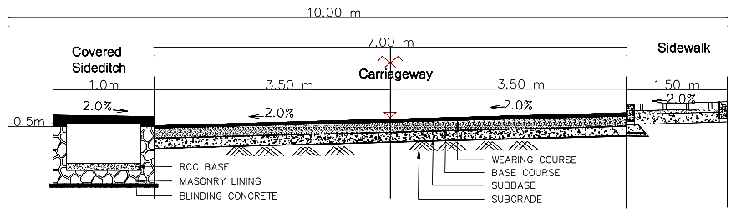
Figure ‎5-2: Typical 7.5m RoW Road section
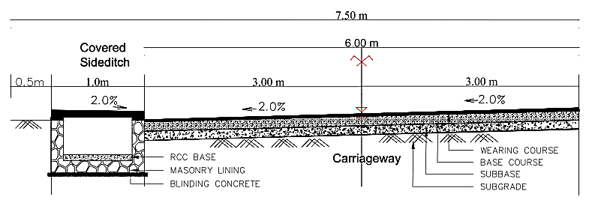
Concrete beacons were fixed to show the limits at an average distance of 200m on each side and at all critical sections such as junctions and bends.

Demarcations for community facilities
Land for each community facility was demarcated in reference to the designs and their limits.
In Gatenga Settlement, expropriation would be for the land Construction of Gashyekero Market. However, since the market already exists, that area was opted for and the extra area required is already catered for under the roads since the buildings there, were valued already under the road limits
The reset of the community facilities which include activities in Murambi G/S and Murambi Market parking lot will not need compensation since the land already belongs to Government.
Table ‎5-1: Status of land for Facilities
Gatenga Settlement Community Facilities Summary
 | Facilities | Area Required (m²) | Land status
1 | Gashyekero Market | 1401 | No Expropriation Public Land
2 | G.S Murambi facilities (football, volleyball and Basketball play grounds, Parking and assembly ground and Rain water tank) | 7650 | No Expropriation Public Land
3 | Murambi Metalwork workshop Roadside Parking | 420 | No Expropriation Public Land

Minimization of the impacts

Options for acquiring effect area
Due to the fact the infrastructures are to be constructed within the communities; the project boundaries were generally on the upper side of the existing roads. This was opted by the design team, so that in case properties along the road are to be affected, then one side, preferably the upper side was chosen since it was found to be having more stable soils for road construction.
Options for having sections of the roads to be constructed in available space was also considered by they were really minimal since the infrastructure is intended to upgrade the very settlements in which they are to be constructed.

Other considerations
Considerations were also made to PAPs whose property was not fully touched by the infrastructure boundary line. Depending on the nature of the house or structure as to whether it is one unit or detached houses and the purpose. The valuation team would make an assessment of case by case and determine what to include in the valuation.
Another case is the portion of the remaining land. If it was discovered that the PAP will not make meaningful use of the remaining land due to its small size, then the whole land was considered for valuation.

Nature of impacts

Physically affected PAPs
The physically affected households are the real owners who are also residing in those facilitates. These ones were found to be displaced and they will need compensation to re-establish their properties in another location.

Economically affected PAPs
The economically affected PAPs are the households who were renting the properties and those who may be having crops in public land. The details are attached the appendix 3 for the Valuation Report indicating the nature of property being affected.

Institutions
These are institutions which include cooperatives, churches, Public Offices which may be losing part of their land. Their numbers are indicated in the summary tables below
The roads and all infrastructures will displace PAPs occupying an area of 5.3 Ha. The details have been indicated in the list of affected PAPs in appendix 3

Summary of the impacts
Table ‎5-2: Summary of impacts
Impact | Unit
Surface Area of permanent land taken for the roads and community facilities | 53,035 sqm i.e., 5.3Ha
Number of Affected Properties (to be paid by Plot Identification) | 225
Number of Property Owners | 206
Number of Affected Households (PAHs) | 204
Males involved Property ownership (those who appear on Land titles) | 176
Females involved in Property ownership (those who appear on Land titles) | 61
Total Number of Affected Individuals (PAPs) | 842
Number of Physically Displaced Households (Property owners Occupied) | 138
Number of Economically Displaced Institutions (Industry, cooperative, companies, churches) | 2
Number of Economically Displaced (Households) and with land, fences and crops | 47
Number of Affected Residences for rent and other economic activities | 8

The total amount of compensation for all the affected properties is Rwf 3,382,852,287. It also includes the 5% Disruption as stipulated by the Law on expropriation to cater for additional expenses to be incurred by the Affected Person during resettlement

Arrangement of the PAPs list
The properties are further arranged according to streets to ease project prioritization depending on the budget. If one of the streets is to be differed to another phase, its corresponding PAPs and the amount is easily identified, and their details have been presented in Appendix 3. More information about the PAP has been indicated in the Inventory form in appendix 2(a) and 2(b)
The table below shows how PAPs are grouped according to streets as the optimal way to ease the project implementation.
Table ‎5-3: PAPs grouped into Streets
Gatenga Settlement Streets ( Prioritized)
No. | Name | Length (m) | Class | Condition | No. of PAPs | RAP Amount (USD)
1 | KK 44 Ave | 2822.4 | Collector | Unpaved | 108 | 1,486,812
2 | KK 526 St | 840.2 | Access | Unpaved
3 | KK 524 St | 844.1 | Access | Unpaved
4 | KK 634 St |  | Access | Unpaved
5 | KK 528 St | 1775.0 | Access | Unpaved | 43 | 849,554
6 | KK 632 St
7 | KK 630 St |  | Access | Unpaved
8 | KK 36 Ave | 2460.3 | Access | Unpaved | 25 | 451,715
9 | KK 46 Ave | 2309.0 | Access | Unpaved | 49 | 594,771
10 | KK 616 St
11 | KK 618 St
12 | KK 610 St
13 | KK 636 St |  | Access | Unpaved
14 | KK 645 St | 803.8 | Access | Unpaved
15 | KK 637 St |  | Access | Unpaved
16 | KK 639 St
17 | KK 641 St
18 | KK 643 St |  | Access | Unpaved
19 | KK 685 St
20 | KK 687 St
21 | KK 679 St |  | Access | Unpaved
22 | KK 666 St
23 | KK 689 St
24 | KK 693 St |  | Access | Unpaved
25 | KK 656 St |  | Access | Unpaved
26 | KK 567 St |  | Collector | Unpaved
27 | Gatenga 1 |  | Access | New
28 | Gatenga 3
29 | Gatenga 5
30 | Gatenga 6
31 | Gatenga 7
Total |  | 11,854.8 |  |  | 225 | 3,382,852

From the data collection and entry exercise done by a team of Valuers, it was found that unlike other settlements, the compensation cost was somewhat appreciable due to the fact that residents of Gatenga settlement are well settled with enough space for road reserves. This caused the number of residents to be removed to be lower.

COMPENSATION STRATEGY, ELIGIBILITY AND ENTITLEMENTS

Introduction
This chapter presents the compensation strategy, eligibility and entitlements. It discusses the methods that have been used to determine what the PAPs will get as compensation and determining who is to be compensated.

Key Principles for Compensation and Eligibility
The key principles of the compensation strategy are the following:
- The land acquisition and resettlement process will be carried out in compliance with Rwandan law and international requirements of WB’s ESF.
- The CoK will seek to avoid physical displacement where possible and to minimize economic displacement (i.e., optimizing the design)
- Replacement values (i.e., market value plus 5%) will be used for the calculation of all compensation, including land, structures, crops and trees.
- The process of resettlement and land acquisition, including identification of affected plots and owners/users, will be carried out by CoK and designated project teams;
- Affected people will have access to a grievance mechanism, including a first tier of internal grievance review by COK, with the possibility for a complainant to resort to a second tier of independent review of the submitted grievance.
- Vulnerable people have been identified and the process will continue during implementation, because only a sample of the PAPs was studied.

Lessons Learnt from Previous Resettlement and Compensation Activities
During consultations, the RAP team consulted about the different experiences of the stakeholders involved in resettlement, notably; CoK, RTDA, MININFRA and RHA, many lessons learnt relevant to the resettlement and compensation activities for projects in Rwanda include the following:
- Reference from a Final Report on Environmental –Social-Safety and Health Safeguards for Agatare project, a number of PAPs shown satisfaction by implementation project and the lives of all them has improved. Some have indicated how their lives have changed by adding investments that will add to their income. Others have shown excited by having in kind compensation of better housing which would have been quite challenging had they just received cash compensation.
- More testimonies indicate that Land-for-land compensation option (resettlement, as opposed to cash compensation) should be promoted as it tends to protect the weakest in the community (females and children, vulnerable people) as opposed to cash compensation which is often detrimental to females and children as it is much more likely to be used (and sometimes misused) to the sole benefit of male spouses. This misappropriation of compensation cash is not easy to mitigate but needs to be recognized earlier and mitigated, as follows:
- Encouraging women/females’ spouses to be meaningfully involved in the whole compensation process and in discussions and decision-making processes on the compensation options;
- Monitoring will be key in ensuring that female spouses are not put at risk of being entirely deprived of project benefits.
- If vulnerable groups are not identified and supported; it may be easy to just forget them. They are always an indicator of people made worse off by the project.

Eligibility
The following categories of people have been identified in the project area and are eligible for compensation.
- People owning land only
- Land and property
- Land, plus building, plus crops
- Crops only and crops will be paid regardless of the age
- People owning land and with titles, but not yet transferred.

Note: The renters (landlords) of the affected buildings will be given three months’ rent free. This is a period between the day they compensate the owner and the time of demolishing the structures as summarized in the table below
Table ‎6-1: Eligibility and entitlement matrix
Type of Loss | Eligibility Criteria | Entitlement
Loss of Land | Various interest and rights –title holder | Compensation –Market Value of Land plus 5%
Buildings/Boundary walls, Fences | Owner of buildings and other structures | Replacement Cost plus 5%
Two houses on the same land | Separate land according to the houses | Compensate both land and property. The Authorities will assist in getting titles.
There is land which is too small to be split (Certain portion remaining with the owner and the rest to the city) in order to get titles, which are necessary for compensation. | Compensate for land | Will get assistance on a case-by-case basis.

The Census
A census was done between 26th April and it ended on by 24th May 2021.

The Cut-Off Date
A cut-off date in Rwanda is determined when responsible entity is ready to pay and it is the day compensation packages are signed by the district authorities which was agreed on determined to be 21st November 2022 during the public consultation meetings. This is when the four months take effect, and it marks the start of the countdown of the 120 days for PAPs to receive their compensation packages and vacate the project land. The 120 days is the grace period given to the tenants.
However, during the census, the public was informed that a census is taking place and after the valuation exercise will follow. The public was further informed that a PAP is not supposed to embark on any new developments within the project area since any new properties/developments were not to be valued.
The commencement meeting with the CUCs members took place on 24th April 2021, where they were informed about the purpose of taking the asset inventory exercise and the expectations. They were introduced to the valuation teams for the settlement and shared the roles of each party.

PROPERTY VALUATION PROCESS

Introduction
This chapter covers the process and procedures of property valuation which had been demarcated for compensation. It elaborates the activities involved which include the census and taking the inventory of the properties, the land survey, and the valuation process including the analysis and the computations. The processes are done in reference to the appropriate laws and guidelines

Census and asset inventory survey and valuation
This was done as per guidance from RPF in order to identify and confirm potential resettlement implications. The purpose of the census and asset inventory survey/valuation exercise is to provide a framework through which Project Affected Persons (PAPs) that is the people who will be affected by the construction of the infrastructures.

Land Survey
Basing on the existing Detailed Study Designs, Consultant’s Surveyor in consultation with the COK team established the demarcations the project boundaries. This was done before valuation assessments of the land, crops/trees, buildings/structures and other properties to be affected by the construction works. After the entire project boundaries were established, beacons were planted at a reasonable distance between each other for future reference.
The demarcating of the land boundaries for the affected houses and land helped to show ownership of property and to calculate the extent of land acquisition. The surveyor worked closely with the affected persons, neighbours and local leaders during the survey for purposes of transparency and confirming land boundaries and ownership of the affected property
For the land which is falling completely within the project area, the owners will submit land titles for compensation and immediately they will be paid. For those who have bought portions from registered land, and they have not yet done subdivisions to acquire the land titles; the team picked the boundary coordinates to assist the valuer in the land value computation as the PAP was advised to proceed with the process of land title acquisition.
The surveyor prepared the strip map showing the project area and respective affected properties/plots and the size of the affected land accompanied by a list of affected land/property owners.

Valuation Survey Procedure
The Valuation process was carried out by a team of experts supported by a number of staff at the head office. The full list of the valuation team has been presented in Appendix 7

Valuation Data Collection
The Valuation Team begun by planting beacons and referencing of the affected buildings/houses by their UPI numbers, as well as plotting boundary fences in the project area. Detailed data regarding the quantity, nature and quality of the assets was then captured. The affected assets included but not limited to; land, buildings, fences, pavements, crops and trees.
The data for each affected asset was captured on a valuation data collection form that was signed by the Valuation Team and the registered PAP or their representative to confirm the count of crops/trees and buildings/structures assessed.
Buildings: Measurement of structures/buildings (where applicable) on each plot was taken by use of tape measure. The replacement value of the permanent buildings was determined based on current construction rates per square meter/cubic meter. The construction rates based on the current market prices were established by the Institute of Real Property Valuers in Rwanda (IRPV). These market prices were determined based on the following main factors:
- Type and quality of materials used
- Workmanship and design of buildings
- Location of building in relation to sources of materials and labour
- Terrain of the building site and the possible amount of levelling involved
Adjustments were made on the rates found inadequate to suit the market replacement rate.
Land: Market values for land were determined with reference to the land reference prices established by the Institute of Real Property Valuers in Rwanda (IRPV) as it appeared in the government gazette of November 2018. Article 22 of Expropriation Law 2015 requires IRPV to establish land prices that are consistent with prevailing market rates.
The valuer used sales comparison approach by considering the recent land sales in the same cells using the recent transactions from Sector Offices. The land rates per square were found to be higher than the IRPV established land rates and the Consultant Valuer used these new rates from the sector land office which were signed and confirmed by the Sector Land Manager since they were reflecting the prevailing market rates.
Crops/Trees: Crops and trees to be affected by the project will be compensated and their market values ascertained from the gazette reference prices established by the Institute of Real Property Valuers in Rwanda (IRPV). Crops/Trees’ values were adjusted for age, condition, and description.

Valuation Analysis, Computation and Report Preparation
Analysis of valuation data collected was properly done including calculation of quantities using international recognized units of measurements as well as applying the appropriate prevailing market rates to each of the affected item. In addition, there was a disturbance allowance of 5% of the total value of expropriated property to be added to make it a fair compensation. A valuation for compensation report was prepared in an agreed form and submitted to the expropriator/client (COK) for approval.

Approval of Valuation Report
After the completion of the valuation of land and property incorporated thereon, the Valuer submitted a report to the expropriator (CoK) which shall in turn submitted it to the CoK City Council for approval. The report contains the list of persons to be expropriated, the size of land and the value of property incorporated thereon belonging to each person to be expropriated, and the fair compensation to be paid to any person whose property is expropriated in the public interest.

Disclosure of Compensation Packages to the PAPs, Signing or Fingerprinting approved fair compensation report by the PAPs
Once the valuation for compensation report has been approved by the expropriator, the report will be disclosed to the PAPs through posting it on the office of the Cell of the place in which the land is located and a communication that the report is published shall also be made to all the PAPs and other relevant parties so that PAPs can check out for their compensation packages.
When the landowner or the owner of property incorporated on land is satisfied with the valuation, he/she shall sign or fingerprint the approved fair compensation report accepting to be paid the compensation.

Contesting the assessed value of land and property incorporated thereon and Analysis of counter-assessment report
After the approval of the valuation report by the expropriator, any person to be expropriated who is not satisfied with the assessed value of his/her land and property incorporated thereon shall indicate in writing grounds for his/her dissatisfaction with the valuation report. Subsequently, he/she shall, at his/her own expense, engage the services of a valuer or a valuation firm recognized by the Institute of Real Property Valuers in Rwanda to carry out a counter-assessment of the value.
The counter-assessment report by a valuer or a valuation firm shall be submitted to the expropriator who shall then invite the two valuers and the PAP in the presence of the expropriator’s representative to discuss the counter valuation report. If the counter-assessment report is accepted by the expropriator or another new value is a greed between the parties, such a report/new value shall replace the initial valuation report and minutes shall also be taken thereof and jointly signed by the representative of the expropriator, the person to be expropriated and valuers of both parties highlighting what has been agreed.

When the counter-assessment report is not accepted by the expropriator, and no new value is agreed upon, minutes shall also be taken thereof and indicate the points of disagreement. Such minutes shall be jointly signed by the representative of the expropriator, the person to be expropriated and valuers of both parties.
When the person to be expropriated is not satisfied with that decision, he/she can refer the matter to the competent court within fifteen (15) days from the day he/she appends his/her signature to the minutes indicating points of disagreement. CoK will write to the IRVP requesting to assign 2 valuers for the same property. If the property owner is not satisfied with their findings, he/she can go to court. Meanwhile the money will be kept on the CoK bank account, and the project will move on, till the court resolution.

Required Documents from PAP
Copies of land title or any other reasonable evidence of property ownership should include;
- Marriage Status certificates
- Copies of National ID or Passport
- Bank Account Details
The list of all affected PAPs to for the area to occupy the project has been appended to this report.

LIVELIHOOD RESTORATION

Introduction
The ESS 5 recommends additional or enhancement measures for livelihood restoration and assistance. To address the issues identified in the environmental and social assessment, the ESS 5 stipulates that: The Borrower will prepare a plan proportionate to the risks and impacts associated with the project
For projects causing physical displacement, the plan will set out the additional measures relevant to relocation of affected persons; (c) For projects involving economic displacement with significant impacts on livelihoods or income generation, the plan will set out the additional measures relating to livelihood improvement or restoration.

Compensation related Actions
For all people who will be compensated under this project; they get 5% of their compensation packages as disturbance allowance. As per Rwandan law, this is supposed to cater for livelihood restoration and any other costs incurred during the relocation process. In addition, these people are supposed to salvage all the building materials they can, after demolition of their structures. Another group of affected people are the women who have been doing business illegally, hawking or selling on roadsides. These will be accommodated in the proposed roadside markets.
The renters of the affected buildings will be given three months’ rent free. This is a period between the day they compensate the owner and the time of demolishing the structures.

Financial literacy
The RAP implementation team will ensure that financial literacy awareness is carried out after disclosure of compensation packages but prior to payment. It will be done as part of livelihood restoration, and it is proposed immediately after disclosure of compensation packages and before payment to enable the proper utilization of compensation money so that PAPs can restore their livelihoods.

Likely topics and benefits
The aim of the awareness on financial literacy is to equip PAPs with basic financial management skills to ensure proper utilization of compensation money. This is to ensure that PAPs do not misuse the compensation money and become worse off. The possible topics include:
- Short background to the project
- Benefits from the awareness
- Why compensation
- What should compensation money be used for
- Lessons learnt from other projects
- Alternative uses of compensation money/investment options.

Employment
The project-affected people will be given priority when offering employment where possible especially for the unskilled traders. This has been a request throughout the consultations with the different leaders. Observations reveal that there are women selling fruits, vegetables and clothes on the side of the roadsides. Due to the poverty situation, they are facing, they are afraid that they may lose their source of income even if it is considered as illegal by security services.
Without pressure of taxation, they are ready to relocate and operate in the markets as sellers of that different stuff. They are requesting for jobs for young women in the project, funds for others for improving their activities in the new markets and working in different associations. They can also be mobilized to operate in different associations and this t will make it easy to advocate for tax reductions in the new markets.
The tenant group include among others, civil servants, sellers in the markets, drivers, carpenters, sellers on the roads, mechanics. Due to the new proposed project, the number of affordable houses will be reduced, and rents will be expensive. They request for timely information to allow them to negotiate favourable terms with the new landlords. The tenants also request for jobs when the project starts.
CoK will endeavour to involve the women in the informal sector in the project as much as possible. They will be given opportunity to operate in markets and also get jobs in the project where possible. They will be informed in time to move and negotiate better deals of rent. This will be possible because the project will give them, 3 months of rent free.

VULNERABLE GROUPS

Introduction
Vulnerable people are people who by virtue of gender, ethnicity, age, physical or mental disability, economic disadvantage, or social status, may be more adversely affected by the land acquisition and resettlement process than others and who may be limited in their ability to claim or take advantage of compensation. The socioeconomic survey only points to the type of vulnerabilities that exist among PAPs, since a total census was not possible due to the numbers affected by the project; identification was not possible at this level. CoK will do a further analysis at disclosure level to further assess the extent of vulnerability and type of assistance required. In the context of the Gatenga Settlement, vulnerable individuals among the project affected people have been found to include the types below:

Types of vulnerabilities

Chronic disease suffered by household heads
The findings of the RAP socio-economic survey show that over 19% of the household heads suffer from a chronic disease of which big number, suffer from high blood pressure (45%) as well as a significant number of household members as per Figure 4-38. The situation is not any different from those who suffer from HIV/AIDS.
This could be mainly from stress; such a condition may worsen if people are not resettled properly. CoK will ensure that people are not made worse off with the resettlement process through a fair compensation and proper follow up.

Disability by Household members
Figure 4-39 indicates that there are 8% (equivalent to 15HH heads) of the household heads who have physical disability and 1% had mental disability. These will be identified and given the necessary assistance. This could be in terms of transport to attend compensation related meetings. In addition, a few households have other members with some form of disability. 2% reported physical disability, 1% had mental disability while 1% had visual impairment. These can be handled by other family members. Further analysis will be done during disclosure to screen out those who really need help.

Owner(s) of property deceased
The survey findings reveal that 4.5% of the affected households had lost the owner of the property as indicated in Figure 4-42. The project will help them to acquire the necessary papers for compensation since their property ownership now falls under succession and in addition 4.5% have orphans in their houses whose rights have to be established prior to payment of the compensation money.
All these are potential vulnerable people that CoK will assess and offer any assistance.

Identification of Vulnerable People
The findings from the socioeconomic survey presented above indicate the different types of vulnerabilities.
Adopting on the findings of the surveys, people with vulnerabilities are estimated as in the table below.
Table ‎9-1: Estimates of vulnerable Household heads
Type of Vulnerability | Estimated Number | Recommendations for Livelihood restoration
Chronic Diseases and Advanced age | 39 | To be assisted to assess replacement area. To ensure that compensation money is well banked
Disability of household head | 14 | Same as above
Property owner deceased | 9 | To assist them acquire land titles in their names of the orphans

The process of identifying vulnerable people will be a continuous process, even during RAP implementation vulnerable people can be identified and given special assistance.

Assistance to Vulnerable People
- For the vulnerable people who will be physically displaced, the project will encourage them as much as possible to take up the in-kind compensation.
- Assistance to illiterate People: CoK will request a District Land Commission to assign an independent advisor/solicitor/community Development personnel to explain the main compensation principles and the resettlement process verbally.
- Assistance in the payment process. This assistance may include provision of transport to the bank to withdraw compensation payment for a physically handicapped or chronically ill people, support in securing powers of attorney for those unable to understand or sign their compensation agreements.
- Advocacy for those who do not have land documents before compensation.

GRIEVANCE REDRESS MECHANISM (GRM)

Introduction
This chapter discusses the process. Principles and procedures through which grievances will be received redressed and resolved. It indicates all the three levels termed as Tiers in which raised grievances need to pass through to be addressed. It also displays the conceptual grievance mechanism which will have to be followed.

General Practice
Based on the ESS 10 (Stakeholder Engagement) as a best practice, a Grievance Mechanism will be set up for the resettlement process. A grievance mechanism is necessary to mediate situations where the affected people have a grievance or a complaint. This process helps to cut down potentially lengthy litigation, which often causes delays.
A Grievance Redress Mechanism will also provide the PAPs and other community members a public forum to raise their objections which need to be addressed impartially. The GRM’s objective will be to quickly and efficiently address any grievances or complaints put forward by the people affected by the resettlement process.
Grievances raised by stakeholders need to be managed through a transparent process, readily acceptable to all segments of affected communities and other stakeholders, at no cost and without retribution. The grievance mechanism should be appropriate to the scale of impacts and risks presented by a project and beneficial for both a proponent/operator and stakeholders, especially PAPs.
The grievance Redress System proposed in the Stakeholder Engagement Plan (RUDIP II SEP May 2020), is general to the whole project implementation. The RAP picks out what is related to RAP implementation. The SEP proposed a contractor, but at this level, we did not have a contractor since the committees are limited to the RAP, so we deleted them.
And since the committee is at local level, we also removed the Supervisory from the client, which is the City of Kigali, however proposed CoK be represented by the project level staff because they had knowledge/information on this RAP.
All the remaining members are already represented in the 10 CUCs based at cell level. Therefore, the consultants’ RAP team proposed that since the Community Upgrading Committees (CUCs) have been set up they remain in place and two PAPs, a male and female be added to represent the views of PAPs. The CUCs are already in place and have been resolving issues during the RAP development. This will help to avoid the setting up of two parallel committees.
The committee’s main role will be to ensure that all complaints/grievances that were received in writing (or written when received verbally) are registered and addressed within the first 24-48hrs at each level as this is the agreed on the standard period for receiving and resolving complaints. In case the complaint escalates to another level, overall then it should be resolved withing 30 calendar days from the day when the grievance was received and registered in Grievance Logbook. The following are the roles of the members as per SEP (RUDIP II SEP May 2020).
Table ‎10-1: Proposed Composition of GRC and their roles
No | Member of GRC | Roles and responsibilities
1 | President  (PAP representative) | - Chairing meetings;  - Give direction on how received grievances will be processed;  - Assign organizational responsibility for proposing a response;  - Referring cases to next level;  - Speaks on behalf of GRC and s/he is the one to report to the cell or the sector.
2. | Village leader | - Represents local government at village level;  - Resolves and lead community level grievance redress  - Sends out notices for meetings;  - Records all grievance received and report them to next local level
3. | Cell Executive Secretary | - Proposes responses to grievances and lead in resolving community grievance unsolved from village level;  - Records and reports all grievances received from village leaders;  - Chairs sensitization meeting at the cell level during public consultations meetings;  - Assists and guides in identifying vulnerable and disadvantaged groups within the cell.  - Signs the valuations sheets for compensation facilitate a proper  - Resettlement Plan
4. | Representatives  of PAPs | - Represents the interests of aggrieved parties  - Give feedback on the efficiency of GRM
5 | Women representative | - Represent the interests of women.  - Advocate for equity and equal opportunities.  - Help in prevention of sexual harassment and promote wellbeing of the women.  - Take part in resolution of any grievance related to sexual harassment and any gender domestic violence that may arise.  - Mobilize women to be active in income generating activities specifically for opportunities in the project’s intervention areas.
6 | Youth representative | - Represent the interests of youth.  - Advocate for equity and equal opportunities.  - Help in prevention of sexual harassment and promote wellbeing of the women and youth  - Take part in resolution of any grievance related to sexual harassment and any gender domestic violence that may arise.  - Mobilize women and youth to be active in income generating activities specifically for opportunities in the project’s intervention areas.

The RAP team proposes another committee, which will be composed of other external stakeholders (see section 10.6)

Possible sources of grievances
In practice, grievances and disputes that may be anticipated for the Project land acquisition programme include the following:
- Disagreement over the valuation of assets (be it land, structure or a crop/tree) and compensation amount.
- A new asset (i.e., structure) was created post cut-off date (i.e., opportunistic occupation of land in anticipation of compensation).
- Absentee landowners who could not be contacted after a number of recorded attempts.
- Deaths, divorces or other events in the family of affected people resulting in disputes about ownership of assets, particularly when such events happen after the cut-off date and before payment of compensation.
- Damages caused by the construction works, and other issues.
- The GRCs may also deal with Gender based Violence by referring the abused parties to relevant authorities including Police or other administrative units. They may also offer counselling.

Grievance Channel for Gender Based Violence (GVB)
The socioeconomic study has demonstrated that GBV is prevalent in the project area and is likely to be aggravated by the project during compensation and/or due to labour influx during civil works. The RPF proposes the establishment of a special GBV task force that will be in charge of receiving and assessing all cases of sexual harassment and GBV.
The task force will include project staff namely: Human resource officer and social safeguards specialist from the contractor, Social Safeguards Specialist from the concerned PIU (LODA, REMA CoK), Gender Monitoring Officer and Environmental and Social Management Specialist from the District , Social Safeguards Specialist from the supervising firm, Women representative from the GRC at cell level and GBV service provider in the area of GBV prevention and handled referral pathways for the GBV survivors. This will be operationalised during project implementation.
For effective prevention of adverse socio effect that could arise during upgrading of the settlement due to misbehaviour of employees in the project area, sufficient mitigation measures and actions have been defined to address any sexual harassment (SH), gender-based violence (GBV)and Sexual exploitation abuse (SEA) or acts that could arise during the Project implementation. Contractor will prevent and report in case previous abuse should happen and it will be handled with confidentiality. Contractor plan to collaborate with local authorized NGO in order to achieve the targeted project execution without any case related to sexual harassment and violence against children.

Principles of the GRM
- At each level of the project GRC, complaints will be solved within a period of 24-48hours at each level or otherwise handed to the next level. Once at judiciary level, due process as mandated by the law will be followed depending on what the courts will require.
- The grievance management mechanism will include two successive tiers of amicable grievance review and resolution. The 1st Tier complaints will be addressed internally by CoK, and if the complainant is not satisfied with the proposed solution. The 2nd Tier will involve the Grievance Redress Committee (GRC), which will be set up at CoK level.
- PAPs are free to go straight to the Judicial System/Court or when they are not satisfied with the outcome proposed by the amicable mechanism.
- The grievance management system will be widely publicized in order to increase access to local people.

Procedure for the GRM
The grievance management procedure should show the proposed action or referrals; the outcome, which shows either closure or referral. The investigation of the received grievance will typically include the following steps:
The investigation of the received grievance will typically include the following steps:
- Allocation of the grievance to a relevant person who will deal with the grievance.
- If necessary, a visit of the disputed properties/ plot boundaries, and discussions/ a meeting with the complainant (and possibly third parties, as need be).
- Review with external parties, i.e., local administrative authorities
- An internal meeting among the CoK staff involved in the grievance management to decide on the proposed solution.
- Approval of the proposed solution by the CoK management.
- Writing a letter to the complainant describing the proposed solution.
- The grievance is classified as “closed” at the level of the first tier when the complainant receives the letter with the proposed solution and acknowledges that (s) he is satisfied. If the agreement on the proposed solution has not been reached, the grievance is escalated to the second tier.

The Grievance Redress Committee (GRC) (Internal First Tier)
The first level will be at community/cell level. As already observed, the 3 CUCs which were formed at cell level in Gatenga settlement are representative enough since they already have vast knowledge on all the stages of the project development and implementation. We propose that at least two PAPs (One Male and one female) selected from the investments which have been finally prioritized be added to CUCs per cell represent the views of the confirmed PAPs. They will be the first level of handling grievances. Already the CUCs are already involved in the mobilization and participatory process of the project. They are already resolving issues with the community and helping the project to move forward. They will be trained on their roles as GRC. At this level all grievances will be handled; those that cannot be resolved will be sent to the next level. More CUCs will be formed based on Cell level following the already set criteria in case the infrastructure is to be implemented in a new cell which this study has not covered to date.

Grievance Redress Committee (External Second Tier)
A Grievance Redress Committee (GRC) will be set up at CoK level. It will be composed of all stakeholders relevant to this project. Members will be called upon to handle grievances related to their mandates. This level will cover grievances, which could not be resolved at the first-tier level. During their regular meetings, and after the consideration of the escalated grievances, the Grievance Redress Committee (GRC) will propose their solutions to the complaints. These solutions, if agreed by both parties, will be binding and final for both CoK and the complainant(s).
The following is the pictorial form of the GRM.
Figure below presents an overview of the two-tiered grievance redress mechanism that the Project will put in place for the Resettlement process.
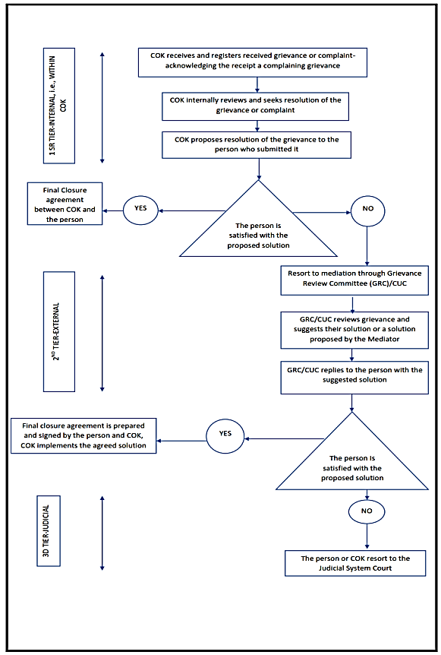
Figure ‎10-1: Grievance Redress Mechanism (GRM)

IMPLEMENTATION OF ACTIVITIES AND RESPONSIBILITIES

Introduction
This chapter presents the different activities necessary for RAP implementation and the institutions or stakeholders responsible for the activities. It details the sequence of the activities and the link between them as well as the responsible parties.

Implementation activities
The following table shows the sequence of the land acquisition/easement and resettlement tasks that need to be carried out and responsibilities assigned to each task.
Table ‎11-1: Impending Activities and responsibilities

Task | Responsibility
Approval of the RAP | CoK
Payment of PAPs | CoK
Relocation | CoK
Monitoring RAP Implementation | CoK

Resettlement Capacity at CoK

Current staffing capacity
The project has so far 7 staff on board under the Kigali Urban Upgrading Team (KUUT) that will collaboratively implement the RAP: Project Coordinator, Project Engineer, Social Safeguards Specialist, Environmental Specialist, M&E Specialist, Financial Management Specialist and Procurement Specialist.

Proposed Resettlement implementation team
Since CoK is the procuring entity and the district is part of it, the CoK City council chairperson will be the highest decision maker on all resettlement actions. It will take control of all the activities done by the various entities and more so in the relations to the prevailing Laws, rules and regulations.
DEA of the District, Representative of District One stop centre, RUDP Project Coordinator, Sector Executive Secretaries, Cell Executive Secretaries and CUC/GRC Presidents will compose the Resettlement Committee.

Resettlement Implementation Plan
This is the timeframe in which specific activities will have to be done. It indicates the tentative duration for each activity as well as the responsible of focal point person.

RAP Activity timelines
The table below details the activities and the roles to be played by the respective stakeholders in and the proposed timelines.
Table ‎11-2: RAP Activities and timelines
Activity | Operations | Duration | Responsibility
Mobilization | - Conducting community sensitization meeting based at cell level  - Conducting meetings with Sector cell and village leaders  - Establishing operation and RAP contact offices based at the settlement. | 1 week | The Resettlement Committee and CUC members
Formation of GRCs | - Conducting meeting with all the PAPs at cell level  - Guide the election of GRC members  - Taking minutes of the meeting  - Guide the GRC on their roles and responsibilities. | 1 week | The Resettlement Committee and CUC members
Confirmation of Property and Value | - Setting out of the boundary lines of the infrastructure upon confirmation of which roads are to be constructed  - Review of the Inventory of the property of the PAPs within the boundary line  - Seeking consent of the PAP on the value of the property by signature | 2 months | The Resettlement Committee and CUC members, Constructor and Valuer
Presentation of Valuation forms for Signatures | - Ensure that each PAP has signed the valuation form (to work on at least 30 PAPs per day)  - Ensure that each PAP has presented the required documents  - Ensure that all the respective local Authorities have signed on the Valuation forms  - Hand the signed Valuation form to CoK for onward processes  - Reporting the challenges encountered and proposals for way forward  - Making weekly progress report on Valuation exercise | 2 months | Valuer
Financial Literacy awareness and sensitization | - Inform the PAPs when they will receive the compensation  - Guide them through elementary book keeping since some may opt to start small businesses  - Guide them how to use bank accounts and SACCOs  - Guide them on issues of Family Finance and Gender | 1 week | CoK will form a Financial literacy team amongst them
Payment of the PAPs’ compensation | - Making payments to the PAPs respective Accounts  - Reporting on the progress of the payments  - Collection of the Land titles from the PAPs upon payments | 2 months
Vacation/demolishing of the building | - PAP to salvage the property after recovering payment  - Removal of all untaken items/debris from the site | Minimum 4 months counting from the first PAP will be paid. | PAPs/ CoK/ Contractor
Monitoring of the Resettlement process | - Recording number of PAPs that have been paid and submitted land titles  - Recording number of PAPs with issues  - Recording number of PAPs that have vacated the site  - Recording the feedback reports from the Compensated PAPs on their livelihood  - Production of quarterly Resettlement progress reports | 26 months | CoK Resettlement team
Resettlement Completion Report | To be Produced at the end of the Resettlement process when all the PAPs have been paid, Vacated the project area and fully resettled. | 1 month | CoK Resettlement team

RAP Implementation Schedule
This is the schedule which indicates how the activities mentioned in table 11-1 are interlinking to each other. The scheduled indicates that the activities will take approximately 6 months in case there are no unforeseen delays. It has been presented in a bar chart form with indicative duration for each activity as indicated in figure 11-1 below

Figure ‎11-1: RAP Implementation schedule
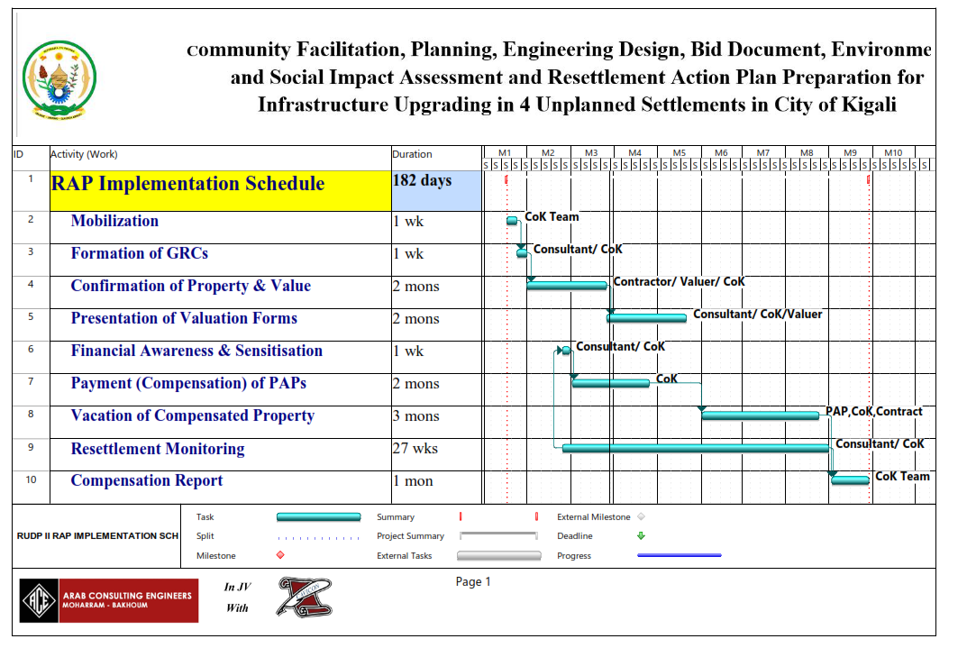

Figure ‎11-2: RAP Implementation Organisation Structure

RAP Implementation Completion Report
This is the report which will be produced when the PAPs have fully been compensated and fully resettled. It will indicate the number of PAPs that have been compensated. The various challenges encountered during the implementation, their causes and how they overcome them.
It will also indicate the amount which has been spent from the Client and the comparison between what was planned and what has been consumed. It will also include livelihood restoration measures and how they were or are being implemented.
The report will also contain feedback information from the resettled PAPs and their respective experiences and livelihood.
Lessons learnt will also be highlighted as well as recommendations for future RAP activities will also be detailed under this report.

MONITORING AND EVALUATION

Overview
Monitoring is the measurement through time that indicates the movement toward the objective or away from it. Monitoring provides the raw data to quantify the progress. Evaluation is putting this data to use, thus giving it value. Evaluation is where the learning occurs, questions are answered, recommendations are made, and improvements are suggested. Without monitoring, evaluation would have no raw material to work with. Monitoring and Evaluation are typically divided into three components, defined as Input monitoring, Output monitoring and Outcome evaluation. The consultant has been given the task of monitoring the implementation of the RAP.

Input Monitoring
Input (or progress) monitoring measures whether inputs are delivered on schedule and as defined in the Land Acquisition and Compensation Framework or Plan. The measured inputs are the services, resources or goods that contribute to achieving outputs and, ultimately, desired outcomes. Input monitoring is done internally on an on-going basis, often as part of the project general management system or quality assurance system.

Outputs Monitoring
Output (or performance) monitoring looks at the direct measurable results of the inputs, for example the number of people who have received compensation. Input and output monitoring together keep track of project implementation efficiency and indicate whether changes need to be made to make the program implementation more efficient. Output monitoring is done internally.

Outcome Evaluation
Outcome (or impact) Evaluation - this activity defines the extent to which the project inputs and outputs are likely to achieve the objectives of the land acquisition and resettlement program. Examples of these outcomes can include, for example the effectiveness of livelihood restoration. Outcome evaluation, together with the output monitoring results, indicate whether the program is genuinely working and should continue to be implemented as it is, or whether fundamental changes have to be made. Outcome evaluation is usually carried out by an external independent group.
Outcome evaluation typically uses a wide variety of indicators. For example, most people feel reluctant to reveal the true amount of their income. Therefore, some indirect indicators can be used to assess if the project affected people are improving their livelihoods and standard of living. Such indicators can include school attendance, or the purchase of certain items such as vehicles or household appliances.

Input and Output Monitoring
The CoK could use the key performance indicators (KPIs) during monitoring of its land acquisition, resettlement and compensation activities presented in below tables as adapted from the RPF.

KPIs for Land Acquisition and Resettlement Process
Table ‎12-1: KPIs for land acquisition and resettlement process
Indicator | Source of Information | Frequency
INPUT INDICATORS
Overall spending | Financial records | Quarterly
Distribution of spending by:  Cash compensation  Rehabilitation - livelihood restoration  Consultation and engagement Vulnerable people  General implementation services & overhead. | Financial records | Quarterly
Financial Literacy | Meeting awareness report | Once before making the payments to PAPs
KUUT staff dedicated to land acquisition & resettlement implementation, and distribution by skill type | RUDP Project Coordinator | Quarterly
Number of PAPs by categories (consistent with categories in the entitlement matrix) | Census and asset inventory survey (continuous checks) | Quarterly
OUTPUT INDICATORS
Number of people who received cash compensation in the period indicated, by compensation type | Data management system | Monthly
Number of individual compensation agreements signed in the period  (i.e., successful negotiations and as such “willing seller-willing buyer”  – which will reduce the number of resettlement cases | Data management system | Monthly

KPIs for monitoring Output of Grievance and Compensation Process
Table ‎12-2: KPIs for monitoring output
Indicator / Issue | Measured THROUGH | Frequency
GRIEVANCES
Average time to process and close a grievance | Measure time interval between grievance registration and closure and time between grievance registration and first acknowledgement of receipt | Quarterly
Number of open grievances over time | Data Management System /Excel format | Quarterly
Number of grievances opened in each quarter and over time | Data Management System /Excel format | Quarterly
Number of grievances closed in each quarter and over time | Data Management System /Excel format | Quarterly
COMPENSATION
Average time for payment of compensation | Measure time between compensation agreement and payment | Quarterly
Number of PAPs paid compensation at full replacement cost?  Is compensation updated to take account of increases in property value? | To establish through interviews the results of property market survey for similar properties with compensation paid.  Investigate whether PAPs were able to purchase a similar property. | Once a year
LIVELIHOOD RESTORATION
Proportion of business activities rehabilitated | To establish through interviews: Have affected businesses been successfully re-established? | Once a year
Proportion of employees being employed after business relocation | To establish through interviews: Are employees still employed after relocation? If not, why not? | Once a year
Jobs and employability | To establish through interviews: Are affected salaried employees still employed in their “old” jobs? | Once a year
Income | To establish through interviews: Are incomes restored? | Once a year and at Completion Audit

Compliance Monitoring and Completion Audit

Compliance Monitoring
CoK will arrange services of an external compliance auditor to check whether the implementation of the programme complies with this framework and international requirements. The scope of work of the compliance auditor will include the following tasks.
The general tasks related to assessing the overall compliance with the RAP and the ESF. This includes Interviewing some affected households and businesses to measure the extent to which project-affected people's standards of living and livelihood are being restored or enhanced, and to gather their opinions on compensation delivery, resettlement and grievance management.
The compensation process shall be reviewed whether entitlements have been delivered in time and, if not, whether delays are justifiable. In addition, it shall be assessed whether compensation is done at replacement cost.
In addition, the assessment will be to establish whether the quality of life and livelihoods of affected households are restored. This includes a review of any livelihood restoration / rehabilitation programmes and the extent to which they are assisting in providing alternative livelihoods for affected households to help offset the impacts of displacement

Monitoring & Evaluation
Monitoring and evaluation will include a review of internal monitoring and reporting procedures to ascertain whether these are being undertaken in conformance with this RAP; and a review of internal monitoring records as a basis for identifying any potential areas of non-compliance, any recurrent problems, or potentially disadvantaged groups or households
The grievance records shall be reviewed for evidence of significant non-compliance or recurrent poor performance in resettlement implementation or grievance management. The vulnerable people screening, and assistance systems shall be assessed, including related records, and performance to determine compliance with this RAP.
Assessment of the implementation includes:
- Assess whether resources are adequate for implementing commitments in this framework and any training or capacity building requirements.
- Assess the data management system and its outcomes.
- Compare actual progress with initial schedule.
Compliance monitoring will take place twice a year during the active phase of land acquisition and resettlement. The External auditor/WB technical Assistant employed by CoK, will dedicate approximately 5 days to each of these missions, with most of this time dedicated to field visits, including interviews with key informants and affected people. Each of the auditor’s missions will result in a report prepared independently for CoK and the World Bank. The auditor will be selected amongst companies where their individual specialists have significant international experience in resettlement.

Completion Audit
CoK will organize for a completion audit carried out by an external auditor (potentially the same as that involved in the compliance monitoring). The overall goal of the completion audit is to verify that this RAP has been implemented effectively and assisted CoK in restoring project affected peoples’ standards of living and livelihoods.
The completion audit has the following objectives:
- Verify that all entitlements and commitments described in the RAP have been delivered;
- Determine whether RAP measures have been effective in restoring or enhancing affected peoples’ living standards and livelihood;
- Check on any systemic grievances that may have been left outstanding;
- Identify any corrective actions necessary to achieve completion of the RAP commitments.
The Completion Audit will focus on livelihood restoration of project affected people. Methods to assess whether livelihoods are restored will be carefully designed. They will mainly include quantitative surveys, resulting in a comparison with the baseline data. This should be done over a statistically significant sample of affected households chosen from all components of the Project.
The Completion Audit could be undertaken by the same consultant who will carry out Compliance Monitoring. The Completion Audit is typically carried out 1.5-2 years after the active phase of land acquisition and resettlement is complete.

BUDGET
This chapter provides the estimated compensations budgets for the different project components. This is based on the valuation reports and the anticipated RAP activities as designed.
Table ‎13-1: Estimated Land Acquisition and Resettlement Budget
# | Item | Cost RWF | Cost USD
A | Compensation
A1 | Property (Land + House +Crops+other structures) for Roads and Other related Infrastructures | 3,382,852,287 | 3,382,852
 | Sub-Total A: Compensation | 3,382,852,287 | 3,382,852
B | Implementation
B1 | Operational cost of the Resettlement Implementation Unit (6 months x 4 people @ 300,000 RWF); These are allowances and logistical support attributed to the proposed staff for the day-to-day operations. They are exclusive of the monthly salary since it is already being catered for by the CoK. | 7,300,000 | 7,300
B2 | Legal support (estim.): This could be in case there are PAPs that have opted to go to courts of Law | 10,000,000 | 10,000
B3 | Independent Monitoring and technical support Agency: It may be required that the Funder asks CoK to employ an independent consultant to assess the progress of the RAP implementation and give guidance were need may be. | 20,000,000 | 20,000
B4 | Financial Literacy awareness: The cost includes facilitation of the PAHs in the meetings since the number is quite big and they may be taught in sessions at least 2 sessions | 5,000,000 | 5,000
B5 | RAP implementation: This cost may include employment of a Valuer who will work with CoK team to have the Valuation forms signed. It will include costs for land transfers and sub divisions | 160,000,000 | 160,000
 | Sub-Total B: Implementation | 202,300,000 | 202,300
 | Total | 3,585,152,287 | 3,585,152
 | Allowable Variation 20% | 717,030,457 | 717,030
 | GRAND TOTAL | 4,302,182,744 | 4,302,183

1 USD=Rwf 1000 Source (BNR USD Exchange rate as of 2nd August 2021)

REFERENCES
- Condominium Law, 2010
- EICV6 2019/2020
- Expropriation Law, 2015
- Final Report on Environmental –Social-Safety and Health Safeguards for Agatare Project (2021)
- Geoinfoafricaltd. (2017). Feasibility And Technical Study Of Upgrading Informal Settlements In Gatenga Sector. Kigali: Kicukiro District of Kigali City, Republic Of Rwanda.
- JV ACE & CAVICON CONSULTANTS LTD. 2021. Final Design Report for Community Facilitation, Planning, Engineering Design for Infrastructure Upgrading in Gatenga Unplanned Settlement in Kicukiro Distrct, City of Kigali.
- Kigali City Master Plan 2013
- Kigali City Masterplan 2050
- Ministerial Order Determining Dispute Resolution Process Related to Land Issues, And
- Ministerial Order No. 001/2006 of 26/09/2006 Stipulating the Structure of Land Registers and The Responsibilities of The District Land Bureau, And
- National Housing Policy, 2015
- National Informal Settlement Upgrading Strategies and Guidelines, 2015
- National Land Use Guidelines, 2017
- National Strategy for Transformation 2017-2024
- National Urbanization Policy, 2015
- Organic Land Law No. 43/2013 Of 16/06/2013 Governing the Main Land Legislation in Rwanda as Mentioned in The Official Gazette, Special Edition From 16/06/2013, Which Determines the Procedure for Use and Management of Land in Rwanda;
- Organic Law N° 32/2015 of 11/06/2015 Relating to Expropriation in The Public Interest (Also Known as the “Old” Law No 18/2007 Of 19/4/2007 On Expropriation)
- Presidential Order No. 54/01 of 12/10/2006 Stipulating the Structure and The Responsibilities of Land Commissions
- Property Valuation Law No. 17/2010 Which Defines Property Valuation in Rwanda;
- RUDP II, Resettlement Policy Framework (RPF), May 2021
- RUDP II, Stakeholder Engagement Plan (SEP), May 2021
- Rwanda 7 Years Government Programme: National Strategy for Transformation (NST 1), 2017 – 2024;
- The Guidelines on Unit Prices of 2018 Provided By IRPV
- The National Land Policy Ensures Equal Rights to Land Use for All Rwandan Citizens (Politique Nationale Foncière 2004);
- The Rwandan Constitution (Ratified In 2003 as Amended In 2015);
- The Urban Planning Codes, 2015
- The Vision 2050
- The World Bank Environment and Social Framework
- The World Bank’s Environment and Social Framework (ESF)

APPENDICES

Appendix 1: Pictures of Stakeholder Engagements

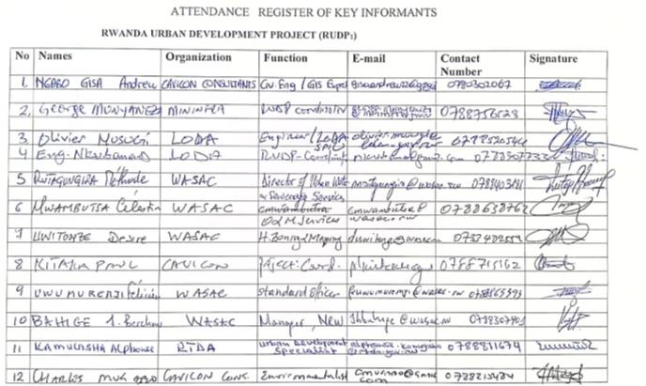
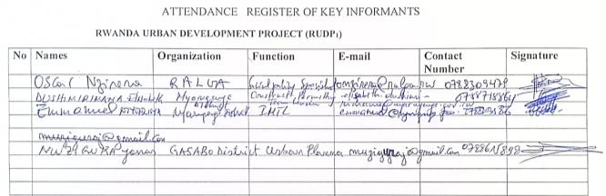
Figure ‎0-1: some of the sensitization meeting with CUC members in Gatenga
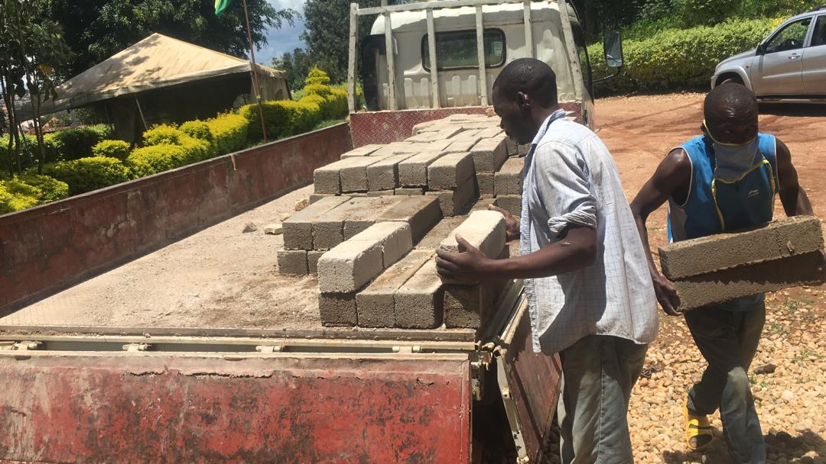
Figure ‎0-2: Community members engaged in project activities for pay
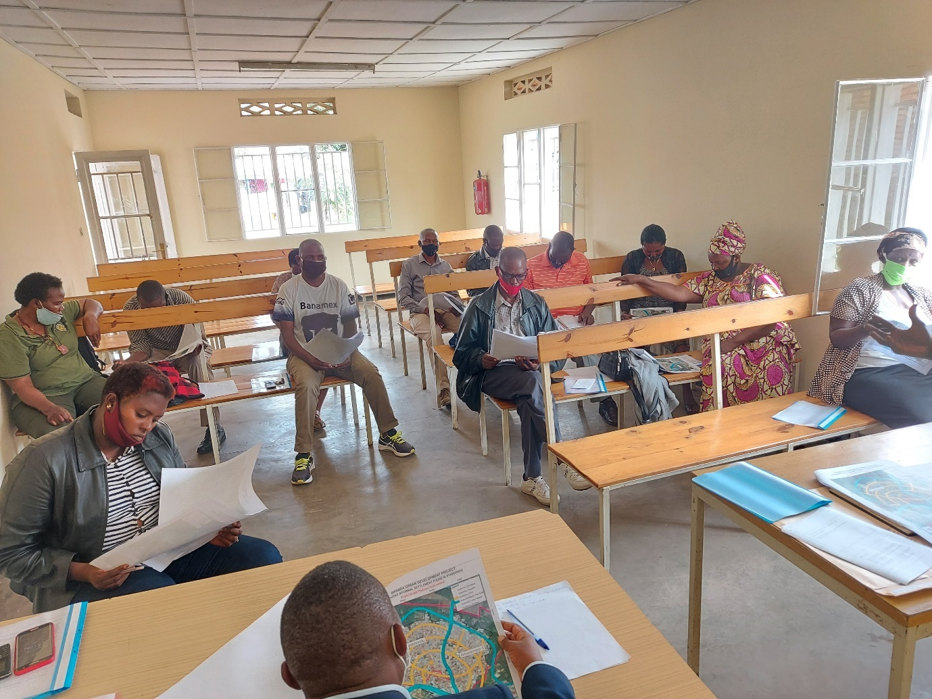
Figure ‎0-3: Meeting with CUC members on Consultations of Project outputs

Appendix 2: Research Tools

Appendix 2a: Data Inventory Form

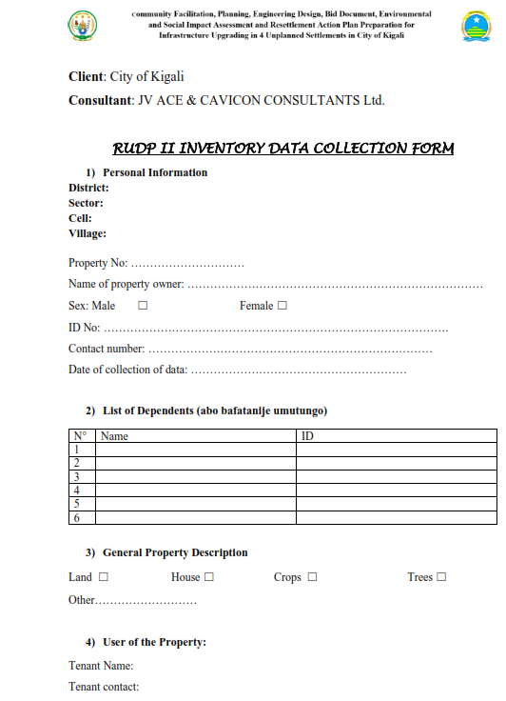
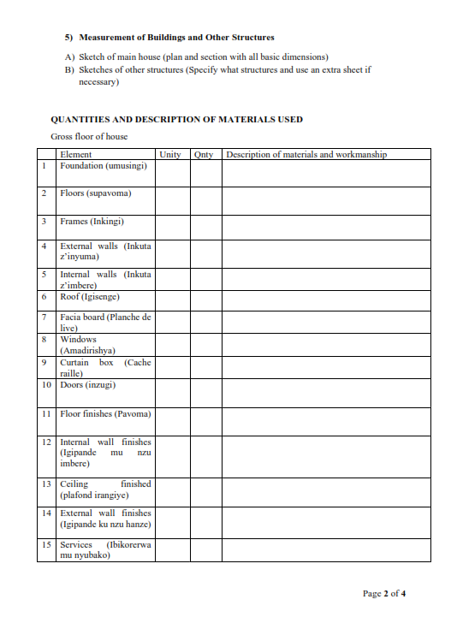
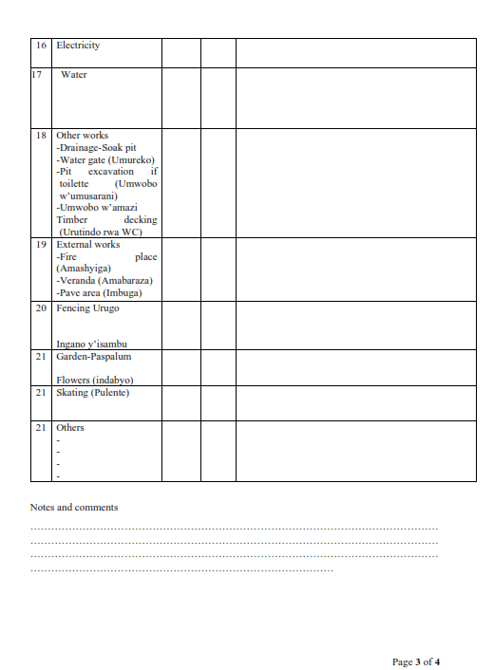
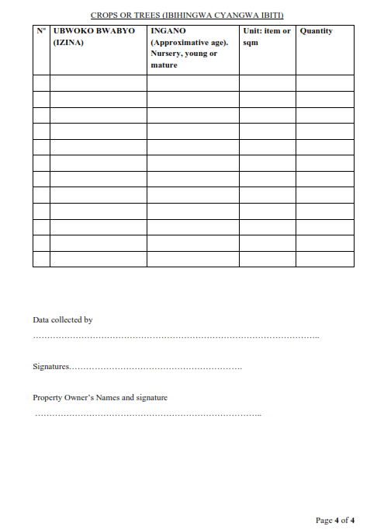

Appendix 2b Property Valuation Form

Appendix 2b (i) House
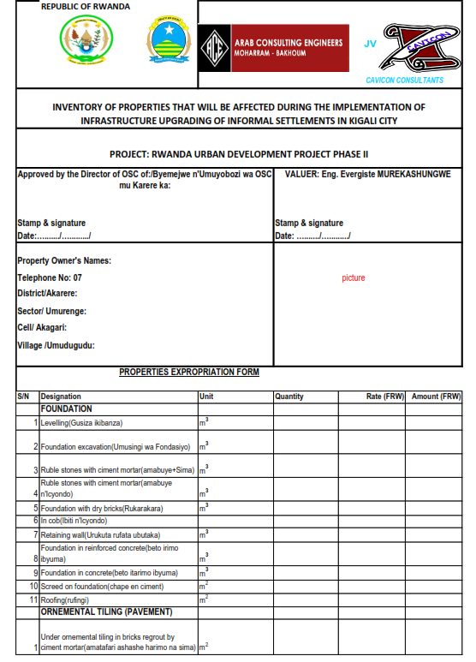
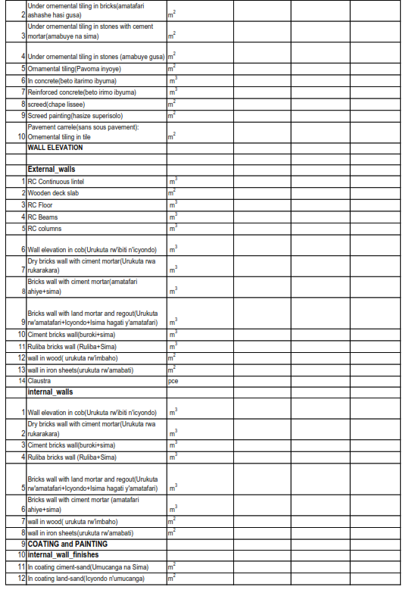
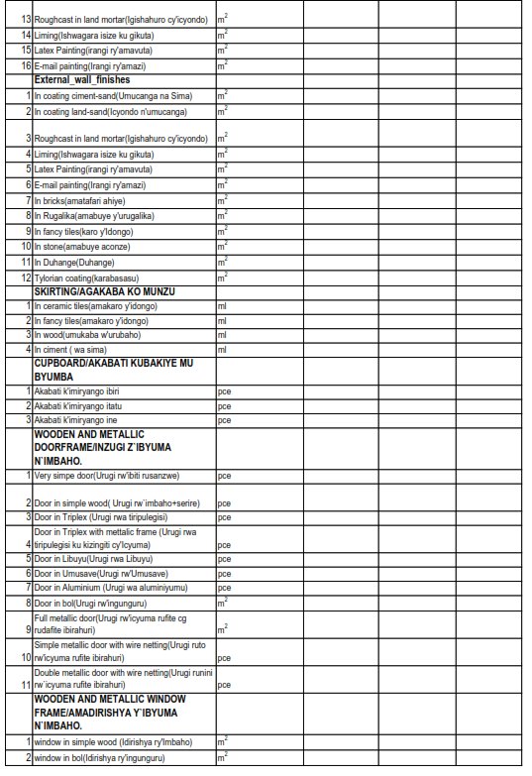
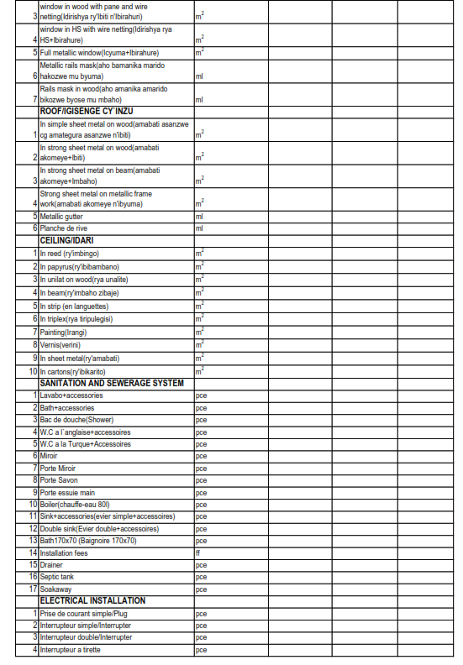
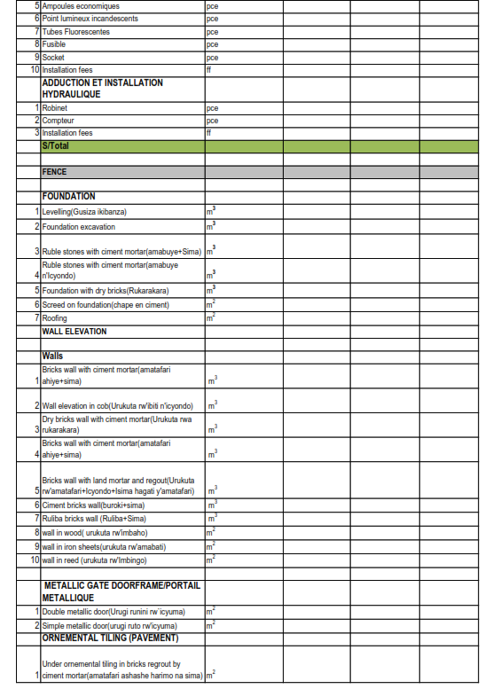
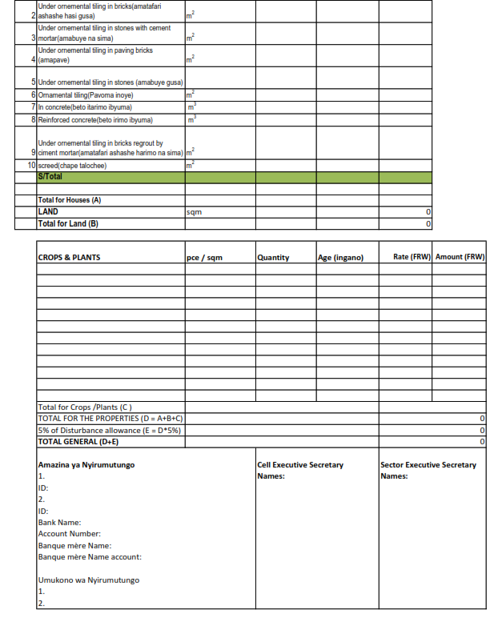

Appendix 2b (ii) Crops
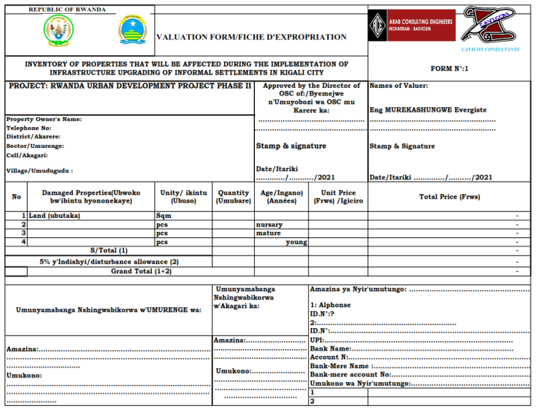

Appendix 2c: Questionnaire for Socio-economic survey

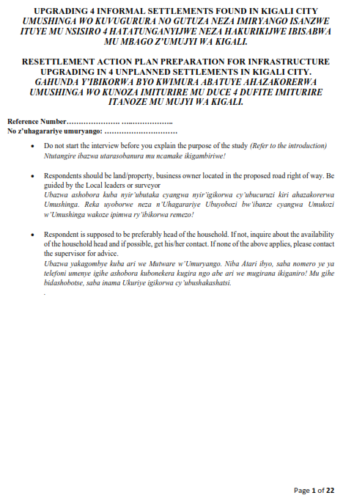
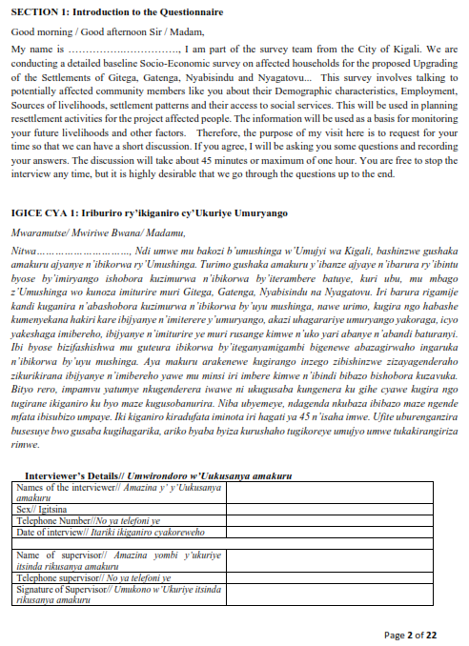
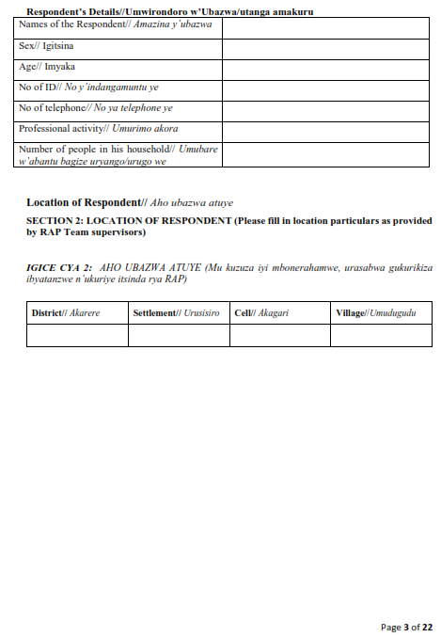
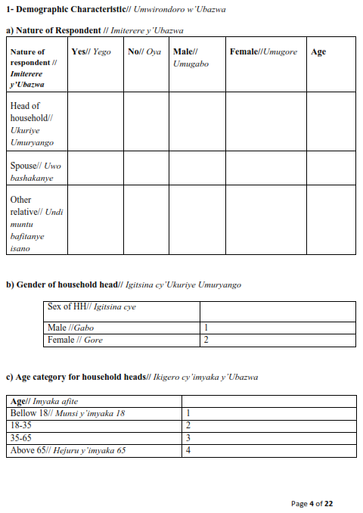
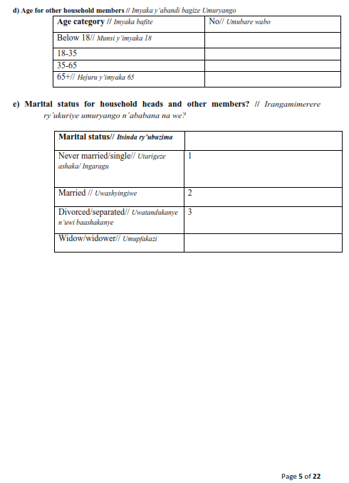
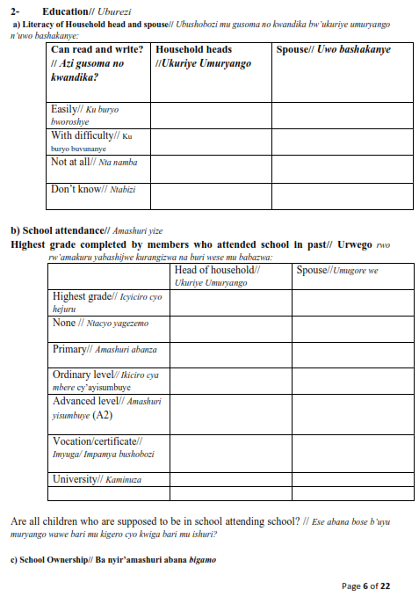
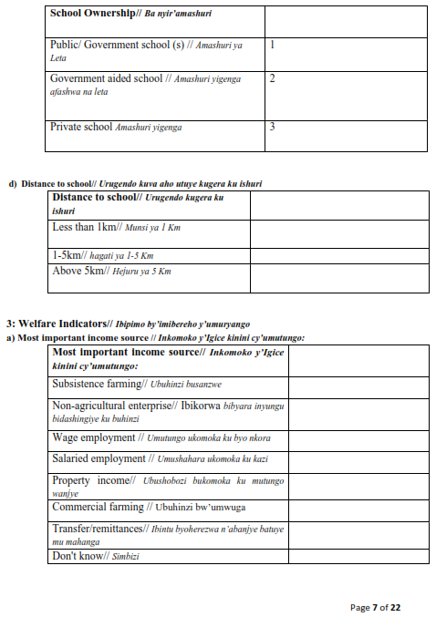
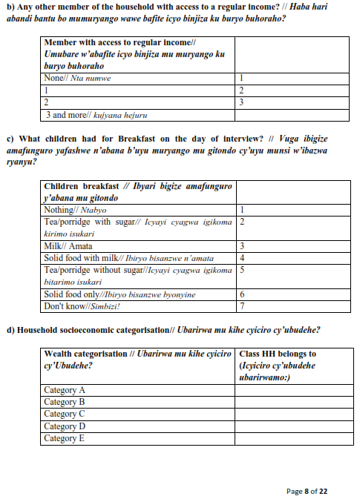
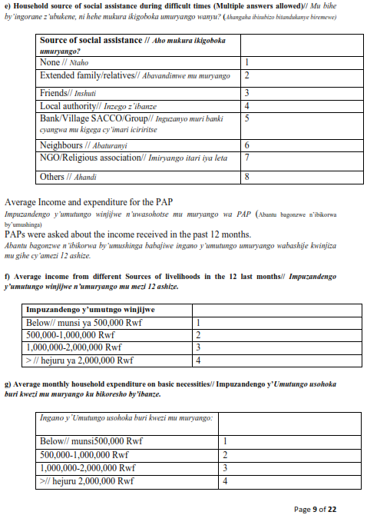
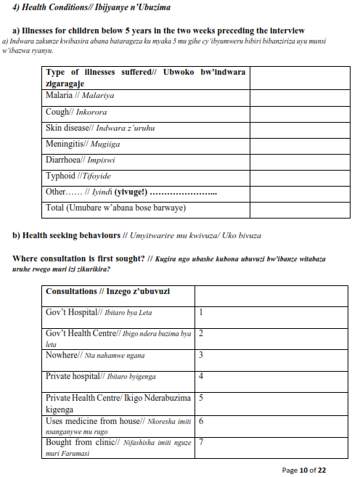
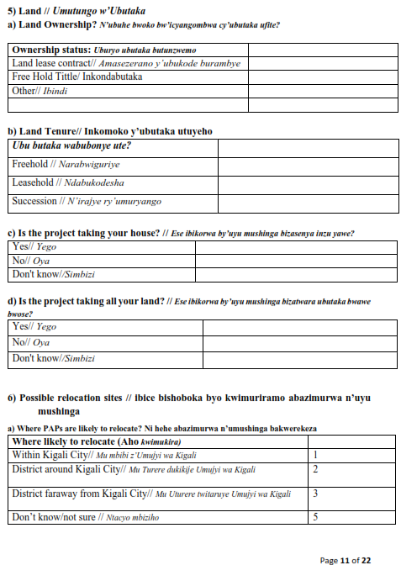
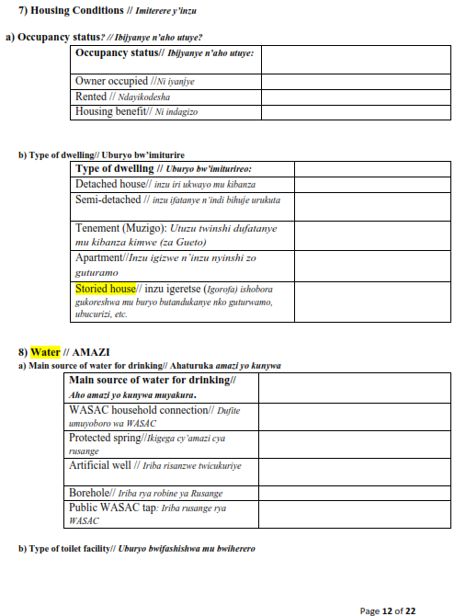
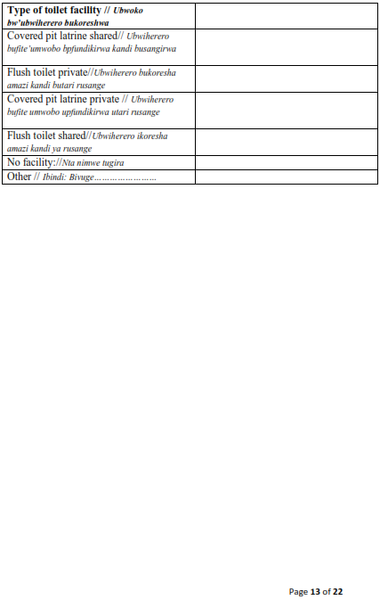
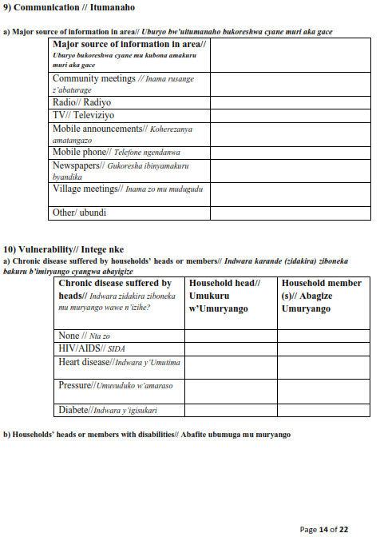
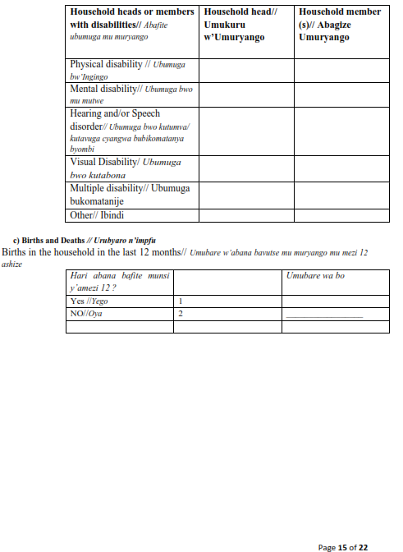
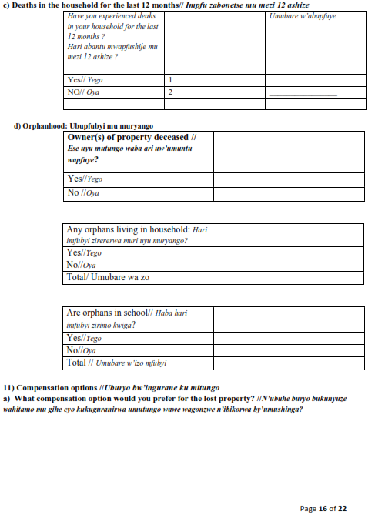
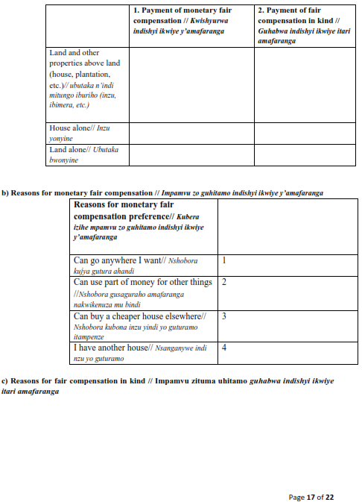
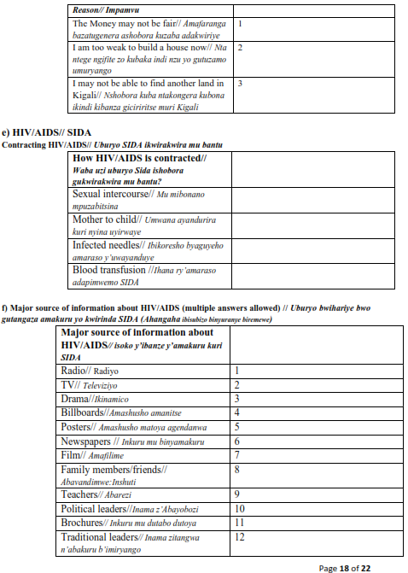
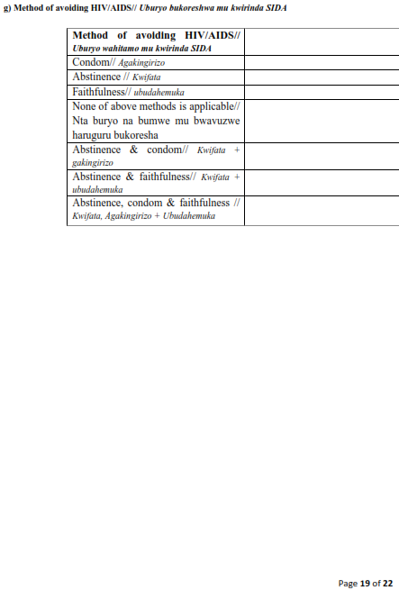
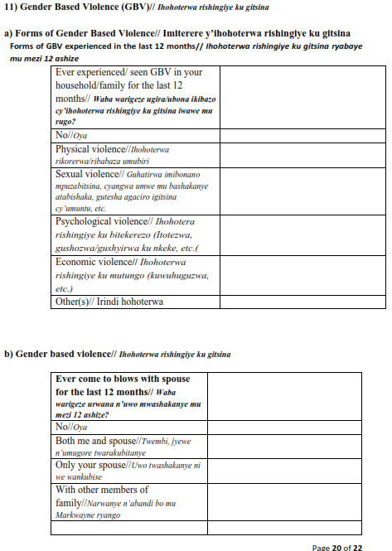
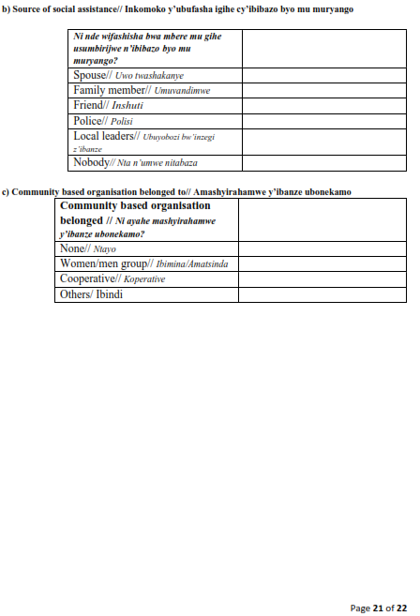
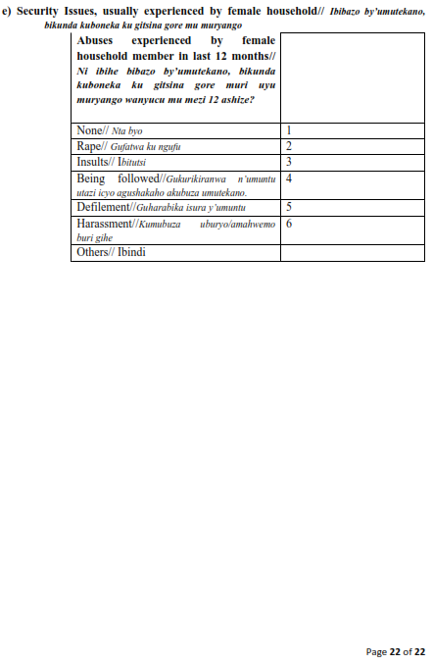

Appendix 3: Valuation Report
- Introduction
Affected properties (land, houses/structures, trees/crops), were assessed for compensation at the prevailing market prices as per expropriation law N0 32/2015 of the 6th November 2015.
The reference prices established by the Institute of Real Property Values (IRPV), for Land, Constructions and Crops, and published in Official Gazette N0 Special of 08/11/2018 served as the base of the compensation computation for this activity.
In order to assist the PAPs to relocate, the Rwandan expropriation provides for 5% of the total assessed value as disturbance allowance. This disturbance allowance also has been taken into consideration for the current assignment.

- Survey and assets inventory

  - Introduction
Article 17 stipulates that a person to be expropriated should be informed about the beginning of the land surveys and asset inventory. Land survey and inventory should be carried out in presence of the affected party or his/her representatives, as well the representatives of the local administrative bodies.
According to Article 21 of the Expropriation Law, the properties to be valued for just compensation include land and other assets on the land including different crops, forests, any buildings or any other activity that was carried out to improve the land’s productivity (irrigation systems, etc.). The value of land and other assets that belong to the persons, whose assets are being expropriated, shall be calculated considering their size, nature and location and based on the prevailing market prices.
The Expropriation Law also requires that local residents should be provided with information about the importance of the project and information on why land acquisition and expropriation are required.
Meaningful sensitization has been done before the valuation process through the community meetings and to individual households during the valuation exercise.

  - Land Survey
Basing on the existing Detailed Study Designs, the Consultant’s Surveyor in consultation with the CoK team established the demarcations the project boundaries. This was done before valuation assessments of the land, crops/trees, buildings/structures and other properties to be affected by the construction works. After the entire project boundaries were established, beacons were planted at a reasonable distance between each other for future reference.
The demarcating of the land boundaries for the affected houses and land helped to show ownership of property and to calculate the extent of land acquisition. The surveyor worked closely with the affected persons, neighbours and local leaders during the survey for purposes of transparency and confirming land boundaries and ownership of the affected property. The affected persons at the project boundary whose land was partially affected, there a consideration to expropriate/compensate the entire land if the remaining portion was assumed to be smaller than 300m2 which cannot acquire a new land title.
For the land, which is falling completely within the project area, the owners will submit land titles for compensation and immediately they will be paid. For those who have bought portions from registered land, and they have not yet done subdivisions to acquire the land titles; the team picked the boundary coordinates to assist the valuer in the land value computation as the PAP was advised to proceed with the process of land title acquisition.
The surveyor prepared the strip map showing the project area and respective affected properties/plots and the size of the affected land accompanied by a list of affected land/property owners.

- Valuation process on different properties
  - Valuation Data Collection
The Valuation Team begun by planting beacons and referencing of the affected buildings/houses by their UPI numbers, as well as plotting boundary fences in the project area. Detailed data regarding the quantity, nature and quality of the assets was then captured. The affected assets included but not limited to; land, buildings, fences, pavements, crops and trees.
The data for each affected asset was captured on a valuation data collection form that was signed by the Valuation Team and the registered PAP or their representative to confirm the count of crops/trees and buildings/structures assessed.
  - Land Valuation
Land values in the City of Kigali are not the same and would therefore not be prorated with a standard cost per unit of measure (in this context cost per m2).
Market values for land parcels earmarked to be expropriated were determined with reference to the land reference prices established by the Institute of Real Property Valuers in Rwanda (IRPV) as it was published in the official gazette of November 2018. The land reference prices are village based, where available and cell based. In the above said document, some villages and cells are missing and therefore, the prices in those entities cannot be obtained from the gazette. For that particular case, the valuer has established similarities with the neighboring entities and has used the values of the similar entities.

  - Buildings /structures
Structure replacement cost approach was employed to determine the market value of the buildings and other structures. The method gives a way of valuation by considering quantities of work versus costs. This is done by multiplying the quantity of construction materials by the unit cost and taking the amount back to the measurement unit.
Measurement of structures/buildings (where applicable) on each plot was taken by use of tape measure. The replacement value of the permanent buildings was determined based on current construction rates per square meter/cubic meter. The construction rates based on the current market prices were established by the Institute of Real Property Valuers in Rwanda (IRPV). These market prices were determined based on the following main factors:
- Type and quality of materials used
- Workmanship and design of buildings
- Location of building in relation to sources of materials and labour cost
- Terrain of the building site and the possible amount of levelling involved.
Ill-fated structures were not uniformly affected (some are partially affected whereas others are wholly affected, or residual structures are not viable). From the foregoing, each affected structure was individually assessed, and replacement cost determined for either rebuilding a new structure of equal or better standard.

  - Crops, Plants and Trees
The type of plants (crops, trees, grass,.) to be affected by the project, their age, usefulness and quantities were recorded since they will be compensated. Their market values were ascertained from the official gazette establishing the land and property incorporated thereon reference prices as prepared by the Institute of Real Property Valuers in Rwanda (IRPV). Crops/Trees’ values were adjusted for age, condition, and description.
For plants that reference prices are not available within the published gazette, the market survey has been conducted to determine their market prices according to their different stage of growth.

  - Valuation Analysis, Computation and Report Preparation
Analysis of valuation data collected was properly done including calculation of quantities using international recognized units of measurements as well as applying the appropriate prevailing market rates to each of the affected item. In addition, there was a disturbance allowance of 5% of the total value of expropriated property to be added to make it a fair compensation. A valuation for compensation report was prepared in an agreed form and submitted to the expropriator/client (COK) for approval.

- Identified Impacts
- Partial loss of land but residual is viable economically enough
- Entire loss of land or partial loss where residual is not viable
- Partial affected structures where residual structures are viable for the owner
- Fully affected / partially affected and remaining structure is non-viable
- Trees and crops, non-food trees, shrubs / permanent grass

- Compensation computation according to the impacts incurred by the property

S/N | Category of Impacts on Property as by the projected activity | Methodology used to come out with the compensation value
1 | The whole plot is affected and there is no structure present on that land | Valuation was carried out on the entire land and on any other existing assets incorporated thereon such as plants.
2 | The plot is partially affected, there is no structure present on that land and the residual land is not viable enough | Valuation was carried out on the entire land and on any other existing assets incorporated thereon such as plants.
3 | The plot is partially affected and only the external improvements such as fence, access way and plants are affected. The residual land is viable enough | Valuation was carried out on the affected portion of land and on those affected improvements
4 | There is a structure which is partially affected in plot partially affected, the residual land is viable enough, but the residual house is not viable | Valuation was carried out on the affected portion of land and on the entire affected structure and on other assets incorporated on that portion of the affected land.
5 | There is a structure which is partially affected in plot partially affected, the residual land is viable enough and the residual house is viable | Valuation was carried out on the affected portion of land and on the elements of the affected structure and on other assets incorporated on that portion of the affected land.
6 | The whole plot is affected and there is a structure within the right of way of the projected road | The PAPS must move. The valuation was carried out on the entire land and all of the assets incorporated thereon (including houses, external layout and plants).

- Challenges Encountered During the Assignment.

S/N | Challenges | Way to overcome challenges
1 | PAPs did not avail themselves for the property valuation purpose | In collaboration with CUCs and local authorities, basic identification of the PAP has been found
2 | Resistance of some PAPs to give valuers access on their properties | CUCs and local authorities have facilitated by convincing those Persons with the interest of the valuation exercise
3 | PAPs without proof of ownership | Valuation was done and the PAPs have been urged to settle the issues that made them not having the land ownership documents so that it will become easy for them during the compensation payment

- Summary of the outcome of the Valuation process
After the calculation of the just compensation for every PAP, the outcome has been filled in the expropriation form. The set of expropriation forms has been arranged in folders according to the village and submitted to the client for verification and approval. A table has been elaborated summarizing the outcome of the valuation exercise. In the table we show the identification of the PAP (Names, ID number, Gender, Contact), the parcel number, the size of the affected land, the type of the affected property, the location of the property (district, sector, cell, village and street) and the compensation amount.
The List of affected PAPs, their properties and compensation amount is presented in the appendix of this report

- Conclusion
The valuation activities have been successfully conducted according to the law, policies and the standards. The expected results have been achieved. Potential PAPs have been identified and their respective properties valued, and the just compensation determined. Expropriation forms have been filled and submitted to the client for approval waiting to be signed by the certified valuer, property owner, and local authorities before payment of the compensation fees.

- Certification
This valuation report has been prepared according to the terms of references given in RFP by the client, to serve the purpose it may be required for, by Eng Evergiste MUREKASHUNGE as a Certified Real Property Valuer.




Eng Evergiste MUREKASHUNGWE
Certified Real Property Valuer

References:
- Organic Law N° 32/2015 of 11/06/2015 relating to expropriation in the public interest.
- Law N⁰ 17/2010 of 12/05/2010 establishing and organizing the real property valuation profession in Rwanda.
- Official Gazette N⁰ Special of 08/11/2018 establishing the Reference Prices of Lands and Property incorporated thereon in Rwanda as prepared by the Institute of Real Property Valuers in Rwanda (IRPV).
- MININFRA, 2016. Resettlement Policy Framework (Development of Urban Infrastructure in six Secondary Cities of Rubavu, Rusizi, Musanze, Muhanga, Huye and Nyagatare of Rwanda, and the City of Kigali)

Appendix 4: RAP Terms of References

1.1 RESETTLEMENT ACTION PLAN (RAP) for each of the 4 sites
The aim of the RAP is to identify and assess the human impact of the planned infrastructure projects under RUDP II interventions in the City of Kigali 4 unplanned settlement sites. Then after, prepare an Action Plan to be implemented in coordination with the civil works in line with World Bank Environmental and Social Framework (ESF), the RPF and Government of Rwanda policies and laws.
- Define entitlement matrix for eligibility for compensation based on the RPF entitlement matrix provided.
- The Resettlement Action Plan will identify the project affected persons (PAPs), determine the extent of displacement impact associated with construction of the roads, drainages, footpath, public spaces, mini-market solid waste collection point and any other intervention under the project, conduct a valuation of their assets to be expropriated. In addition, carry out their socio-economic baseline surveys and engage them in participatory discussions regarding the plan and formulating a plan of action to adequately compensate people for their losses.
- To identify the project affected persons (PAPs) and type of assets they own
- To present a social-economic basis of project affected persons (PAPs) for which identification of entitlements and livelihood restoration strategies for minimizing the impacts on the PAPs so as to improve their livelihoods and standards of living or at least to restore them in a pre – displacement levels
- To carry out consultations with relevant stakeholders including potentially affected persons to obtain their views and suggestions regarding the social impacts of the project and agree on the measures to cover the losses.
- To set the parameters and establish entitlements for project affected people, describe the institutional framework, mechanism for consultation and grievance resolution, the time schedule and the budget and propose a monitoring and reporting system.
- Carry out the valuation of affected properties by the project interventions in consultation with the local leaders as per the law Governing Expropriation in Rwanda, the World ESS 5 and inform the respective owners the process of valuation and their reserved rights during the valuation process.
- Identify gaps between World Bank guidelines/policies/laws and the laws of the Government of Rwanda on matters addressing issues of involuntary displacement and suggest how the gaps have been addressed to meet international best practices guided by the RPF for this project
1.1.1 Scope of work for RAP
The consultant is required to develop Resettlement Action Plans for each one of the four sites unplanned settlements sites under the City of Kigali in RUDP II (Gatenga, Mpazi, Nyabisindu and Nyagatovu). The scope of work of the consultant includes but is not limited to the following:
a) Review safeguard documents developed and applied by International Financial Institutions (IFIs) financed projects in Rwanda and more specifically ESF documents developed for RUDP II namely the Resettlement Policy Framework, the Environmental and Social Management Framework, the Stakeholders Engagement Plan, the Labor Management Procedures and the project Environmental and Social Commitment Plan, as well as the experiences and lessons learnt while executing social safeguards activities of the RUDP I;
b) Study country framework assessments that may have recorded the involuntary resettlement experiences of road /transport/ Urbanization sector projects;
c) Collect and review national laws and regulations and WB’s Environmental and Social Framework (ESF) paying a particular attention to ESS5 (land Acquisition, restrictions on land Use and involuntary resettlement) and other provisions governing the preparation and implementation of Resettlement Action Plans (RAPs) for WB financed projects, to assess their applicability to the project, and related requirements. These shall also include other social issues especially those related to cultural heritage (ESS8 and Community-Health-and-Safety (EHS) aspects of the affected population, labor management etc. and shall identify and detail the gaps and suggest measures to address them;
d) Review existing cadastral maps and other available data regarding the population, land ownership and usage, and socioeconomic characteristics of the population and their practices in the project impact area;
e) Identify the key institutions, departments, and stakeholders authorized to carryout land acquisition activities along with their respective mandates, roles and responsibilities. It is necessary to outline clearly the enforcement and institutional capacity in implementing resettlement/land acquisition processes and provide an assessment of the strengths, weaknesses of each entity and opportunities for their capacity enhancement, identify scope for improvement of current processes for land acquisition and provide suggestions that could be implemented by the project within the existing legal frameworks in Rwanda;
g) Review existing grievance redress mechanisms (GRM) mandated by law and application of the same in practice and suggest improvements to be implemented to comply with WB environmental and social standards as highlighted in the project SEP and RPF;
h) Identify potentially disadvantaged or vulnerable individuals or groups (if any) that might be disproportionally impacted by resettlement and measures to support them or areas within the project area with land tenure conflicts or land disputes that require particular attention.
1.1.2 V. Tasks of the assignment
In order to complete this assignment, consultant is expected to carry out following tasks;
- Field assessment
The consultant shall conduct a field assessment and collect baseline information (primary and secondary) relevant to social screening to determine the various social impacts that may affect the lives of the people and or habitats in the proposed project four locations/areas;
a) The Resettlement Action Plan will identify the project-affected persons (PAPs), determine the extent of displacement impact associated with construction of the roads, drainages, and other investment under the Community Upgrading Plans. Conduct a valuation of their assets to be expropriated in accordance with the Rwandan expropriation law and laws governing property valuation and the Institute of Real Property Valuers in Rwanda and World Bank ESF, ESS5 on land Acquisition, restrictions on land Use and involuntary resettlement in particular.
b) From the data by the Detailed Design team, estimate the approximate size of land parcels that needs to be acquired, the current land usage, number of households, businesses and other roadside activities that are likely to be affected.
c) Identification of common/community property and or resources that may be affected (e.g. wells, hand pump, schools, community buildings, graveyards etc.) and examine the extent of socio-economic impacts they are likely to incur.
e) Determine the scale of physical relocation of residential households, public infrastructure, commercial enterprises and other persons/families/households, who may be directly and or indirectly affected on account of land acquisition and or execution of the project and dress a list of PAPs affected by economic displacement and/or physical displacement and evaluate the subsequent losses/impacts and design appropriate mitigation/compensation measures;
f) The consultant will conduct stakeholder consultations, in the four selected unplanned settlements, with key interested parties including community Service Organizations, non-governmental organizations through focus group discussions and interviews to gather qualitative data and information on the social concerns, suggestions and recommendations to avoid, minimize social risks and adverse impacts, if any to implement the project.
2. Social Survey of selected households/locations
a) Conduct a survey of potentially affected households in the four unplanned settlement sites, business entities and losses that may occur due to resettlement or access restrictions. The survey also should assess whether there is a potential issue associated with land appreciation resulting from the project and potential impacts to those without security of tenure.
b) Dress the social, economic, and demographic profile of the people and communities affected such as population, gender, vulnerable groups, economic activities, employment, income and poverty status of the people in the project area; describe local economic development trends and ongoing government initiatives for development in the project area; conduct a preliminary analysis of the nature, scale and magnitude of all potential direct, indirect, induced and cumulative impacts that the proposed investments are likely to cause, and classify the same using established methods and propose adapted mitigation or rehabilitation measures.
3. Stakeholder Consultations
The consultant will conduct stakeholder consultations, in the four selected unplanned settlements sites, with key interested parties including community Service Organizations, non-governmental organizations and Community representatives for each of the four sites through focus group discussions and interviews to gather qualitative data and information on the social concerns, suggestions and recommendations to avoid, minimize social risks and adverse impacts, if any to implement the project. Furthermore, the consultant shall:
a) conduct consultations with each stakeholder category and present a Stakeholder Analysis of local stakeholders such as local government, associations, resident communities, road users, and or others who could play a role in the project implementation process with positive/negative influence on the outcomes;
b) Record and analyse people’s perception of the project, its adverse impacts, and minimum acceptable mitigation measures (relocation options, if any are required assistance offered) that will enable them to cope with displacement or loss of livelihoods – temporary or permanent in nature, if any;
c) Consultations should also focus on coping mechanisms currently being used by communities;
d) Hold separate Focused Group Discussions (FGDs) with women and other vulnerable groups (as identified from the survey) living in each of the four selected unplanned settlement sites.
e) Draw up impact categories critical to determine potential adverse impacts and analysis of the relative vulnerability and risks to the affected communities
f) Analyze key impacts on different groups of people (such as land owners, small farmers; small businesses, shop keepers, commercial establishments, women), and communities (common properties, lands),
g) Summarize the concerns, suggestions by stakeholder for consideration by project authorities and technical consultants, during development. Segregate the impacts on the various stakeholders by pre-construction and construction stage (such as disruption, loss of access, loss of livelihood, impact on host community due to labor influx, health, etc.)
4. Eligibility and compensation
The consultant must elaborate on the following:
- Eligibility: Definition of displaced persons, criteria for determining the eligibility for compensation and other resettlement assistance including relevant cut-off dates.
- Valuation and compensation for losses: the methodology to be used for valuing losses or damages for the purpose of determining their full replacement costs and a description of the proposed types and levels of compensation consistent with national laws as well as World Bank ESF and ESS5.
- The consultant will identify the project affected persons (PAPs) in each of the four unplanned settlement sites, determine the extent of displacement impact associated with construction of the roads and drainages, conduct a valuation of their assets to be expropriated in accordance with the Rwandan expropriation law and laws governing property valuation and the Institute of Real Property Valuers in Rwanda together with World Bank ESF, ESS5 on land Acquisition, restrictions on land Use and involuntary resettlement in particular and the principle of full replacement cost.
- Resettlement measures: a description of the compensation and others resettlement measures that will assist each eligible PAP to achieve the resettlement objectives. Apart from compensation these measures should include programs for livelihood rehabilitation, Grievance resolution mechanism, consultations and disclosure of information.
- A list of all affected properties highlighting the affected area, its location and identification ID; specifically, on the Mpazi upgrading sites, a further assessment and implementation of the resettlement house like the one constructed by SKAT in the area must be considered and used as a mode of resettling project affected persons within the same neighbourhood. The resettlement site must be identified and affected people mobilized and consulted on this resettlement option.
- Site selection, preparation and relocation
If a resettlement site is an option, describe the alternatives relocation sites as follows:
- Institutional and technical arrangements for identifying and preparing relocation sites whether rural or urban for which a combination of productive potential, locational advantages and others factors is at least at the same level as the previous site with an estimate of time needed to acquire and transfer land and others resources.
- Any necessary measures needed to prevent land speculation or influx of eligible persons at the selected sites.
- Since resettlement is regarded as a sustainable action for the affected properties in Mpazi upgrading sites, a further assessment and implementation of the resettlement house like the one constructed by SKAT in the area must be considered and used as a mode of resettling project affected persons within the same neighbourhood. The resettlement site must be identified and affected people mobilized and consulted on this resettlement option.
- Procedures for physical relocation under the project including timetables for site preparation and transfer.
- Housing infrastructure and social services: plans to provide (or to finance rustlers provision of) housing, infrastructure (water, electricity, feeder roads) and social services to host populations and any other necessary site development, engineering and architectural designs for these facilities should be described.

- Legal framework
The consultant shall collect and review national laws, regulations, WB’s Environmental, Social Framework (ESF, ESS5), and other provisions governing preparation and implementation of Resettlement Action Plans (RAPs) for WB financed projects, to assess their applicability to the project, and related requirements. These shall also include other social issues especially those related to ESS8: cultural heritage, and Community-Health-and-Safety (EHS) aspects of the affected population. Identify and detail the gaps and suggest measures to address them
- Institutional framework and RAP implementation responsibilities
The RAP should be clear about implementation responsibilities of various agencies, offices and local representatives. These responsibilities should cover:
- Delivery of RAP compensation and rehabilitation measures and provision of services
- Appropriate coordination between agencies and jurisdictions involved in RAP implementation and;
- Measures (including technical assistance) needed to strengthen implementing agencies capacities of responsibility for managing facilities and services provided under the project and for transferring some responsibilities to PAPs related to RAP components (community-based livelihood restoration, participatory monitoring.
- Implementation schedule: Propose an implementation schedule covering all RAP related activities starting from preparation, implementation, monitoring and evaluation for each of the four identified project locations. It should identify targeted dates for delivery of benefits to resellers and hosts and a clearly defined closing date. The schedule should show a clear link to the implementation of others project activities.
- Cost and budget: the RAP for the specific each of the four sites should provide detailed (itemized) cost estimates for all RAP activities including compensation, allowances for inflation and others contingencies.

- Grievance redress mechanism
Develop in a participatory manner Grievance Redress Mechanism (GRM) to be covered in the RAP. The mechanism must be based on principles set forth in the project RPF and SEP and ensure that affordable and accessible procedures are in place for third-party settlement of disputes arising from resettlement or during project implementation. The mechanism should take into account the availability of judicial and legal services as well as community and traditional dispute settlement mechanism. The mechanism shall ensure representation of all project affected people including women and vulnerable groups present in the project area.
- Monitoring and evaluation of RAPs implementation
Arrangements for monitoring of RAP activities by the implementing agencies and the independent monitoring of these activities should be included in the RAP in the section on monitoring and evaluation.
N.B: in case Voluntary Land Donation (VLD) is identified as an option, the consultant will prepare a separate Voluntary Land Donation report as part of the scope of this assignment.
- Prepare a document tilted Resettlement Action Plan (RAP) for each of the four unplanned settlement sites (Gatenga, Mpazi, Nyabisindu and Nyagatovu)
The RAP should contain the following sections:
- Executive Summary
- Project Description
- RAP Purpose and Objectives
- Legislative Framework for the Land Acquisition and Involuntary Resettlement in Rwanda
- The World Bank Social Safeguard Policies/ESF
- Gaps Between the Rwandan Regulation and the World Bank Policies
- Social Assessment and socio-economic survey Finding
- Eligibility categories and Methods of Valuing Affected Assets.
- Organizational Elements, Entitlement Matrix and Procedures for Delivery of Entitlements
- Measures to address Gender and other social Vulnerabilities
- Methods for Consultation with and participation of PAPs
- Resettlement Action Plans (RAPs) and Income generation/Restoration plans
- Grievance Redress Mechanisms
- Implementation Arrangements
- Monitoring and Evaluation Procedure
- Budget and Funding Arrangements and time
- Annexes.

- EXPECTED OUTPUT/DELIVERABLES AND REPORTING FORMAT
The Consultant is expected to submit to the Client the following:
- Three (3) copies of ESIA and RAP draft reports for each sites at stage I
- 10 (Ten) copies of final ESIA report incorporating the client’s Submission of the ESIA draft report. The final ESIA for each of the four sites will be submitted to RDB for approval and a certificates should be issued by RDB respectively for each site
- 10 (Ten) copies of final RAP report incorporating the client’s and World Bank’s comments on RAP draft report
The reports shall also be provided in soft copy in Microsoft World, Microsoft Excel for tables/graphs, spreadsheets, AutoCAD drawings and shapefiles for all PAPs and concerned infrastructure that will be constructed.

Appendix 5: Minutes of Stakeholders engagements
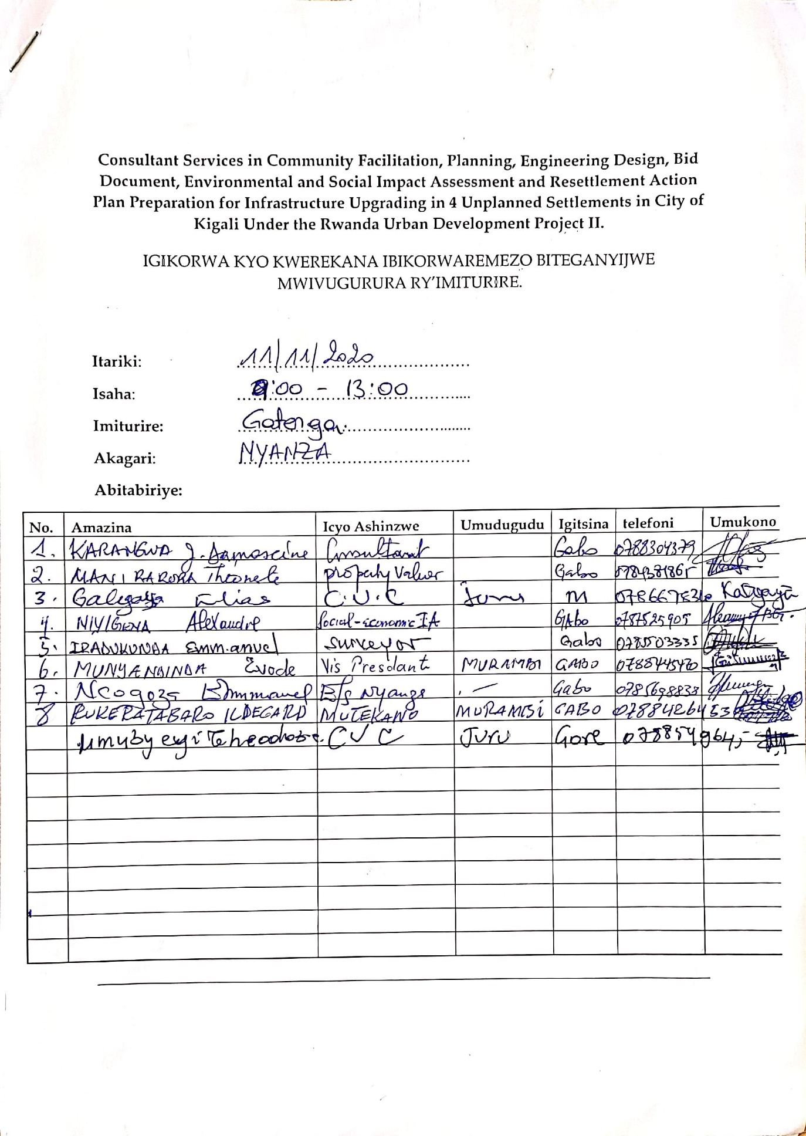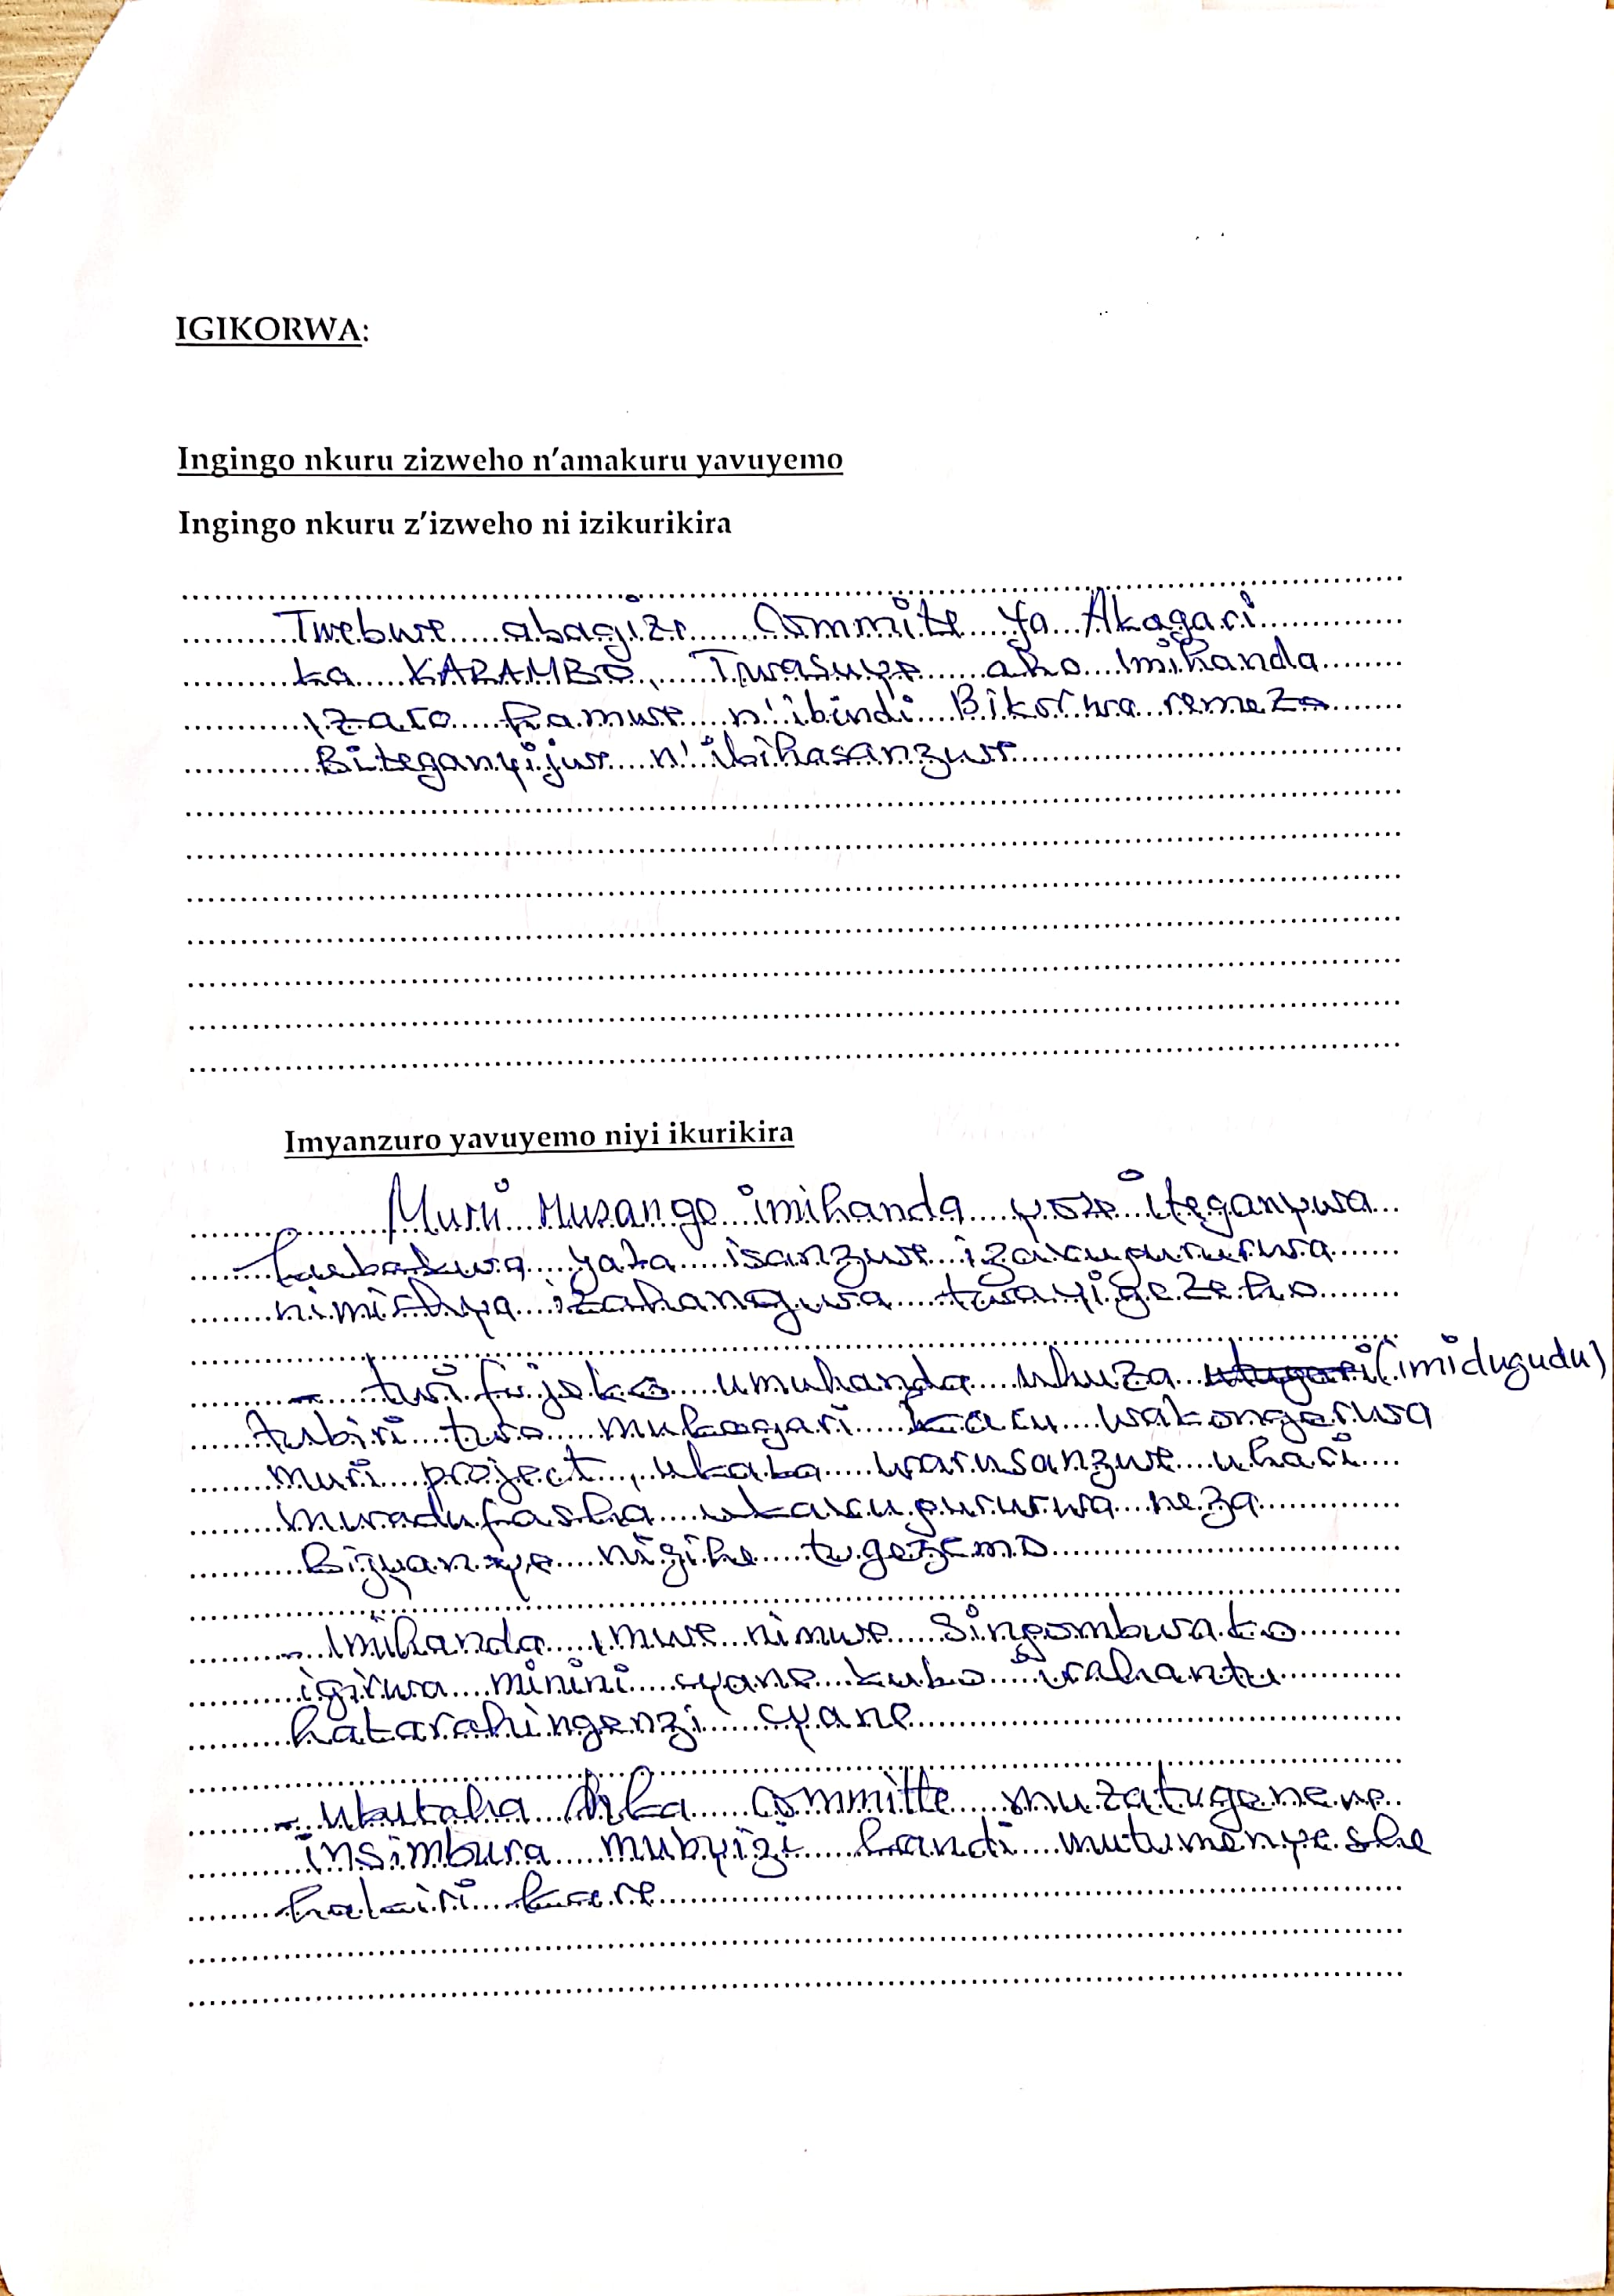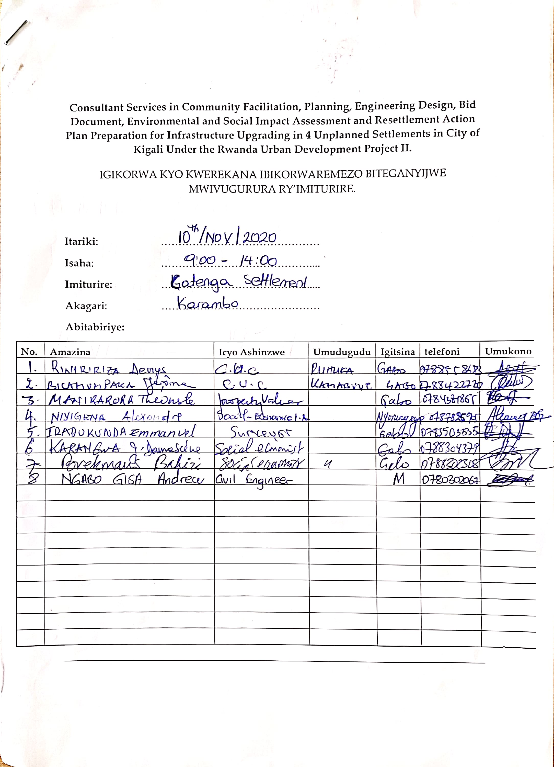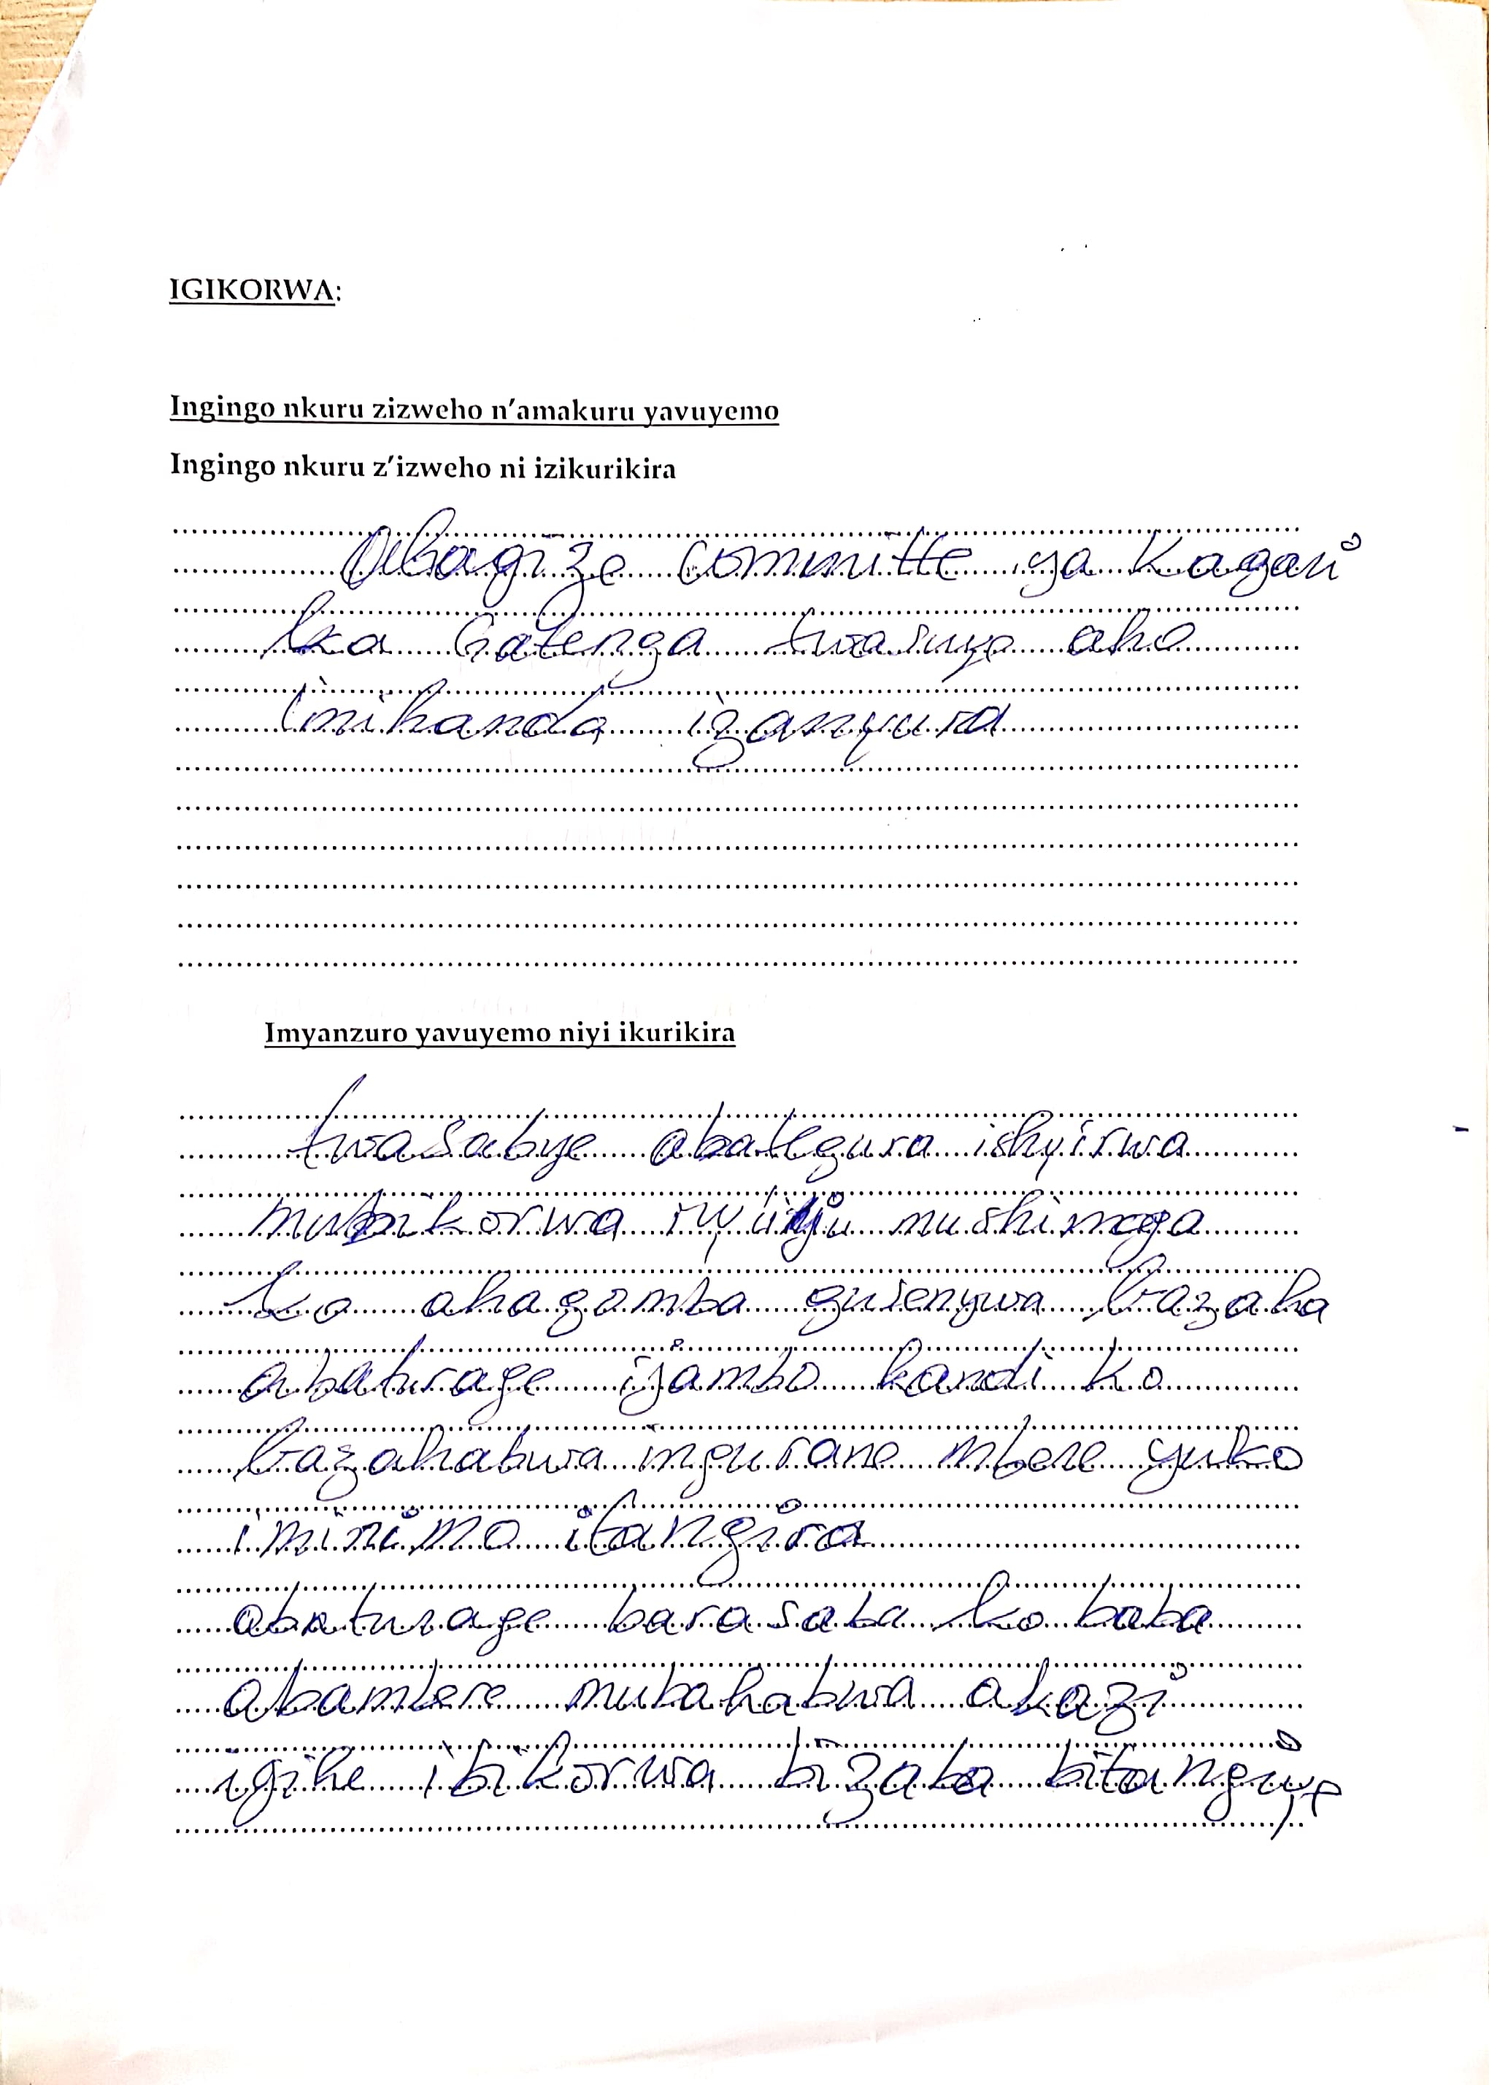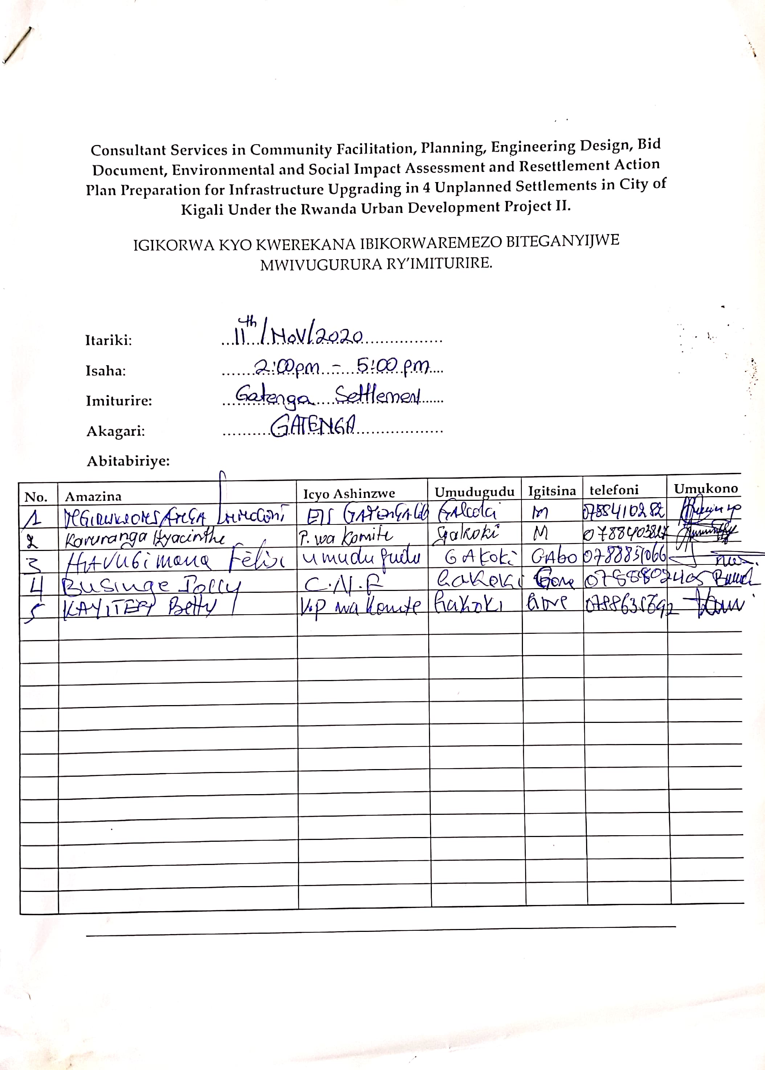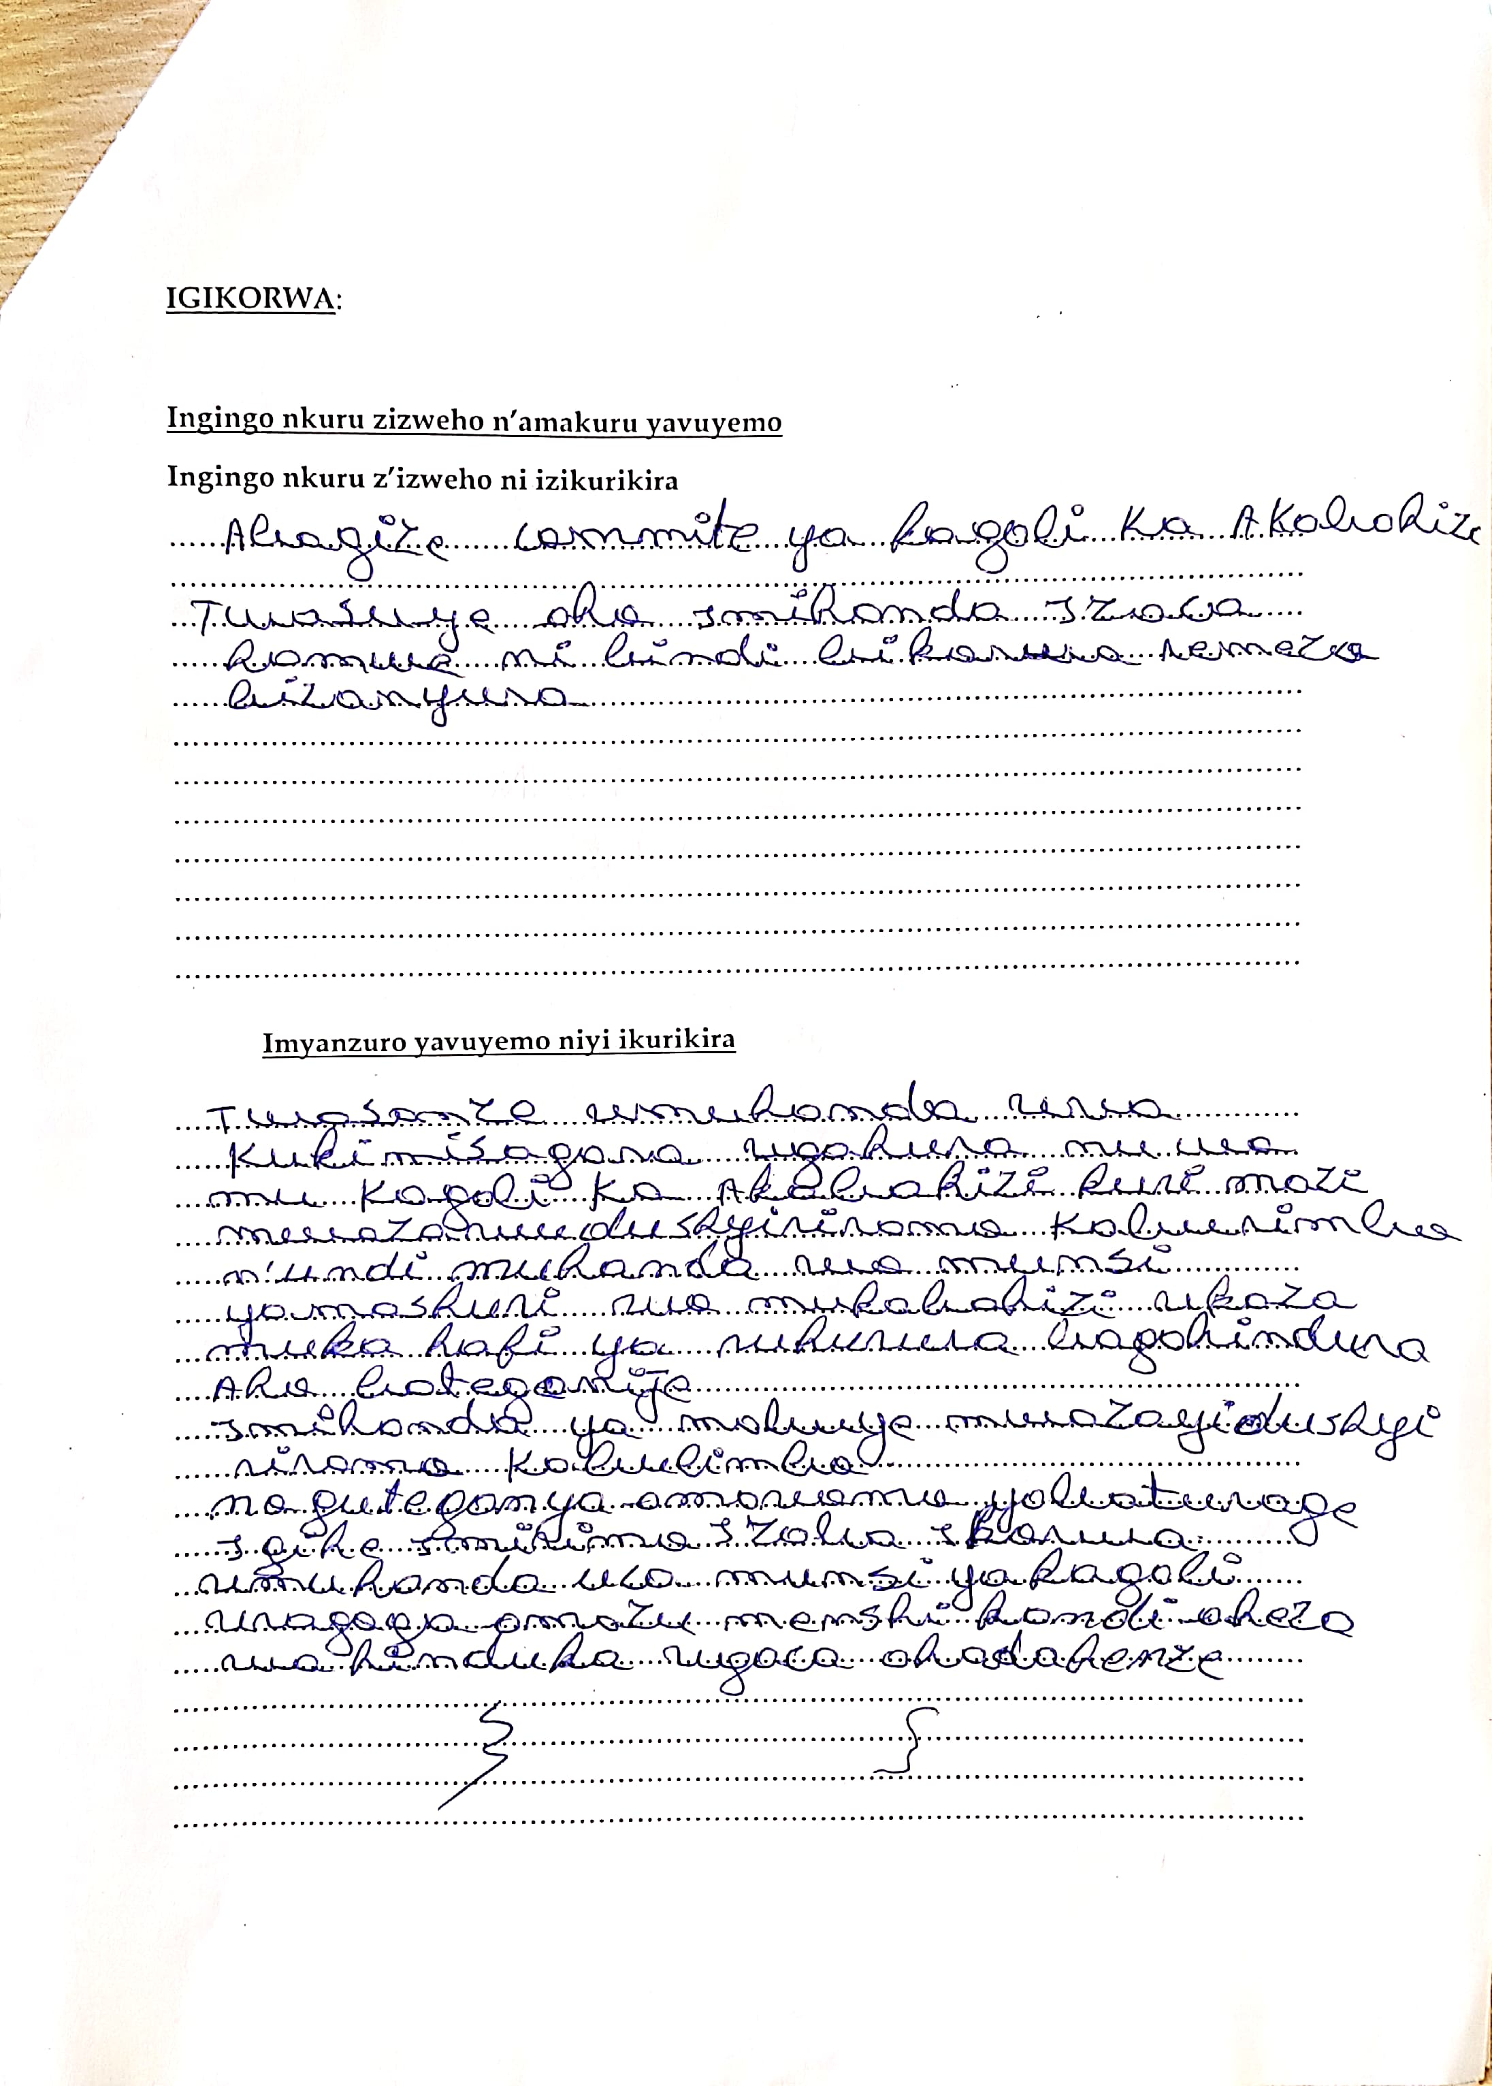

Appendix 6: Minutes of Property Valuation Kickoff Meeting

Consultant Services in Community Facilitation, Planning, Engineering Design, Bid Document, Environmental and Social Impact Assessment and Resettlement Action Plan Preparation for Infrastructure Upgrading in 4 Unplanned Settlements in City of Kigali Under the Rwanda Urban Development Project II.
MEETING TO KICKOFF THE PROPERTY VALUATION EXERCISE IN GATENGA SETTLEMENT, TO ASSIST THE CLIENT ESTIMATE THE POSSIBLE EXPROPRIATION COST.

Date: Monday, April 19th, 2021
Time: 10:00am.
Venue: Gatenga Cell Offices.
Meeting Held: Meeting with the City of Kigali (CoK) representatives, the Community Upgrading Committees (CUCs), the property valuers and the local leaders, to kick off the Property valuation exercise for the Possible PAPs, to assist the client estimate the possible expropriation cost.
Present:
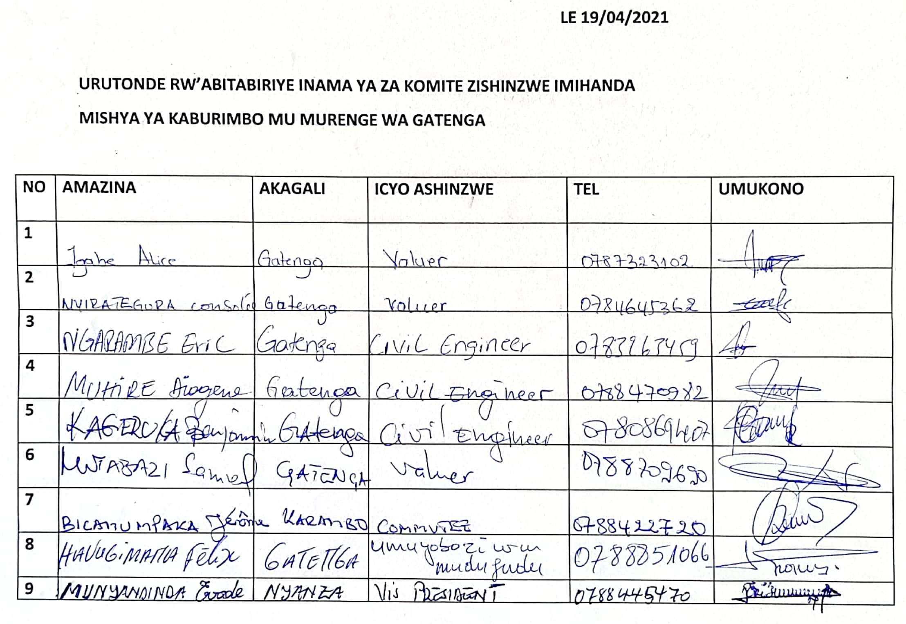
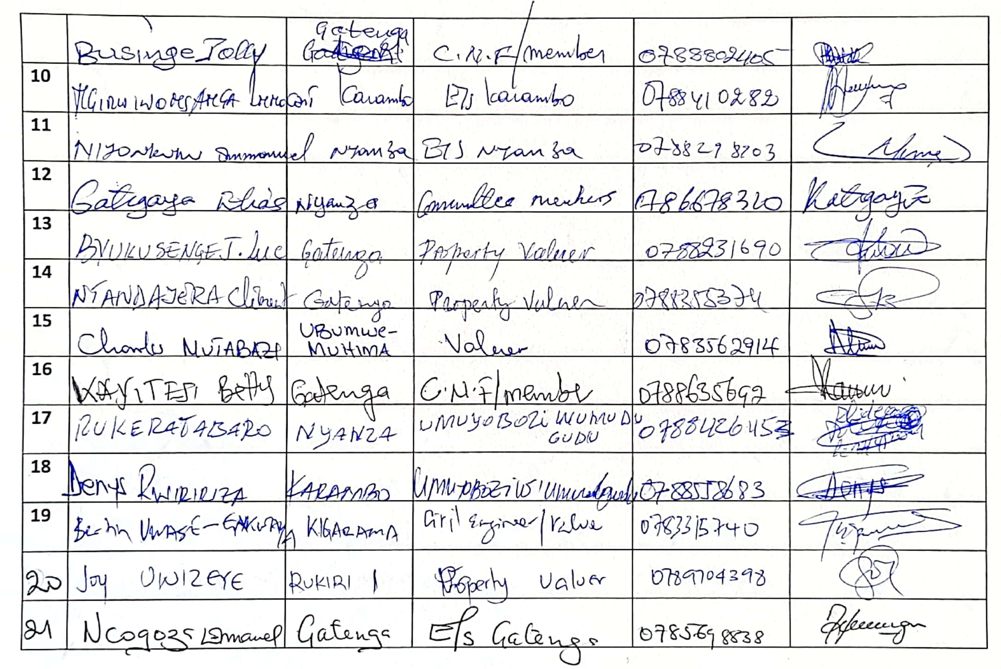
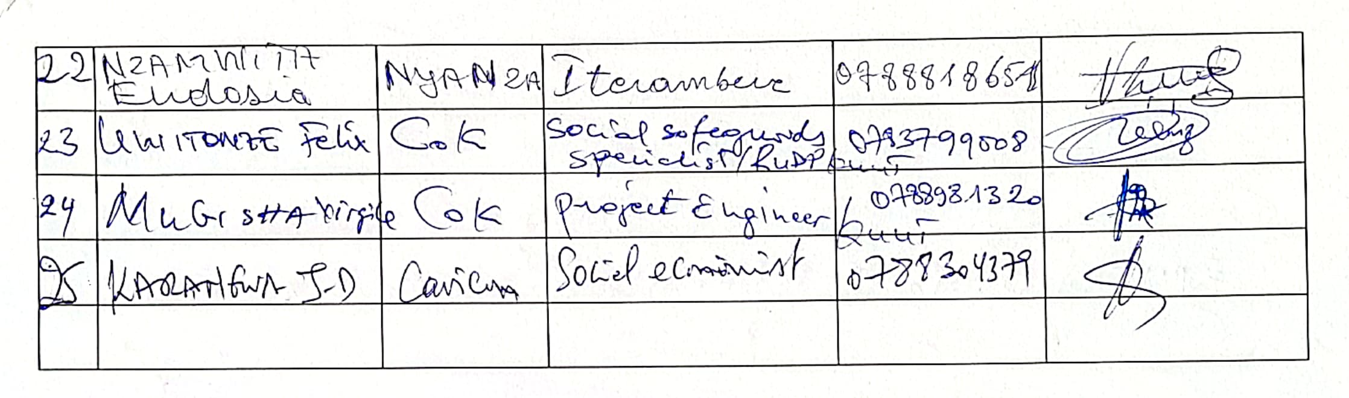

MEETING PURPOSE: Officially kicking off the property valuation exercise to assist the client estimate the probable expropriation cost and prepare a RAP Budget.

Meeting Agenda
10:00 - 10:05am: Introductions
10:10 - 11:00am: Brief Overview of the project by the Consultant team Representatives.
11:00 - 11:15am: Description of the exercise and the outcomes by the client representatives.
11:15 - 11:45am: Question and answer session
11:45 - 12:00pm: Closing remarks by the consultant team.
Summary of Discussion and Key Outcomes
The key issues that were discussed during the meeting were:
- The Consultant team, emphasized how this valuation exercise was intended to assist the client with the estimation of the possible expropriation costs, following the layouts previously agreed upon between the client and the consultant team.
- There was a query on the concrete beacons, on their significance and how they would assist in the exercise, and the consultant team emphasized how the CUC members had to assist in protecting the beacons to ensure accuracy during implementing of the project.
- The CUC members inquired on the possible scenario where the residents would not be present for the valuation, and the consultant agreed with the CUC s to always communicate in the WhatsApp group that was formed between the CUCs, client and the consultants on the area they would be valuing the day prior, to enable the CUCs prepare the residents to be present for the exercise.
- The consultant emphasized how the residents had to be present, sign approving the valued data, and some sketches be made of the area, to avoid possible cases where disputes might arise in the future implementation.
- The client emphasized how the expropriation cost was to be covered by the government of Rwanda, hence strongly advised the residents to take the exercise serious, be present and avoid providing wrong data and over-estimating the costs.
- The residents asked on the upcoming infrastructure, to which the consultant team emphasized how the residents would be involved further to get their opinions on the CUPs they felt where necessary in their settlements, such as recreation facilities.
- The CUCs were agreed to bridge the gap between the residents and be present to remind the residents be present and welcome the property valuers, to be able to complete the project in time.
- The CUCs asked about cases where the property owners might be missing land titles, to this the consultant agreed to value the property, report the cases.
- The participants agreed that no further, construction, or rehabilitation works, should be setup after, the valuation exercise, as the present infrastructure will be recorded.


Prepared by Approved by

NGABO Gisa Andrew KITAKA Paul
GIS Engineer Projects Coordinator

Appendix 7: List of RAP Team Members
RAP TEAM
No. | Name of Expert | Position Assigned
Key Staff
1 | FLORENCE NANGENDO | Social Safeguard Specialists (1)
2 | MINANI FAUSTIN | Social Safeguard Specialists (2)
3 | CHARLES MUGABO | Environmental Specialist (1)
4 | NOREEN NAMARA | Environmental Specialist (2)
5 | BREKMANS BAHIZI | Community Laisse Officers/NGO (2)
6 | DAMASCENE KARANGWA | Community Laisse Officers/NGO (1)
7 | PAUL KITAKA | Project Coordinator (CAVICON)
8 | NGABO GISA ANDREW | Civil Engineer
9 | MUREKASHUNGWE EVERGISTE | Valuer
Support (Field Staff)
10 | MUTABAZI SAMUEL | Property Valuer (Team Leader)
11 | NTANDAYERA CLEMENT | Property Valuer
12 | MUTABAZI CHARLES | Property Valuer
13 | IGABE ALICE | Property Valuer
14 | MUHIRE DIOGENE | Property Valuer
15 | NGARAMBE ERIC | Property Valuer
16 | NYIRATEGURA CONSOLEE | Property Valuer
17 | UWASE GAKWAYA BERTHIN | Property Valuer
18 | BYUKUSENGE JEAN LUC | Property Valuer
19 | KAGERUKA BENJAMIN | Property Valuer
20 | UWIZEYE JOY | Property Valuer
21 | DUKUZIMAN EVODE | Social Economist (Team Leader)
22 | NIYOMUKIZA OLIVIER | Social Economist
23 | MUGENI KATO ANGELIQUE | Social Economist

Appendix 8: Template for Grievance Redress Mechanism Form


UMUJYI WA KIGALI
AKARERE KA …………………………
UMURENGE WA ………………………
AKAGALI KA …………………………..

RUDP UNPLANNED SETTLEMENT UPGRADING PROJECT/RUDP

Akanama Gakurikirana Ibibazo by’Abaturage ku Mushinga ……………………(Settlement)

IFIHI YO KWAKIRIRAMO IBIBAZO MU GIHE HASHYIRWA MU BIKORWA UMUSHINGA
No | Amazina | Itariki ikibazo cyakiriweho | Uburyo cyatanzwe | Aho ikibazo cyakiriwe | Ubwoko bw’ikibazo: ubusabe, Impungenge, Ikirego | Incamake y’ikibazo | Icyiciro:  -Kwimurwa,  -Rwiyemezamirimo | Icyakozwe | Uburyo cyatanzwe | Aho ikibazo cyakiriwe | Aho bigeze  +iminsi 60 | Aho bigeze  +iminsi 90

Bukozwe Na:………………………… Bwemezwe na:…………………………………
E/S wa Akagali President was CUC/GRC

The ESS 5 (Land acquisition, restrictions on land use and involuntary resettlement) recognizes that project-related land acquisition and restrictions on land use can have adverse impacts on communities and persons. It may cause physical displacement (relocation, loss of residential land or loss of shelter) and economic displacement (loss of land, assets or access to assets, leading to loss of income sources or other means of livelihood), or both.
Sagashya and English, Land Administration System for Rwanda: Technical and Economic Analysis, 2014

